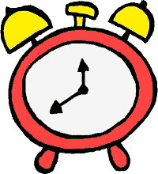
Robo Clock Pre-Assessment Answer Key

- A quarter past 12 PM is 12:15 PM
  - Would the minute hands on the clock move clockwise or counter-clockwise? clockwise
  - How many degrees would the minute hand move? 90 degrees

- A quarter to 12 PM is 11:45 AM
  - How many degrees would the minute hand have to move from 12 PM to show the new time? In which direction? 270 degrees clockwise OR 90 degrees counter-clockwise

- Half past 3 PM is 3:30 PM

- Half an hour to 3 PM is 2:30 PM

- How many minutes are in quarter of an hour? 15 minutes

- How many minutes in half of an hour? 30 minutes

- How many degrees make up 12 hours of the clock? (Hint: a full circle) 360 degrees

