Ultrasound Imaging Worksheet Answers
1. Use the acoustic imaging device to record data.
In cm | 1 | 2 | 3 | 4 | 5 | 6 | 7 | 8 | 9 | 10
grid | 0 | 2 | 4 | 6 | 8 | 10 | 12 | 14 | 16 | 18
distance | 21 | 21 | 15 | 11 | 10 | 10 | 11 | 15 | 21 | 21
height | 0 | 0 | 6 | 10 | 11 | 11 | 10 | 6 | 0 | 0

2. Use the graph paper to plot the data.
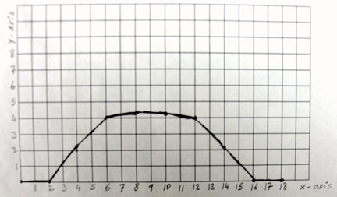
Title: One-dimensional shape of the object inside the box.

3. What is the shape of the object, as depicted by the graph?
Possible answers: round, oval or circular object.
4. What object is likely inside the black box?
Based on the image check list shown to the students before the activity, expect object identification to be quick. In this case, it is a ball with a radius of about 6.5 cm. The top is almost flat because the measurements are not accurate enough for a small variation of the distance. Note that the precision of the EV3 ultrasonic sensor is about 1 cm.

