Volume Worksheet

Calculating the Volume to Fill Engineered Objects Geometric Shapes

Prisms, cones and cylinders refer to 3-dimensional (3D) objects that an external (surface) walls that enclose an interior compartment. Often referred to by other names, a “box” is a square or rectangular prism and a “can” is a cylinder. The volume of the compartment depends on the external walls’ dimensions.

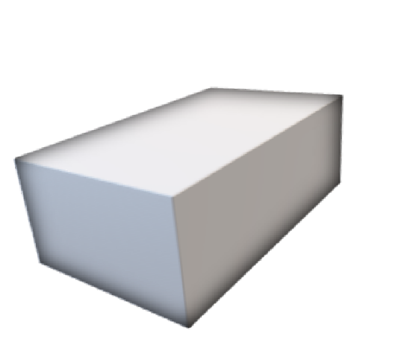
To simplify the prototype, use either square or rectangular prisms. Calculate the volume needed to fill prism without any objects added. Volume units are written cubed (ex. cubic centimeters written as cm³) or used a “liquid” unit (ex. milliliters). Object(s) added into the internal compartment will reduce the final resin volume as the object(s) takes the resin space.
Cuboid or Rectangular Prism  (Box; Ice Cooler) | - four sides (walls)  - flat sides  - 90° angle at edges  - space within walls | c c  b | Volume (V) = abc  If a=b=c then named Cube or Square. (b is similar to its height)  If two or no measurements equal then named Rectangle.
Triangular Prism | - three sides  - polyhedron with five faces  - right triangular prism has rectangular sides, otherwise called  oblique triangle | h a  c | V= (½ a)(c)(h) where base = (½ a)(c) and height=h
Cylinder (Paint can) | - Circular base exactly over each other with axis at right angles to base is “right  cylinder”  - If one base is displaced sideways call oblique cylinder | h  d | V = (base)(height) where base=(π)(radius²) & Radius = ½ diameter (d)  V=Base x height = π(r²)(h)

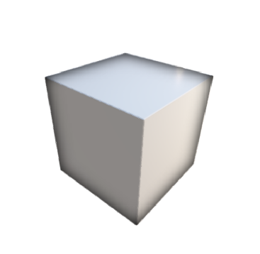

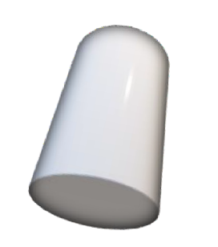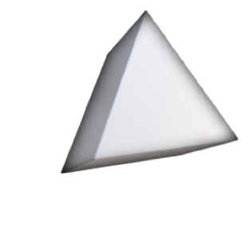

Calculate the Volume. π = 3.14

Section A. Paint Containers
- Sketch each can and label the canister’s base diameter and height. Calculate the maximum amount of paint that each paint canister can store.
Can A: base diameter = 5 cm
height = 30 cm

Can B: base diameter = 10 cm
height = 20 cm

Can C: base diameter = 5 cm
height = 20 cm

- What is the volume of a cylinder that has a radius of 3 inches and a height of 6 inches? (Convert to centimeters).

Section B. Boxes
- When preparing for a picnic, an ice cooler is to be filled with drinking water. Which cooler can hold the most water?

Cooler A: a = 40 cm
b = 40 cm
c = 40 cm

Cooler B: a = 25 cm
b = 32 cm
c = 40 cm

- Calculate the volume of a cooler that has the dimensions of width 25 inches, length 32 inches and height 40 inches. What is the volume in inches and centimeters?

- What is the volume of a box with a base of 4 inches by 4 inches and a height of 10 inches?
(Convert to centimeters).

- What is the volume of a box with a base of 8 inches by 8 inches that has a height of 10 inches?
(Convert to centimeters).

Section C: Triangular Prism with 90-degree angle

- Calculate the volume of a right triangular prism with sides of 3in x 4in x 5in and a height of 12 inches. (Convert to centimeters).

- Calculate the volume of a right triangular prism with sides of 3in x 4in x 5in and a height of 10 inches. (Convert to centimeters).

- Calculate the volume of a right triangular prism with sides of 5in x 12in x 13in and a height of 12 inches. (Convert to centimeters).

