How to Create a Galvanic Cell Student Worksheet Answer Key

Instructions: In the space below, draw a diagram of your working galvanic cell including your completed electrical circuit. Make sure to clearly label the parts of your cell including the metal strips, electrical components, and chemical solutions.

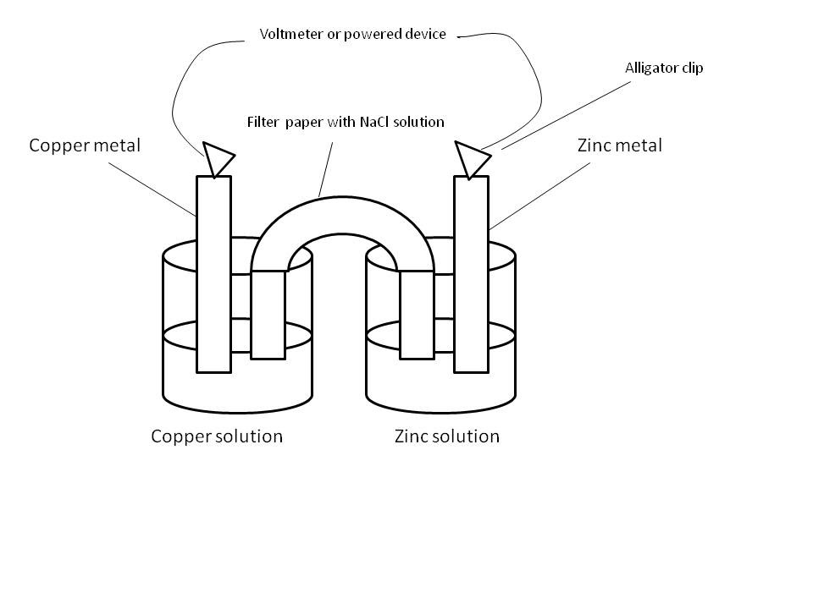

Discussion Questions

- Which substance is being oxidized in your galvanic cell?
The zinc metal is oxidized into zinc ions.

- Which substance is being reduced in your galvanic cell?
The copper ions are reduced into copper metal.

- Based on the activity series, what other metal ions could be used to power this reaction?
(answers can vary) lithium, potassium, barium, calcium, and magnesium

- Use the space below to write out the balanced redox reaction for this cell:
Oxidation
Zn(s) Zn²⁺(aq) + 2e⁻
Reduction
Cu²⁺(aq) + 2e⁻ Cu(s)
Zn(s) + Cu²⁺(aq) Zn²⁺(aq) + Cu(s)

Post-lab Discussion Questions (Answers may vary)

- After completing this activity, how would you define a voltaic cell? If this definition is different from how you would define one before this lab, explain how and why your definition changed.
A voltaic cell can be defined as an electrochemical cell that relies upon chemical reactions to produce electrical energy.

Note: A student’s definition may have changed after conducting this activity due to the process of actually creating the voltaic cell and seeing how it powered an electrical device.

- Why do you think it is important to have a salt bridge connecting the two metal ion solutions?
The salt bridge serves to as a connection for oxidation and reduction half reactions in to allow ions to move and maintain charge balance throughout a voltaic cell.

- Do you feel this would be a reliable and environmentally safe source of energy? Explain your answer.
Answers can vary. This could be a reliable source of energy because a voltaic cell can produce a constant source of electrical energy until the half reactions eventually stop. It may not be environmentally safe, however, due to the waste products produced from the half reactions.

- Did having access to fewer materials have a dramatic effect on your activity? How do you think engineers and scientists deal with this challenge in the workplace or during real world experiments?
Answers can vary. Having access to fewer materials could have severely limited this activity due to the need for raw materials to power the reaction. Engineers and scientists could deal with supply constraints by improvising and/or substituting other materials in place of missing supplies.

- What are some possible sources of error from this activity? How could this have affected the overall outcome or success of your experiment?
Answers can vary. Error could have occurred during the setup of the half reactions, the salt bridge, or the process of creating the electrical circuit.

- How could this activity be improved upon for future implementation?
Answers can vary.

