Icosahedral  - Spherical in shape, but a closer look reveals they are icosahedral.  - The genetic material is enclosed inside of the capsid.  - Viruses with icosahedral structures are released into the environment when the cell dies, breaks down, and lyses, thus releasing the virions.  - Examples: poliovirus, rhinovirus, and adenovirus | 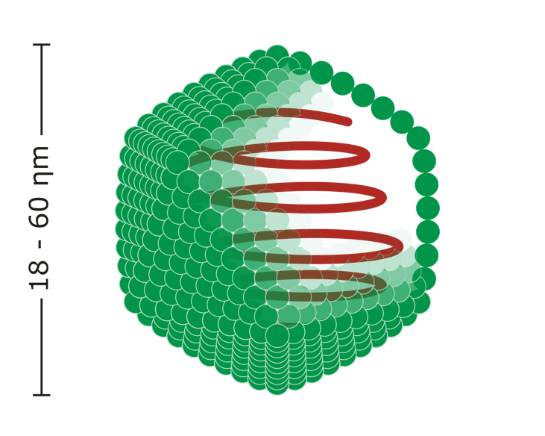
Envelope  - Its structure is a conventional icosahedral or helical structure  - Its structure is surrounded/enclosed by a lipid bilayer membrane  - The envelope of the virus forms when the virus exits the cell via budding mechanism  - Examples: influenza, hepatitis C, HIV | 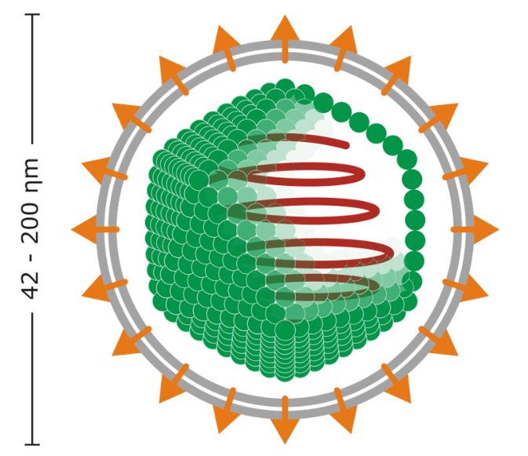
Complex  - Its structure is a combination of icosahedral and helical shape  - May have a complex outer wall or head-tail structure  - The head-tail structure is unique of bacteriophages (viruses that only infect bacteria)  - The head of the virus possesses an icosahedral shape with a helical shaped tail  - The tail in a bacteriophage is used to attach to the bacterium. It creates a hole in the cell wall, and it inserts its DNA into the cell.  - Examples: variola virus (smallpox) | 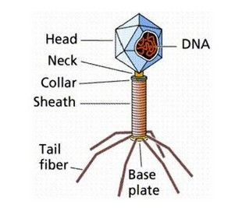  http://www.fabpretty.com/science/microbiology/transmission-and-symptoms-of-virus/
Helical  - Its structure is composed of a capsid with a central cavity (hollow tube).  - The central cavity is made of proteins arranged in a circular form.  - The circular morphology of creates a disk like shape that attaches helically simulating a toy slinky.  - The hollow tube shape allows for the nucleic acid to be stored in the middle.  - Helical viruses are usually around 15-19 nm wide and 300-500nm.  - Example: Tobacco Mosaic Virus | 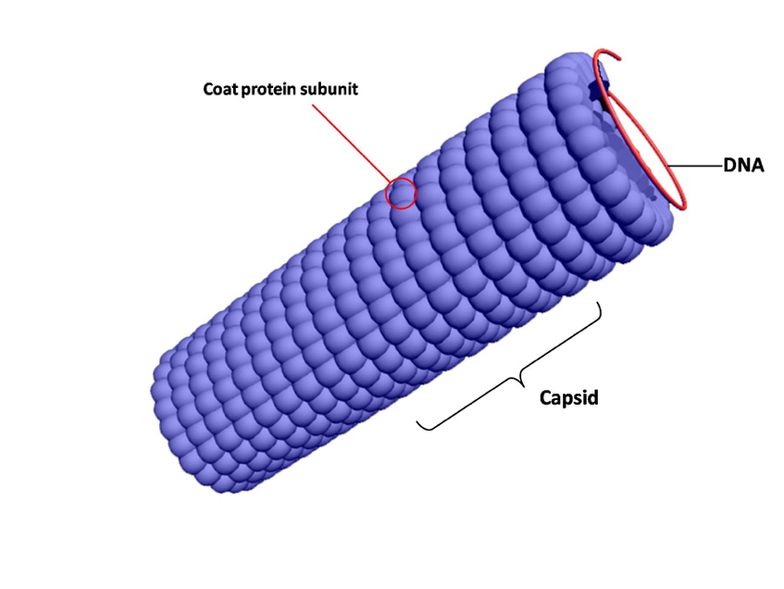  https://commons.wikimedia.org/wiki/File:Helical_capsid.jpg

