Student Worksheet
Before you begin: Think about all of the potato chip bags in the aisles of your favorite stores. How many of these bags do you believe are produced per year to meet consumer demands?

Background: Snack bags, such as potato chip bags, are made up of several layers of polymers. These include one called biaxially orientated polypropylene, which the polymer that gives a bag a thin, film-like feel. Low density polypropylene, or LDPE, which is commonly used in all plastic materials, and an outer layer of thermoplastic resin. In other words, all these polymers are non-biodegradable plastics that are not easily recycled. Most end up in landfills, or worse, in our oceans and waterways
Plastic is an environmental toxic pollutant because of the harmful chemicals that harm oceans, landfills and air. Plastic can take hundreds or thousands of years to degrade. So, think about those colorful potato chip bags. Yes, those bags also take centuries or a millennium to breakdown partially. What can we do to solve this global, environmental issue?

You Do The Math:
Graph the data table below of consumers who purchased bags of Lay’s potato chips
Year | # Lay’s bags sold  (millions)
2014 | 27.59
2015 | 35.44
2016 | 32.09
2017 | 32.74
2018 | 34.62
2019 | 35.22

In six years, how many bags of Lay’s potato chips were sold?

Discussion:
Think about other brands of potato chips. How many bags of potato chips in total do you believe were sold?

Where are all of these potato chip bags now?
Your Task: You are to design a biodegradable potato chip bag prototype using biodegradable products. Remember to design bags that will appeal to the buyer and pass a quality control test.

My Biodegradeable Husk Bag
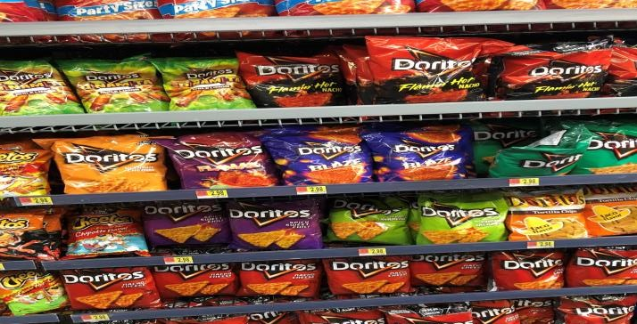
Materials:
- corn husk
- glue
- colored markers
- digital scales
- heat lamps
- golf balls
- timer
- water container
- meter stick

Quality Control Test:
TEST | Run 1 | Run 2 | Run 3 | % Score | Passed (100%) | Failed (<100%)

Weight of bag (1.5 -2.0 ounces).
Shake (left, right and up down) Count as you shake. | 20 | 20 | 20
Toss up (5ft: 10Xs) | 10 | 10 | 10
Drop test (at waist, arm, above head). Is it intact? | Yes  No | Yes  No | Yes  No
Temp under a heat lamp:
1 min, 3 min 5 min
Tensile Strength using 3 golf balls
Moisture: wet or dry | Yes  No | Yes  No | Yes  No

Shake the prototype 10 times in a left to right motion; up and down 10 times. Toss the bag up in the air about 5 feet 10 times (catch the bag). Submerge the prototype in the pan of water and count to ten. Drop the bag from waist height, arm height and above your head. Tensile Strength Place as three golf balls inside the prototype. Place prototype under a heat lamp for 1, 3, and 5 minutes.

Reflection:
What worked and what didn’t work in your design? What would you do differently?

How can the success of this design apply to the real world?

What might you want to learn more about because of this? Do you care about toxic plastic pollutants? Why?

