**Wiring Schematics Handout**

### **For the buttons:**

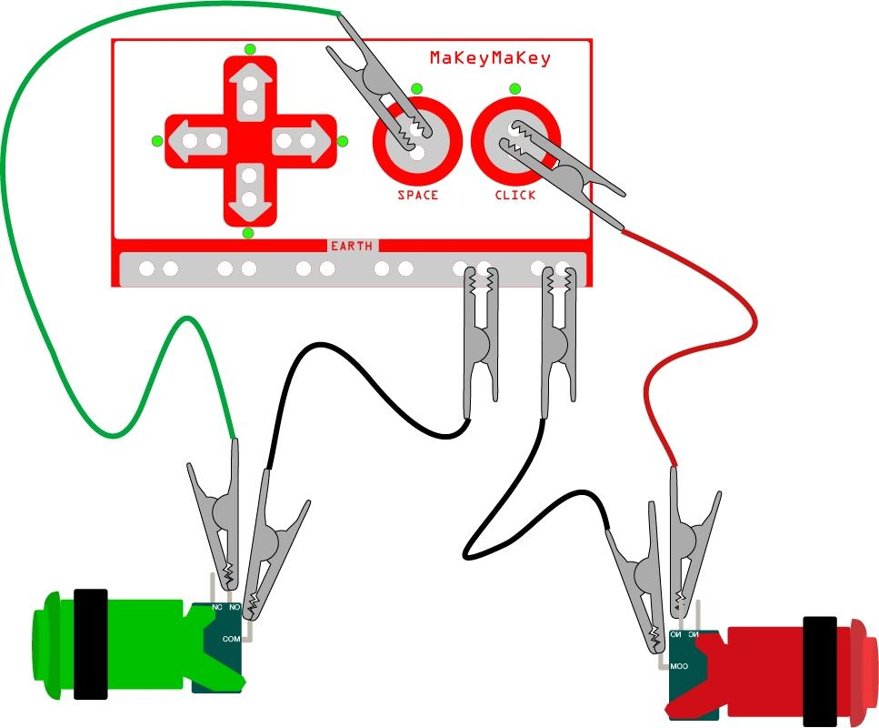

### **For the joystick:**

