Visual Aid

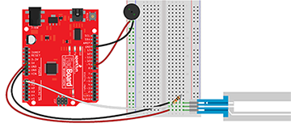

Figure 2. A wiring schematic of the keyboard.

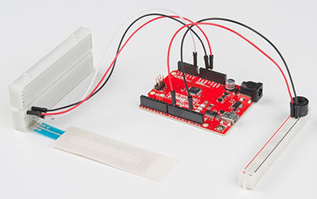

Figure 3. An assembled keyboard with cut breadboard.

