Egg Dropper Construction and Use
Introduction
This document describes the construction and use of an egg-dropping device for the TeachEngineering activity, “Naked Egg Drop.” Below is a photograph of the prototype device:
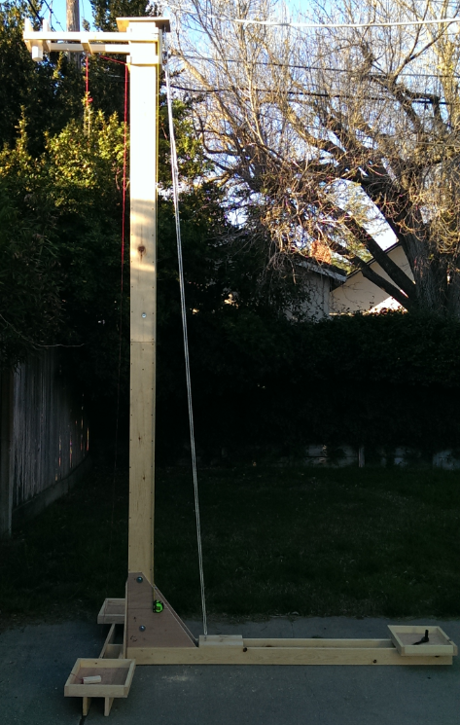

Without this egg dropper device, students must climb a ladder to drop the eggs. Using a ladder, the maximum drop height is about 8’ and requires students to dangle themselves precariously to aim the eggs. This project was conceived to bring a cool machine element to the contest, improve safety and eliminate the aiming skill required if a ladder is used.
The egg dropper is constructed in five parts that disassemble into pieces that are each no more than 6’ long. All five pieces fit in a full-size sedan with a fold down rear seat (and no passengers).
The egg is placed in the PVC pipe on the upper left and held in place with a u-shaped rod. The rope is pulled to lift the slider to the appropriate height, which is determined from reading the modified tape measure. A smaller rope is used to pull the rod out of the PVC, releasing the egg. The square platforms hold five-gallon buckets of water to stabilize the structure.
The construction of an improved version is outlined here. A CAD drawing of this new design is below:
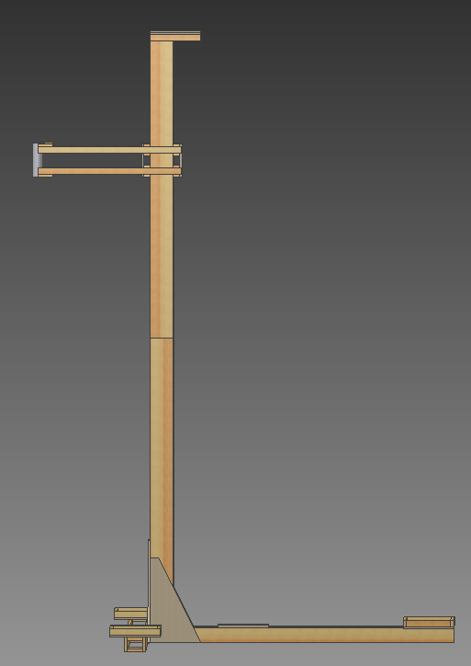

A Word of Warning
The egg dropper is 12’ tall and heavy enough to seriously hurt someone if it falls over. It is complicated to make and adjust for proper functionality. Only experienced builders who are confident that they can safely build a complex project should attempt this project. Read the entire document before you decide to purchase the required materials, which cost ~ $300. This project takes a few weekends of work.
Procedures
Parts List
Wood:
(15 +1-3 extra) 1”x2”x6’ whitewood boards
(6) 1”x4”x6’ whitewood boards
(4) 1”x6”x6’ whitewood boards
(1) 1/2”x2’x4’ plywood (not MDF or OSB)
Note: It is best if all boards are “whitewood,” which is graded in increasing quality and cost as: #2, #1, D and C. In big box home stores, this is pine, typically Radiata Pine. Carefully selected #2 boards work, but even C boards must be selected based on straightness. When picking boards, look down the long edge and make sure that the board is not twisted or bent. The hardware store floor is almost certainly not flat, so do not rely on it to check for straightness. Take the time to go through the whole pile, and possibly to multiple stores, since crooked wood makes the assembly process much more difficult. If you can find straight #2 or #1 boards, make sure they have no knots near the edges or ends.
Hardware:
(2) 1 lb. boxes of #8 x1-5/8” exterior wood screws
(3) ¼-20 U bolts with plate, approximately 1-1/2”x1-1/2”
(6) ¼-20 nuts
(7) ¼-20 washers
(1) small eye screw (that fits surveyor’s twine, see below)
(1) carabineer
(2) 7” 3/8-16 hex head bolts
(2) 5” 3/8-16 hex head bolts
(1) 6” 3/8-16 hex head bolts
(1) 3-1/2” 3/8-16 hex head bolts
(12) 3/8” washers
(6) 3/8-16 hex nuts
(>12”) 1/8” steel rod
Other:
8 oz. bottle weatherproof wood glue (such as Titebond Woodworker III or similar)
duct tape
(at least 8”) 2’ SCH40 PVC pipe
(1) 1-1/2” PVC pipe end cap to use as a test egg, for testing the rig
12’ tape measure
(at least 30’) 3/8” rope
(1) spool surveyor’s twine or other light rope
(4) 10” zip ties
(1 stick) hot glue
(3) five-gallon buckets with water, to stabilize the tower
(optional) exterior house paint and brush
(optional) storage bag or box, to store loose hardware for transport
(optional) blue tarp, 8’ x 6’
(optional) gloves
Specialty Tools:
(1) 3/8” wood boring bit that can drill at least 6” deep
corner level

Plywood Cut Layout
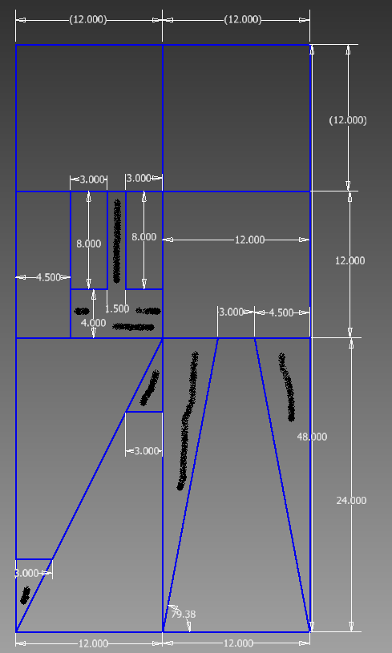
Careful cutting yields all the required pieces from 1 sheet of 2x4’ plywood. The scrap pieces have “spray paint” lines drawn through them. All pieces can be smaller than their stated measurements by a saw kerf. The one piece that needs to be precise are the 3x8” pieces—the 3” dimension must be exact.

The five main parts are the Lower Tower, Upper Tower, Front Brace, Rear Brace and Slider. The construction instructions for each piece follows.
Lower Tower
Below is a CAD drawing of the completed Lower Tower:

Components: Cut boards as necessary.
(2) 6’ 1x6
(2) 6’ 1x2
(2) 1’ 1x2
#8 1-5/8 exterior wood screws
weatherproof wood glue (such as Titebond Woodworker III or similar)
Instructions:
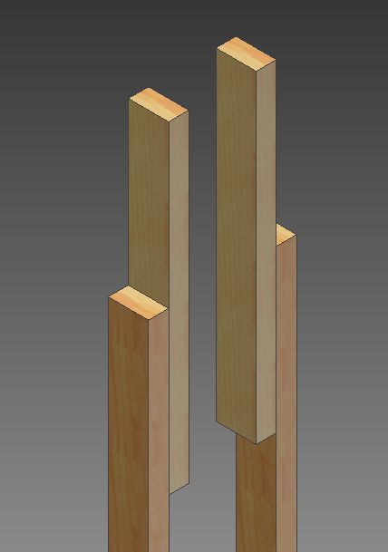
Glue the two 1’ pieces of 1x2 to the ends of the 6’ 1x2s as shown, using a 6” overlap:

Spread a generous amount of glue on each surface and clamp them together, making absolutely sure that the edges of the boards are parallel. You may want to clamp them down to a flat piece of wood covered with wax paper or parchment paper to ensure that they are straight. Wipe off the excess glue that squeezes out (if none does, you didn’t use enough glue) and leave the clamps on overnight.

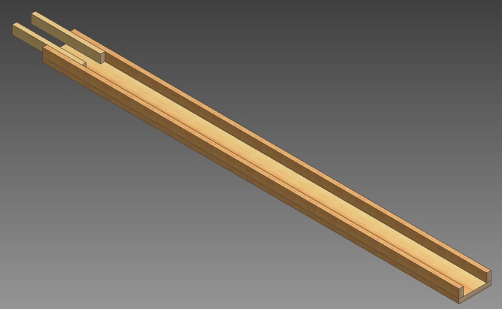
Put down one of the two 6’ 1x6 boards on a work bench. Put the 6’ long 1x2 assemblies on top and make sure that all the edges line up:

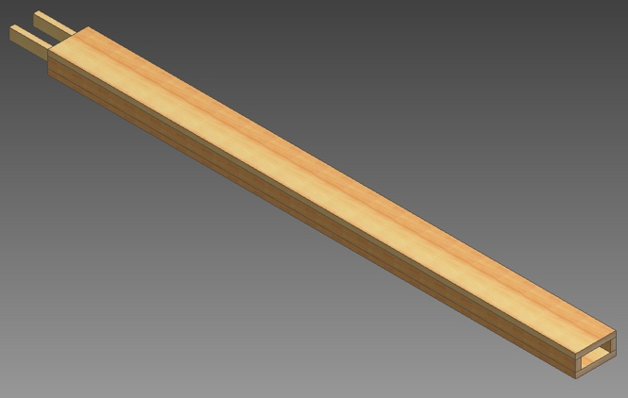
Spread a generous amount of glue on the top faces of the 1x2s and place the other 6’ 1x6 on top:

Align one end of the 1x2 so that it lines up with the corner of the 1x6 and drive a screw to fasten the corner. Now go to the opposite corner of the same 1x2, line it up with the edges of the 1x6 and drive in a screw. With the two ends of the boards lined up and screwed, drive a screw in every 6” or so all the way down. Starting in the middle and working your way out will help to keep correct and bowing of the 1x2. If you picked good boards, you should be able to pull everything into alignment by hand. Repeat this process on the other 1x2. Wipe off any glue that squeezes out.
Flip over the now U-shaped assembly, spread glue on the tops of the 1x2s and screw on the other 1x6 with the same attention to keeping everything lined up and straight. Be sure to offset the screws by an inch or so as to not hit the screws from the other side. You may need to use several large C-clamps to pull the boards straight so that all edges are flat.
Upper Tower
Below is a CAD drawing of the completed Upper Tower:

Components: Cut boards as necessary. Refer to the layout for the plywood cuts.
(1) ½”x4-1/2”x12” plywood piece
(2) 1’ 1x2
(2) 6’ 1x6
(2) 6’ 1x2
(2) 16” 1x2
(1) U bolt, about 1.5” wide with ¼-20 nuts
(2) ¼-20 nuts
(2) ¼” washers
#8 1-5/8” exterior wood screws
weatherproof wood glue (such as Titebond Woodworker III or similar)
Instructions:
Glue the two 16” 1x2s together using glue and clamps:
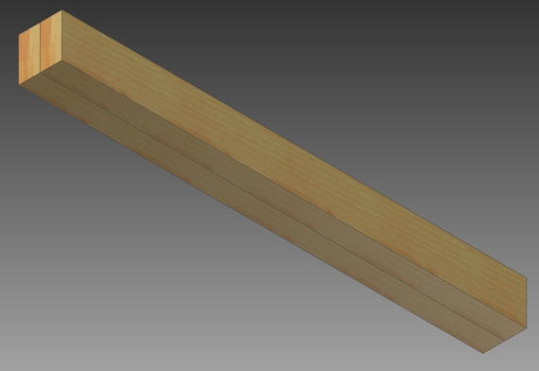

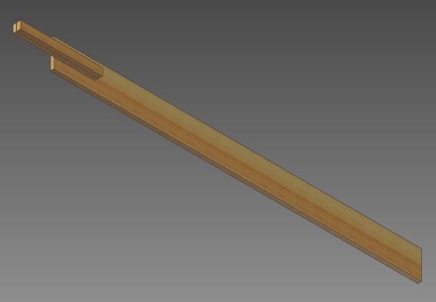
After the glue has dried, glue the two pieces to one of the 6’ 1x6 as shown, using 8” of overlap and no screws. Make sure that the 1x2 assembly is centered on the 1x6 and that they are parallel.

Use the same process as you used on the Lower Tower to add the 1x2s and 1x6 as shown:
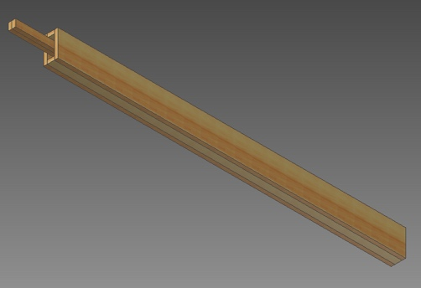

Attach the two 12” long 1x2s to the tower as shown, using glue and screws. Make sure that the two pieces are aligned and flush to the top of the 1x6s:
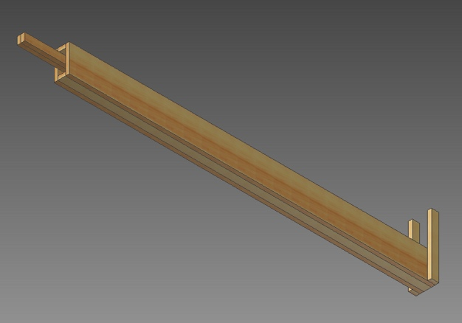

Now use glue and screws to add the plywood to the top of the tower:
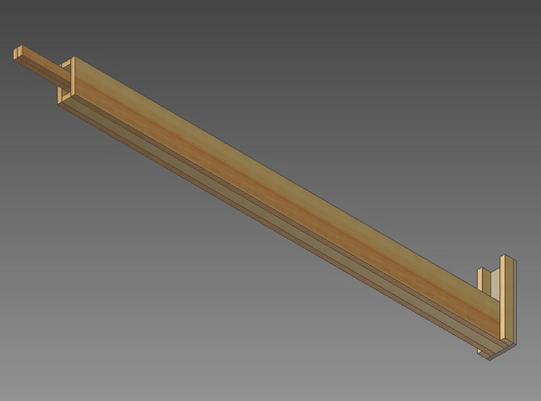

Drill two ¼” holes for installing the U-bolt with the 2 extra nuts and washers. Make the holes about 2” away from the edge of the board. The U side faces down toward the other side of the Upper Tower.
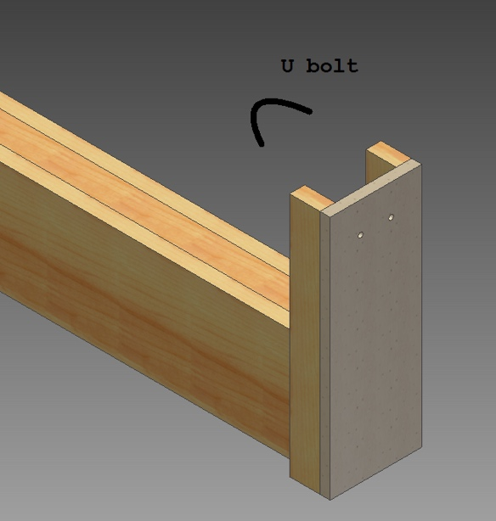

Front Brace
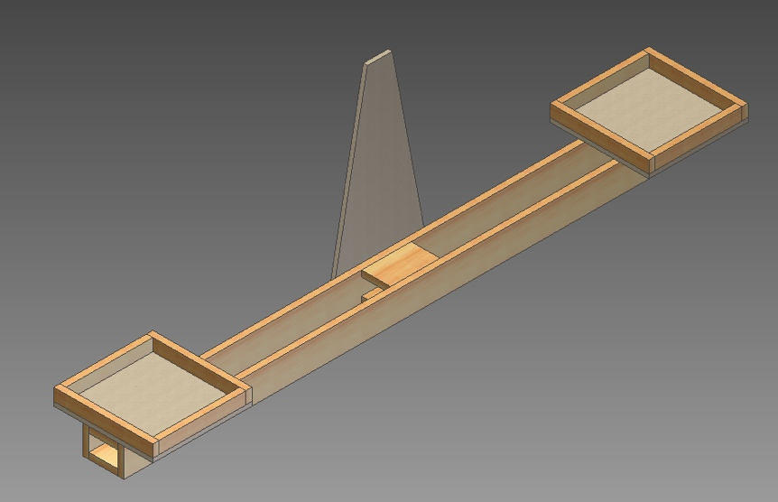
Below is a CAD drawing of the completed Front Brace:

Components: Cut boards as necessary. Refer to the layout for the plywood cuts.
(1) trapezoidal ½” plywood piece
(2) ½”x12”x12” plywood pieces
(4) 12” 1x2
(4) 10-1/2” 1x2
(2) 6’ 1x4
(6) 6” 1x4
#8 1-5/8” exterior wood screws
weatherproof wood glue (such as Titebond Woodworker III or similar)
Instructions:
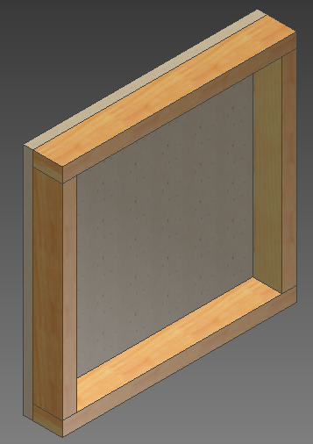
Make the two bucket stands by gluing and screwing the 12” and 10-1/2” 1x2s to the 12”x12” plywood pieces.

Assemble the beam using glue and 2 screws per 6” spacer as shown. Make sure the center of the two middle spacers is aligned with the center of the 6’ 1x4.
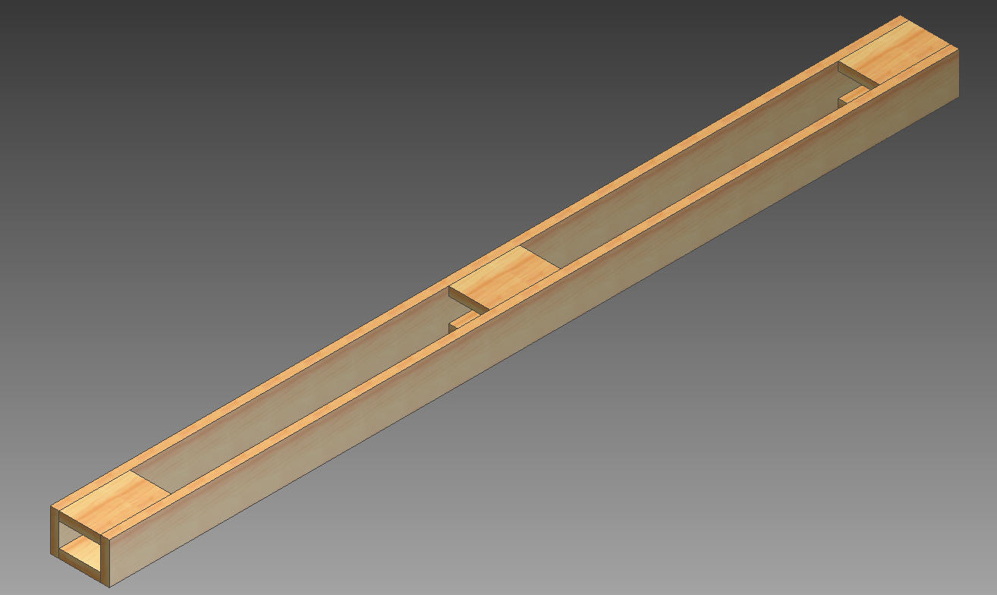
Add the bucket stands with glue and screws. The outside edges of the bucket stands line up with the ends of the 6’ 1x6s. The bucket stands should be centered on the beam, but this is not critical.
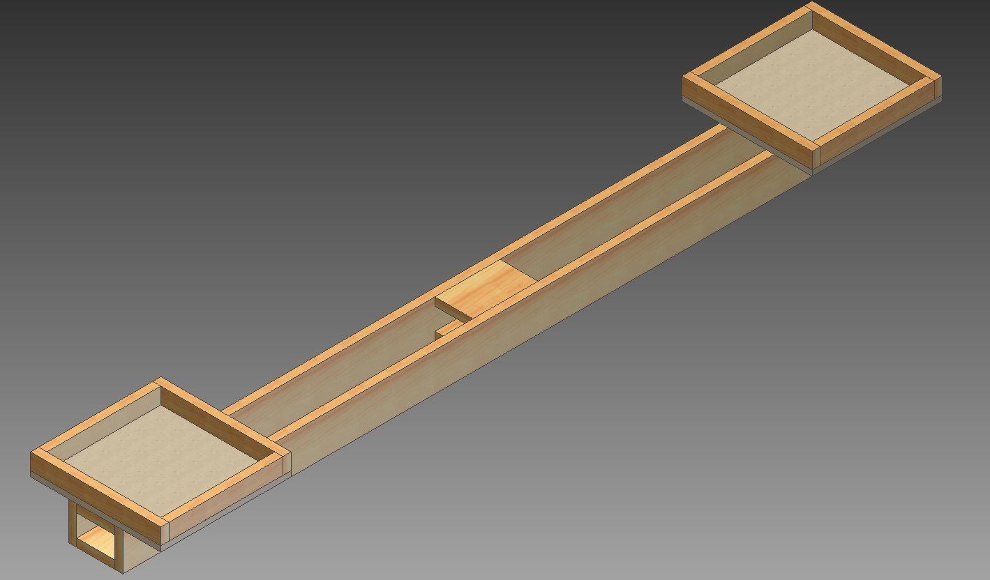
Mark the center of the beam, and the center of the bottom of the plywood trapezoid. Smear glue onto both parts, line up the center marks, and use 6-8 wood screws to attach them.
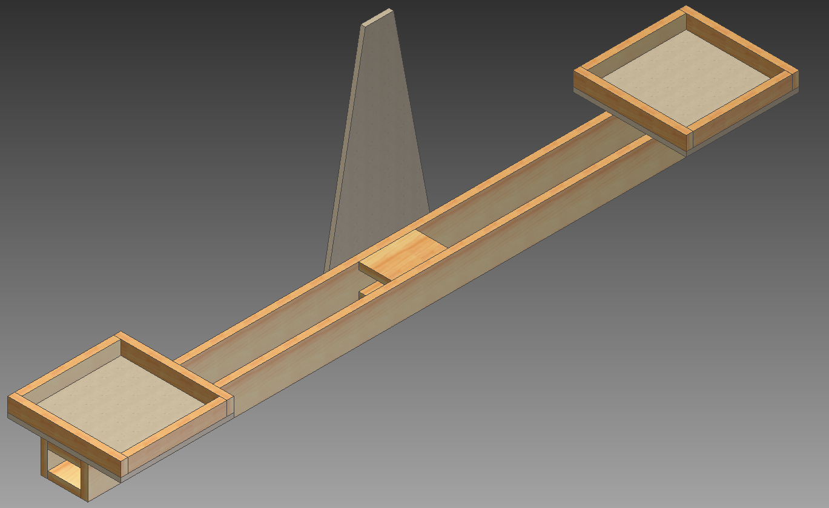
The screws might protrude into the inside of the beam. These tips can be cut off with a hacksaw or Dremel tool.
Rear Brace
Below is a CAD drawing of the completed Rear Brace:
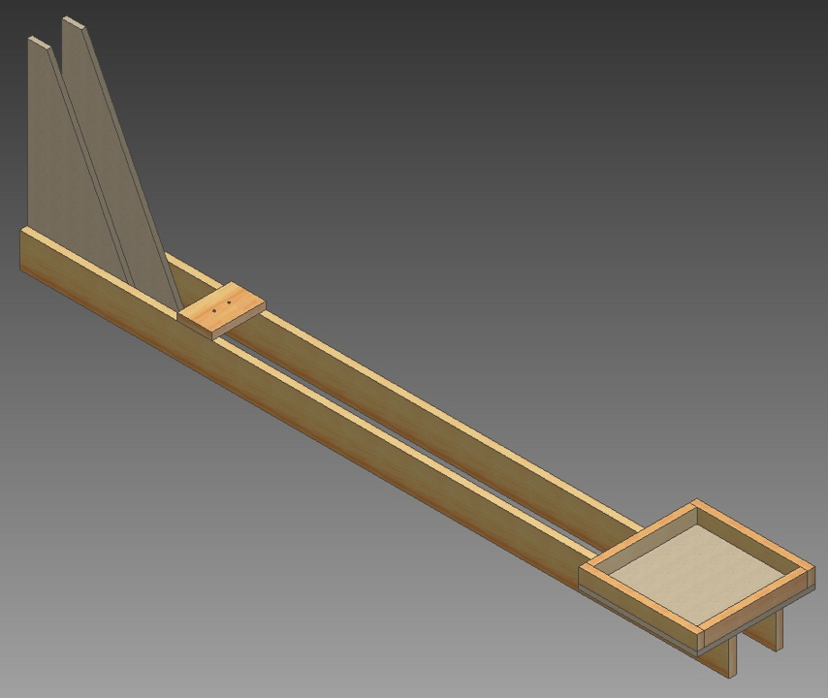

Components: Cut boards as necessary. Refer to the layout for the plywood cuts.
(2) triangular ½” plywood pieces
(1) ½”x12”x12” plywood piece
(2) 10.5” 1x2
(2) 12” 1x2
(1) 5.5” 1x4
#8 1-5/8” exterior wood screws
weatherproof wood glue (such as Titebond Woodworker III or similar)
(1) U bolt
(2) ¼-20 nuts
(2) ¼” washers

Instructions:
Build a bucket stand just as before:
Add the two plywood triangles to the 1x4s (remember to make them mirror images as shown). Use plenty of glue and 8-10 screws through the plywood into the 1x4s.
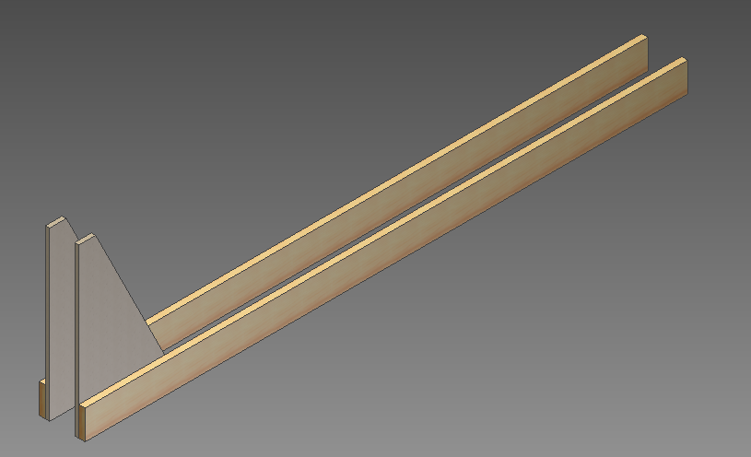

The screws will protrude slightly out the back of the boards. Cut off the ends with a hacksaw or Dremel tool.

Stand both plywood pieces up as shown and use the Lower Tower as a spacer between the plywood. Use C clamps to hold them in place. Use glue and 6 screws to attach the 5.5” 1x4, so that its front edge is about 16” from the front edge of the triangles. Drill holes for another U bolt as shown. The U bolt faces up and is installed with the extra nuts and washers.
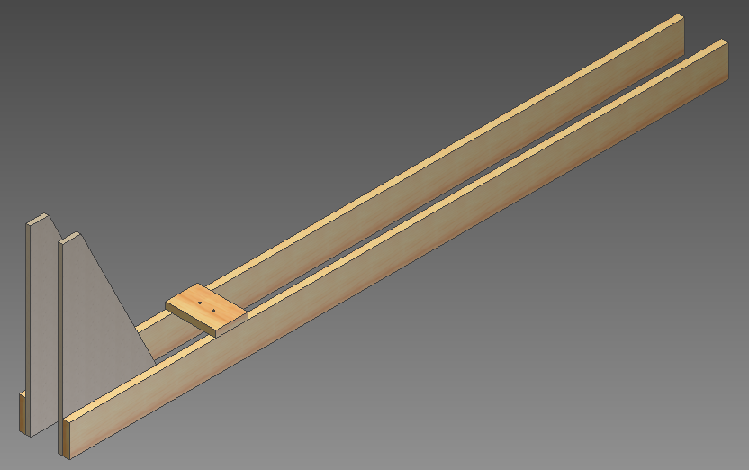

Use glue and 4-6 screws to attach the bucket base, flush with the rear of the 1x4, and center.
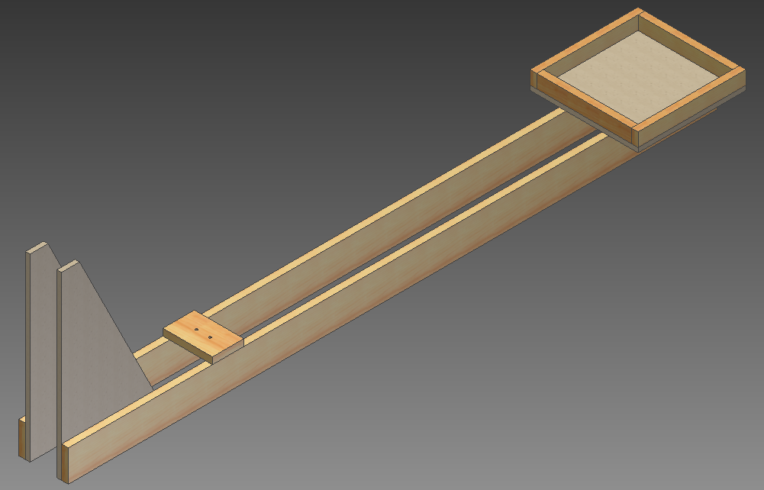

Slider
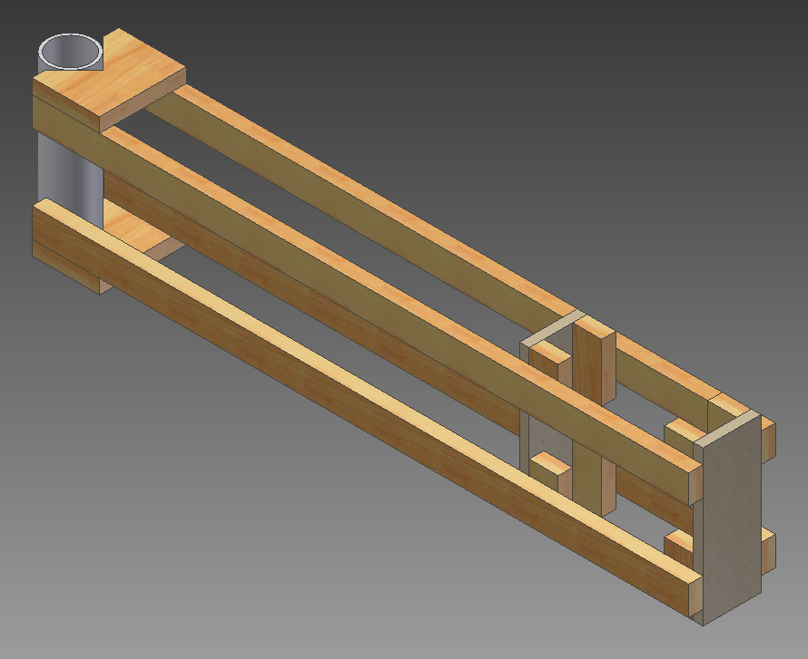
Below is a CAD drawing of the completed Slider:

Components: Cut boards as necessary. Refer to the layout for the plywood cuts.
(1) 8” SCH40 2” PVC pipe
(2) 4.5” 1x4
(4) 34” 1x2
(2) ½”x3”x8” plywood pieces
(8) 3” 1x2
(1) 8” 1x2
#8 1-5/8” exterior wood screws
weatherproof wood glue (such as Titebond Woodworker III or similar)
(about 20’) light surveyor’s twine
(1) small eye screw that fits the selected twine
(1) 12” long 1/8” steel rod
(3) ¼” washers
(1) U bolt
(2) ¼-20 nuts
hot glue

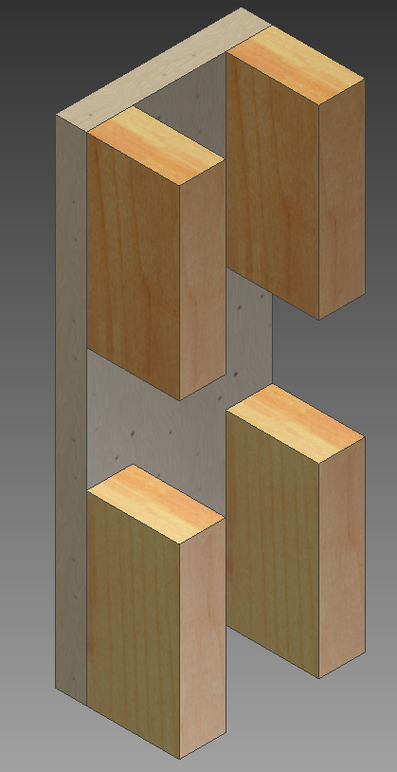
Instructions:
Make the two rub rails assemblies by gluing and screwing the 3” 1x2s to the plywood, flush to the edges as shown. Use 2 screws per 1x2.

Cut a square corner out of the long side of the 4.5” 1x4s. Make the back of the corner about 2” from the flat edge.

Attach the notched 1x4 pieces to the 34” 1x2s with glue and 2 screws per 1x2.
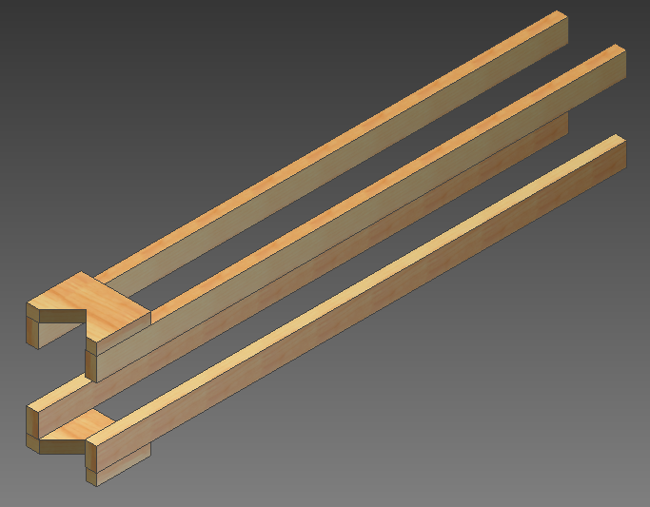

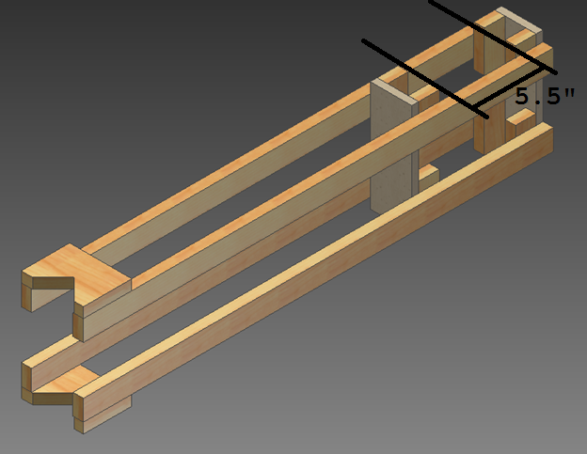
Glue the arms to the rub rails. The spacing between the rub rails is critical. Make the distance 5.5” as in the drawing:

The easiest way to ensure the right spacing is to assemble the slider while the rub rail assemblies are clamped to the Lower Tower as shown:
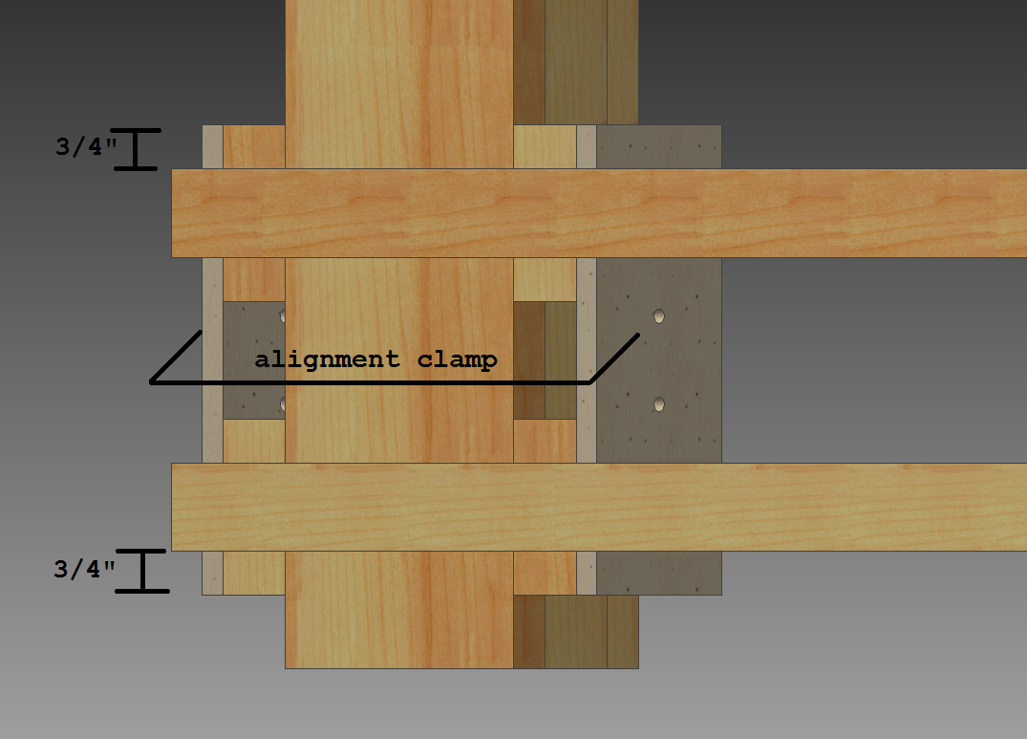

Wrap the Lower Tower with one layer of wax or parchment paper so you do not accidentally glue the slider to the tower. Align the rub rails and clamp them to the tower. Smear plenty of glue on the arms and rub rails then drive one screw into each rub rail/arm pair.
Bend the steel rod into a U shape, between 1” and 1-1/2” wide. Make sure that the ends of the rod are sanded or filed smooth.
Use the U bent rod to make two holes on the PVC pipe. Drill two 1/8” holes all the way through the pipe, so that the U can be slid all the way through the pipe:

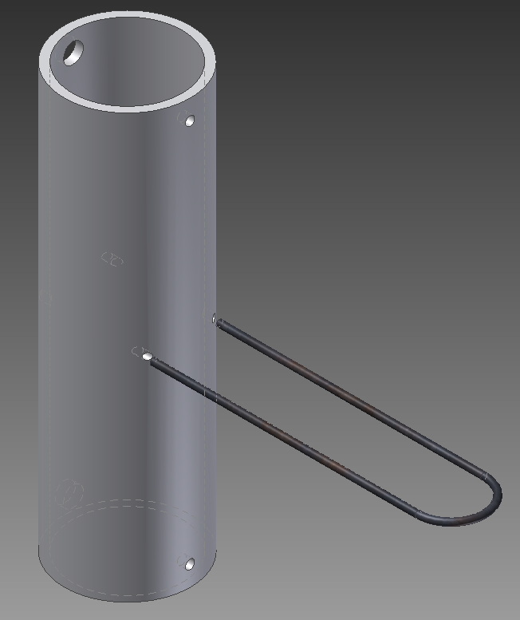
On the center line of the pipe, drill two 11/64” holes, 3/8” from the edge, all the way through the pipe (see right). Use a 3/8” drill bit to expand both 11/64” holes on the back side of the pipe.
Put the 11/64” holes against the corner notches and use two #8 screws to attach the PVC pipe to the arms (the 3/8” holes permit you to inset and tighten these screws). Be careful not to over tighten these screws.

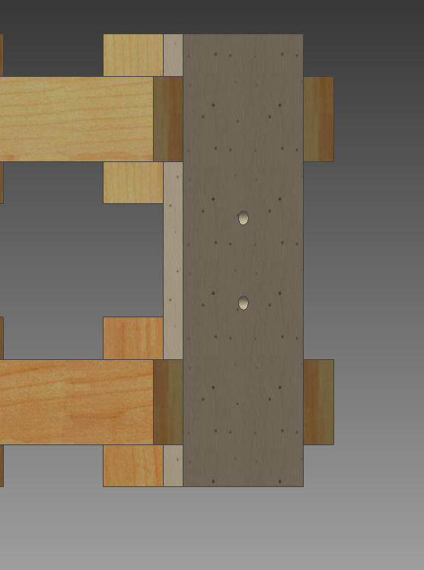
Drill holes to attach another U bolt to the back of the rub rail assembly, and install the U bolt with the two extra nuts and washers.

Tie the end of the line to the U rod and hot glue it in place. Insert the U rod into the holes in the PVC pipe, and pull the line straight back to the plywood rub rail facing the PVC pipe. Mark the plywood where the line hits it, and install the eye screw on the mark. Run the line through the eyes screw then tie the third ¼” washer to the line and hot glue it in place. This keeps the drop line attached to the Slider.

Drill a hole in the end of the 8” 1x2 and tie the loose end of the line through it to act as a handle.
Final Installation
Components:
(1) carabineer
(2) 7” 3/8-16 hex head bolts
(2) 5” 3/8-16 hex head bolts
(1) 6” 3/8-16 hex head bolts
(1) 3-1/2” 3/8-16 hex head bolts
(12) 3/8” washers
(6) 3/8-16 hex nuts
duct tape
(1) 12’ tape measure
(>30’) of 3/8” rope
(4) 10” zip ties
(1 stick) hot glue
Instructions:
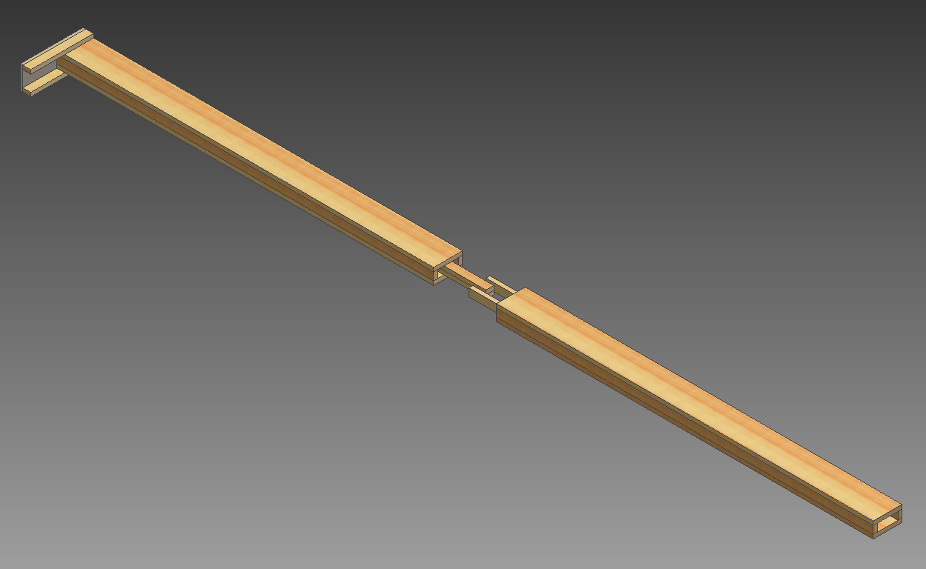
Slide the Lower and Upper Tower piece together as shown:

They might be very difficult to slide together. Make sure the two pieces are going in straight. If it is still difficult to slide them together, lightly sand the protruding 1x2s until you can push the two tower piece all the way against each other. Do not sand too aggressively; a tight fight is desired. Light mallet blows might be required, but it should not be so tight as to be impossible to disassemble.

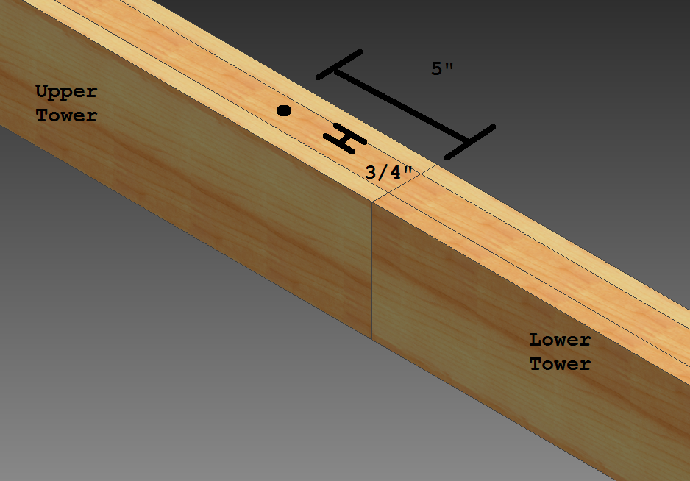
Make sure that the two tower pieces are perfectly straight, without a bend at the intersection. Drill a 3/8” hole through the whole assembly as shown:

It is very important that this hole is drilled straight. Make sure that you will not be drilling through a wood screw.
Use a 6” 3/8-16 bolt and nut with a washer at each end to secure the tower pieces together.
Drill a second 3/8” hole as shown, all the way through the tower. Check that you will not be drilling through a wood screw.

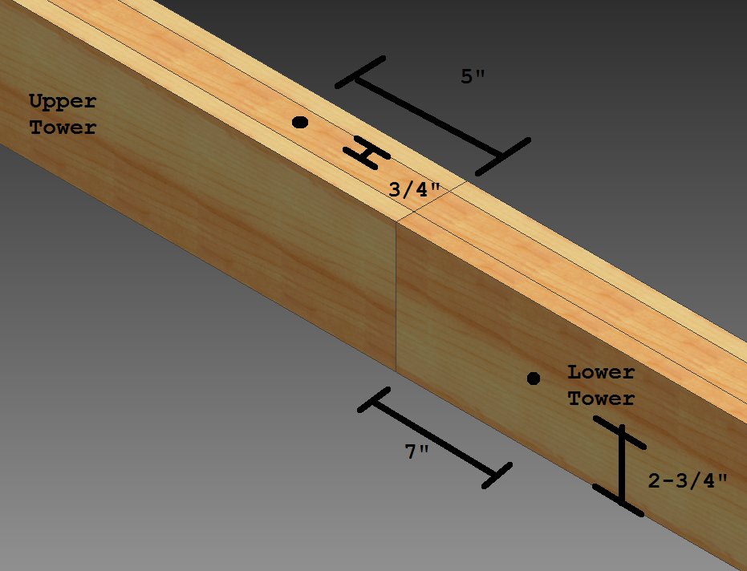

Add a 3-1/2” 3/8-16 bolt with a nut and two washers.
Slide the Slider onto the Lower Tower as shown.

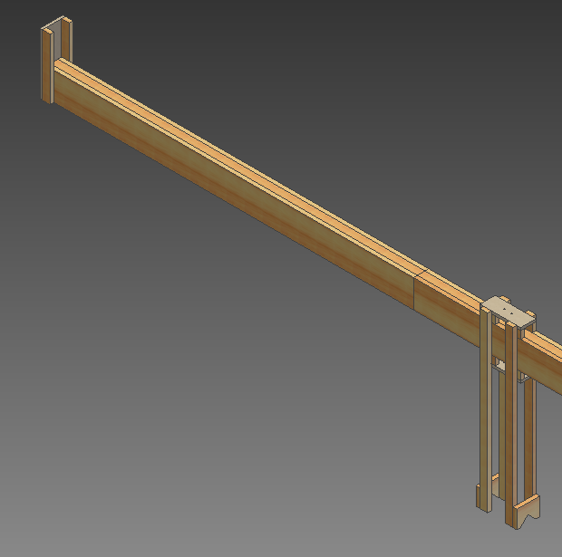

Move the slider up and down the Lower Tower. It should move freely but not loosely. If it will not fit on the end of the lower tower, sand the inside of the arms and rub rails that are interfering. Rounding over the upper and lower corners of the rub rails and arms helps the slider to move freely. This is probably the most critical part of the project and should be done very carefully. If you sand too much, you will need to remake the Slider.
If you drilled the hole for the 6” 3/8-16 bolt in the middle of the tower, the bolt head and nut should clear between the 1x2 rub rails. The 3-1/2” bolt and nut will interfere with the Slider arms. Move the slider up against the bolt and nut, and mark the arms where they interfere. Remove the slider and use a coping saw, jig saw, etc. to cut out a notch on all 4 arms to allow the free passage over the nut and bolt. Be careful not to cut away too much material. Sand the arms smooth after cutting out the notch.
Find a big section of level, flat ground. Make sure no overhead power lines or any other obstructions exist within 14 feet above this area. With an assistant, stand up the tower assembly (remove the slider first). Bring up the Rear Brace as shown:
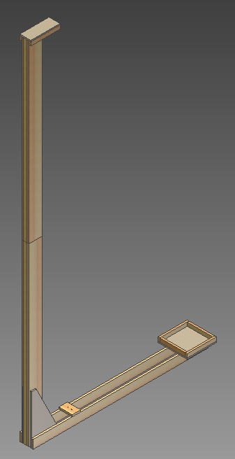

Use a corner level to ensure that the tower is plumb, and bump the rear brace until it sits flush with the front of the tower. Use two clamps to hold the tower to the Rear Brace and have your assistant hold the tower from falling over.

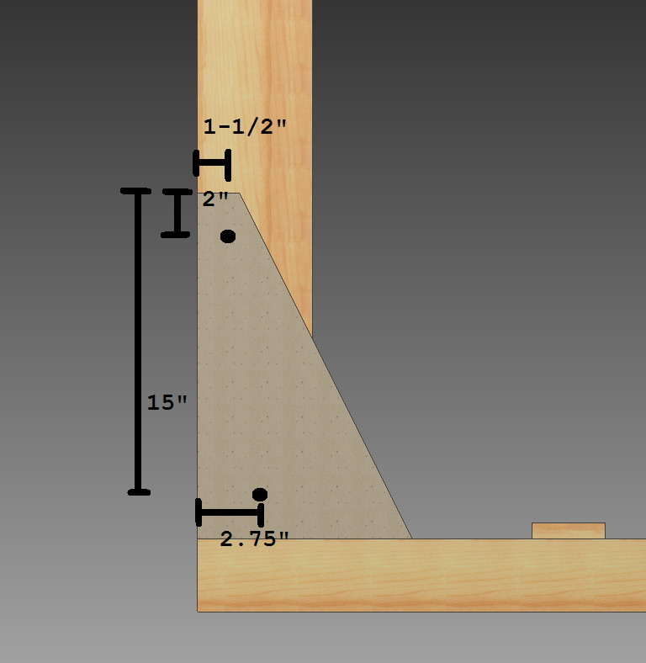
Drill two 3/8” holes through both pieces of plywood and the tower as shown:

Use two 5” 3/8-16 bolts with nuts and washers to attach the rear brace to the lower tower.

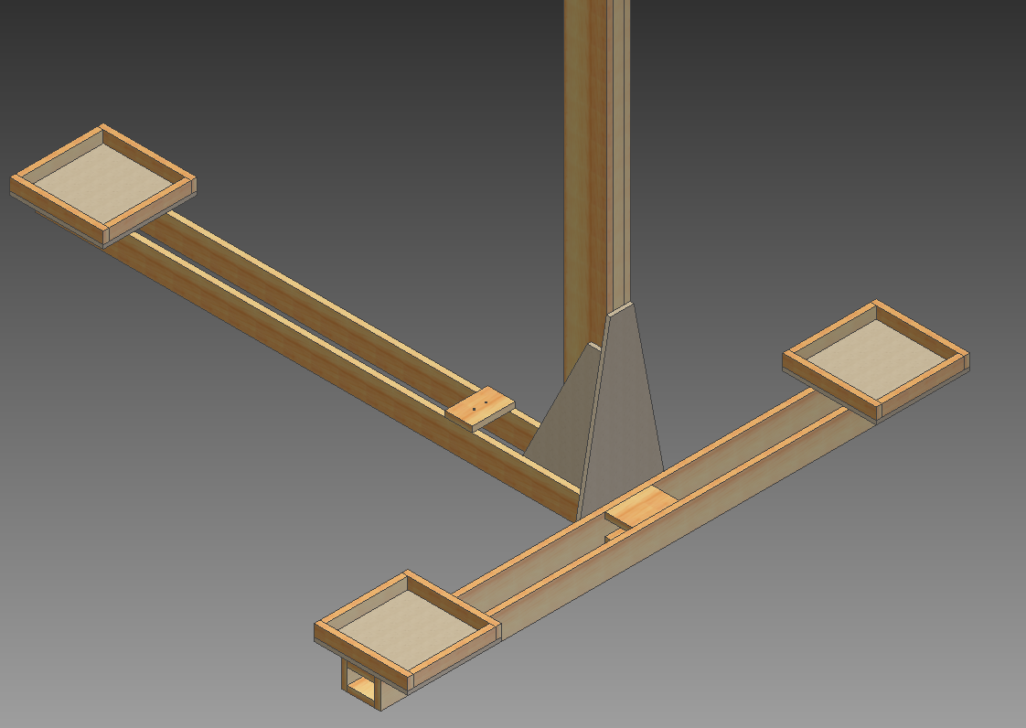
Use the corner level to make sure that the tower is plumb, and line up the front brace as shown:

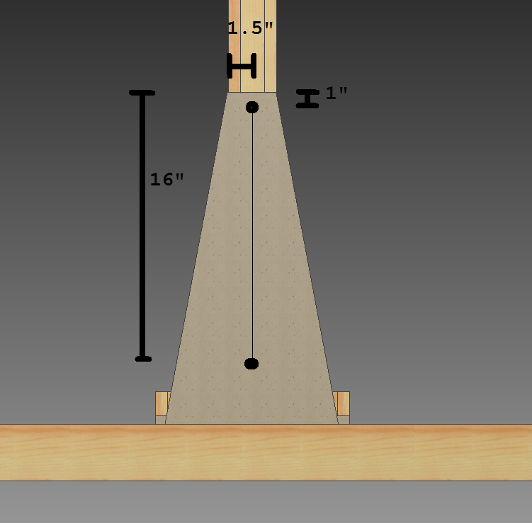
Drill two 3/8” holes through the plywood and all the way through the tower. Make sure you are not going to drill through a wood screw. The holes should be as shown:

Use two 7” 3/8-16 bolts with nuts and washers to attach the Front Brace.
Remove the Front and Rear Braces, then add the Slider. While keeping the tower flat on the ground, bolt on the Rear Brace.
Cut a piece of 3/8” rope 30’ long. Add a carabineer to the U bolt on the slider and tie one end of the rope to the U bolt on the slider using a bowline knot. Run the free end of the rope through the U bolt on the Rear Brace, up through the U bolt on the Upper Tower, then back down to the carabineer, forming a complete loop between the Upper Tower and Rear Brace U bolts, with the Slider U bolt in-between. Tie a bowline so that the rope needs to stretch about 1 inch to reach the carabineer, then attach it. Make the rope fairly tight—this pulls on the slider just enough to lock it in place so that it will not slide down by itself. Moving the slider up or down should require pulling on the rope.
Stand up the tower and bolt on the front brace. Test the slider and ensure that it moves only when the rope is pulled. If gravity can pull the slider down, tighten the rope. The slider should move up smoothly, but will probably move down jerkily—this is okay. If the slider moves inconsistently or roughly, the tower itself can be sanded. Again, undertake sanding with extreme care. Rubbing wax candles onto the rub rails and arms or the towers can help to ease movement. The positions of the Rear Brace and Upper Tower U bolts can also be moved to adjust the rope tension.
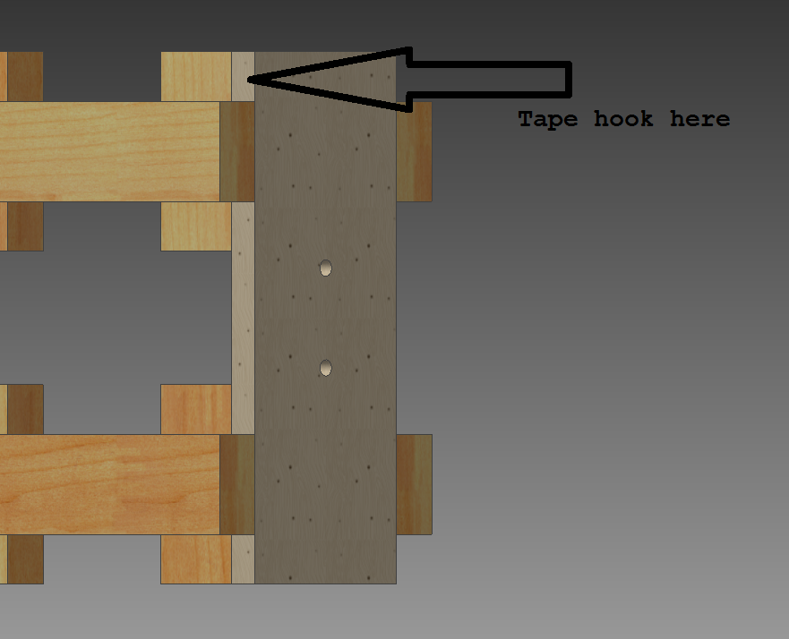
A 12’ tape measure is used to show the drop height of the egg. Use a piece of duct tape to attach the end of the tape measure to the top arm of the slider.
Tape hook here

Let the tape measure hang down to the plywood triangle on the rear brace and mark this location. It will be somewhere near the tape measure in this picture:
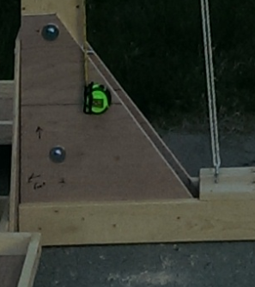

Drill 4 holes at the corners of the tape measure, and secure it in place with zip ties.
Lift the slider until the middle of the PVC pipe (the resting place of an egg) is 100 cm above the ground—this is the minimum drop height. On the back half (the blank side) of the measuring tape, use a permanent marker to draw a line against the front edge of the measuring tape body. Write “100” above this line. Lift the slider and draw line on the back of the measuring tape every 10cm with that appropriate label (110, 120, etc.). Continue moving up the slider up and marking the tape measure, until the slider is at its maximum height.
With an assistant, remove the bolts holding on the Front and Rear Braces, lay down the tower, unhook the carabineer, remove the slider (keep the line and rope coiled and attached to the slider), and un-bolt the two towers. Place all the loose hardware in a storage bag.
To waterproof the bucket stands, apply a coat of exterior house paint, but this is not completely necessary. DO NOT PAINT THE TOWERS OR SLIDER.
Assembly and Use
All the pieces fit in a large four-door car with a fold-down rear seat (with only the driver).
Find the flattest and most level area of blacktop or concrete available. Ensure that no overhead obstructions exist, especially power lines. Grass is too soft and the eggs will not break if dropped on grass. Set up an 8 x 6’ or larger blue tarp on the ground.
With an assistant, assemble the Upper and Lower Tower pieces with the appropriate bolts. Take care not to over tighten the bolts, but ensure that they are snug, and that the joint is secure and straight. Run the hoist line for the slider through the U bolts and to the carabineer. Bolt on the Rear Brace, stand up the tower, and then bolt on the Front Brace.
Using a corner level, ensure that the tower is plumb. If not, use shims from leftover plywood and boards to lift up the low sides of the braces and plumb the tower.
Fill three five-gallon buckets with water and place them on the bucket stands to help stabilize the tower.
Now that the tower is up, supervise it at all times. Have the people who built the structure always be near it, and always be looking aloft for problems. Enforce a 12’ perimeter at all times, except for the student currently testing an egg dropper. Always have the slider in the down position when a student is setting up an egg catcher. Immediately dissemble the tower if it becomes windy or if the tower is damaged.
Test the egg dropper with a 1-½” PVC end cap as a test egg. A few drops from each height reveal the average location of the drop point; mark this spot on the tarp to help students place the egg catchers.
Use the 8” 1x2 handle on the drop line to gently push the egg above the holes for the U rod. Insert the U rod and gently lower the egg onto it. When purchasing eggs, make sure that they fit in a 2” SCH40 pipe. Usually, US grade medium or small eggs work well. Pull the hoist rope to raise the slider while watching the back side of the measuring tape. Keep raising until the slider reaches the height requested by the student. It is important to make sure the drop line is free while lifting the slider, if it catches, lifting the slider pulls the drop line and releases the egg. Make sure to lift slowly to prevent the egg from bouncing around and breaking. If you lift past the distance that the student requests, do not lower the slider with an egg in it because the jerky action of lowering the slider will break the egg.
For long events, have the person hoisting the rope wear a pair of gloves. Also have this person always be aware of the integrity of the rope, and replace it if it becomes damaged.
After students have left, and with an assistant, disassemble the tower and re-store the hardware.

