Stereognosis Worksheet Answer Key

- One pair of partners should watch the video: What is Materials Science?
The other set of partners will begin the Stereognosis activity. One partner wears the blindfold while the other partner presses down on each sample one at a time, sorting the samples, by touch alone, from smallest to largest Young’s Modulus. (Think of it as softest to stiffest.) The sighted partner’s job is to present the samples and do the sorting. Write the number 1‒6 underneath the corresponding sample from smallest to largest Young’s modulus. If no blindfold is available, you can place each sample inside a paper bag and reach inside to do the “squishing.”
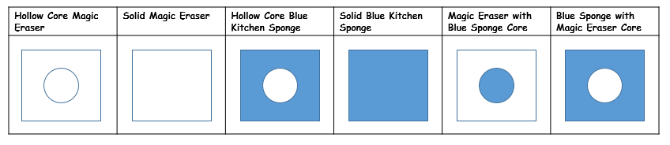
*Answers will vary according to student perception.
- Mix up the order of the samples, remove the blindfold (or take the samples out of the bags), and together in pairs, order the samples from least to greatest Young’s Modulus, using all of your previous knowledge that Young’s modulus refers to the material itself and the formula for calculating Young’s modulus depends on the cross-sectional area of the sample. Do not let the previously blindfolded partner see their previous answers. (Place the samples as you found them for the next group please.)
*Answers will vary according to student perception.

- Using complete sentences, explain why the two sets of sorting differed.
*Answers will vary however, answers should reference that stiffness is force versus displacement that the empty core samples weren’t appropriate test samples. In addition, answers should reference that since the Young’s Modulus formula depends on the cross-sectional area of the sample, the hollow core samples weren’t appropriate test samples.

