What is a Wave? Pre-Assessment Key

Directions
Answer the following questions the best you can. You are not expected to know the answers, and this
assignment will not be graded.

- List two examples of waves.
(This is open-ended—students may include some answers not listed here) ocean waves, hand waves, sound waves, light waves, radio waves, UV waves

- What is the amplitude of the following sine wave?

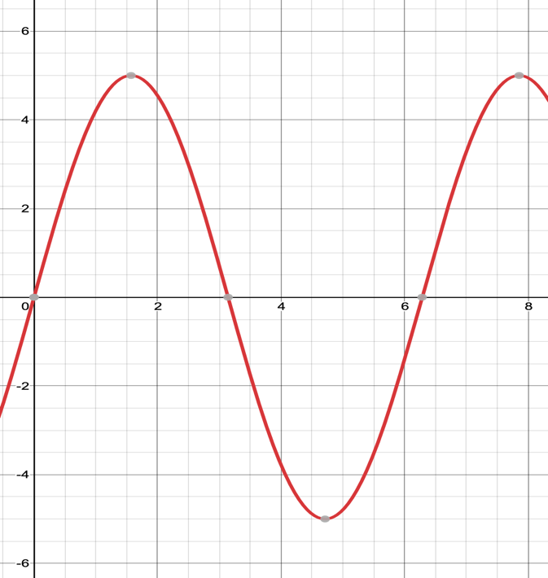
The amplitude is 5.

- Describe the frequency of a wave and how increasing or decreasing the frequency affects a wave.
Increasing frequency = more peaks per second, shorter period
Decreasing frequency = less peaks per second, longer period

- How does introducing a negative phase angle affect the graph of a sine wave?
Negative phase angle = move wave to the right

