Analyzing Brain Waves Jupyter Notebook Worksheet

Directions
Open the file AnalyzeBrainWaves_NOTEBOOK.ipynb in Google Colaboratory by selecting “File->Open Notebook” (NOTE: You will need a Google Account to use Google Colaboratory.) Read each cell (block) of text and run each cell of code by clicking the play button on the left side of the block as indicated by the red circle in the figure below.

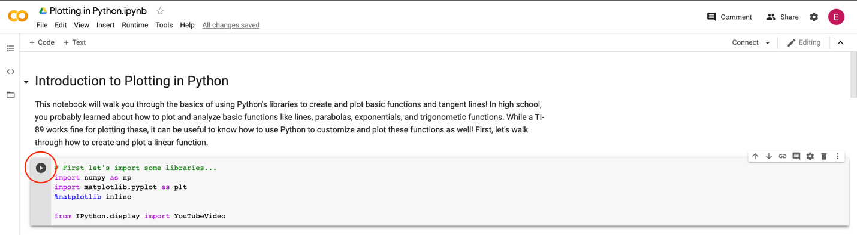

Important note: The data you will examine in this worksheet is actual EEG data collected for research. This data will not perfectly resemble the waves we saw in the slides—there is noise in the data, making it harder to read. When you complete this notebook and worksheet, keep this in mind!

As you read, watch, and run each cell, answer the following questions. This is a graded assignment.

- EEG Background. Watch the video “Ride the (Brain) Wave” by Brainfacts.org that is linked in the notebook.

  - List and briefly describe the five types of brain waves discussed in the video.

- Plotting an EEG. Run the first code cell. When you are prompted to open a file, select EEG_Example1.csv or EEG_Example2.csv. Then, run the remaining two code blocks to view the four plots. Each plot corresponds to a channel, or a different location of the brain.

  - Looking at all four channels, what similarities do you notice? Why do you think these similarities exist?

  - Look closely at the area of highest activity (or the area with the largest, most rapid spikes) across all of the channels. Which of the four channels has the strongest activity in this area? Using the titles of the plot as a guide, what area of the brain would you guess has the highest activity in this area?

- Power spectral density. Run the cell titled “Calculate and plot the power spectral density of the EEG signals.” Then, use the plot to answer the following:

  - At which frequency is there a “spike” in power contribution? What is significant about this frequency in regard to power outlets (HINT: look up the frequency of a power outlet and think about the sensitivity of the EEG recording device)?

  - Of the four EEG signals, which signal contains the most power? How do you know this (HINT: each channel is represented by a different-colored line)??

- Band-pass filter. Run the code cell in the section titled “Band-pass filter the EEG to get waves.” Then, use the plots to answer questions 3, 4, and 5.

  - In the EEG signal associated with the Left Frontal Lobe, at which time (in seconds) is there the most power from delta waves? How did you find this (HINT: look at the plot that has “Delta Power” labeled)?

  - In the EEG signal associated with the Right Occipital Lobe, at which time (in seconds) is there the most power from gamma waves? How did you find this?

  - Using the EEG signal associated with the Right Frontal Lobe, observe the plot labeled “Spectrogram.” Each point in the spectrogram represents a fraction of power to frequency (if the point is blue it represents a negative value, and if the point is green it represents a positive value). As the frequency is increased, what can you say about the value of the power-frequency fraction based on the plot?

