Background
Jupyter Notebooks are excellent teaching tools that contain a mix of Python code, text descriptions, and educational images (including GIFs). Because coding is such an important skill in multiple fields of work, even the smallest exposure to code is beneficial for students and teachers. Jupyter Notebooks allow for students and teachers to run pre-written code without having to write anything—they can see what specific lines of code can do within a web browser. Jupyter Notebooks may also be edited, so students and teachers can make small changes and see how it affects the code output.

Jupyter Notebooks are free and easy to use, and Google Colaboratory allows students and teachers with Google accounts to run a Jupyter Notebook within their preferred web browser. Simply log in with your Google account, and you can open a Jupyter Notebook you’ve downloaded for a lesson or unit.

Getting Started
To get started, open your web browser and navigate to Google Colaboratory.
- Click “File->Open notebook” as shown in the figure below.
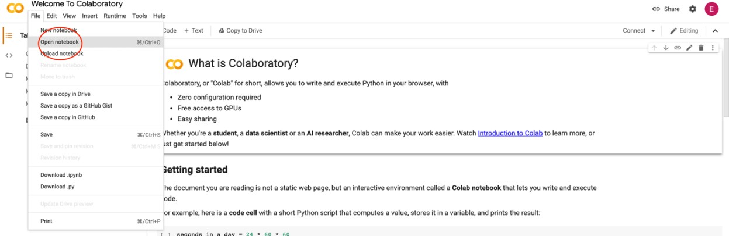

- From here, you can choose from Google’s example Jupyter Notebooks, or you can upload your own from your computer, Google Drive account, or GitHub account. Choose the notebook you’d like to open by clicking on it. For this tutorial, we recommend choosing Google’s notebook titled “Overview of Colaboratory Features” as shown in the figure below.

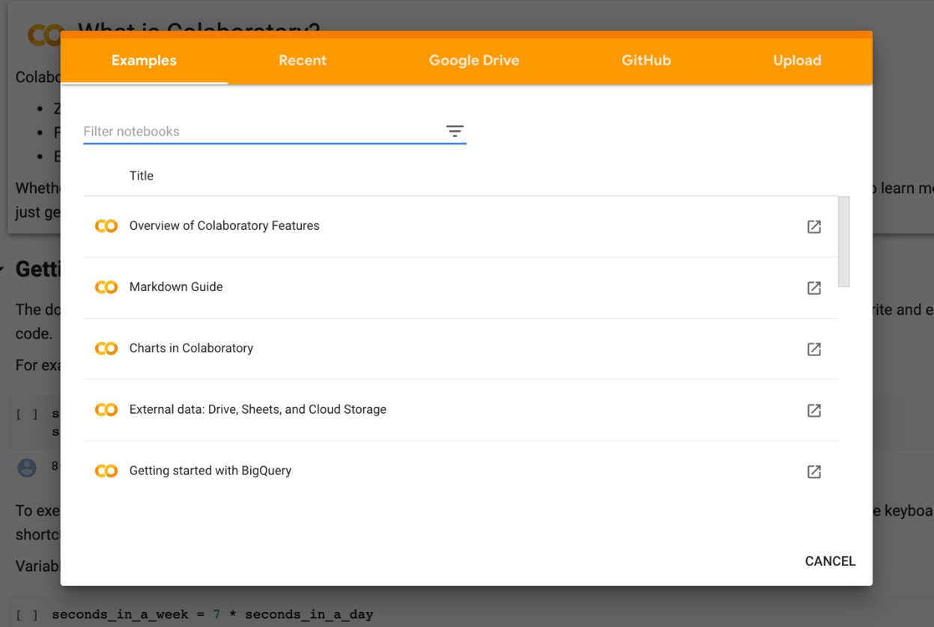

- Once you’ve opened the notebook, you’ll see a Table of Contents on the left, and your notebook on the right. The Table of Contents lists all the cells, or blocks of text and code, in the notebook. To run a cell containing code, simply click the Play button as shown in the figure below.
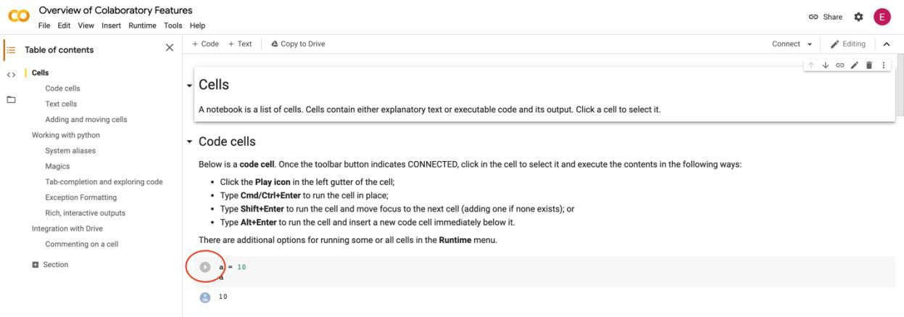

- Read and run the “Overview of Colaboratory Features” notebook. We also recommend having your students complete this tutorial.

- Read and run the “Markdown Guide” notebook. Markdown is the coding language used to format text within text cells. We also recommend having your students complete this tutorial.

Other Resources
Linked below are additional resources on Python and Markdown. Feel free to browse through them and use them as suggested or required readings for students.

Python
https://www.learnpython.org/ - Interactive Python tutorials https://www.w3schools.com/python/ - Interactive Python tutorials https://www.programiz.com/python-programming/tutorial - Interactive Python tutorials https://www.tutorialspoint.com/python/index.htm - More information about Python

Markdown
https://www.markdowntutorial.com/ - Interactive Markdown tutorial https://www.markdownguide.org/basic-syntax - Guide for using Markdown https://guides.github.com/features/mastering-markdown/ - Guide for using Markdown https://medium.com/analytics-vidhya/the-ultimate-markdown-guide-for-jupyter-notebook- d5e5abf728fd - Guide for using Markdown in Jupyter Notebooks https://www.markdownguide.org/cheat-sheet - Markdown Cheat Sheet

