What is an ECG? Post-Quiz

Directions
Answer the following questions the best you can.

- List one reason we use electrocardiograms.

- Label the 3 main parts of an ECG wave in the figure below.

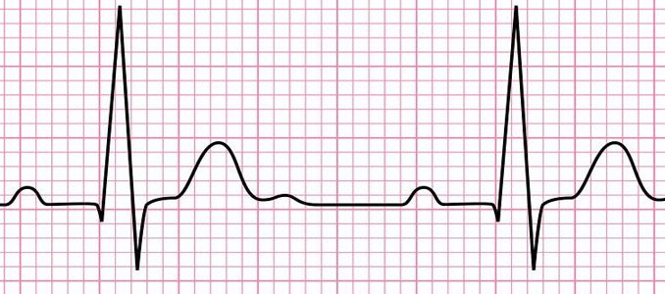
https://www.onlinebiologynotes.com/wp-content/uploads/2018/08/ECG-678x300.jpg

- What action of the heart is represented by the QRS complex?

