Navigating a Maze Worksheet
Answer the following questions related to the program design:
- Define the task you would like to perform:

- Write a set of instructions in English (such as: go forward X inches, turn Y rotations left, etc.) that the robot needs to do to successfully navigate the provided maze structure.

- Are other solutions possible?

Answer the following questions related to the EV3 software:
- What are the three choices for the “Direction” option on a Move Block?

- What does “Steering” control? How do you change the steering?

- What does “duration” mean? What is a rotation?

- How many inches does one rotation typically make the robot move?

- Assuming that the steering pointer pulled all the way in one direction, how many rotations is generally a good, 90-degree turn?

- Brainstorm about possible programming solutions and write below the one that your group thinks is a good one.

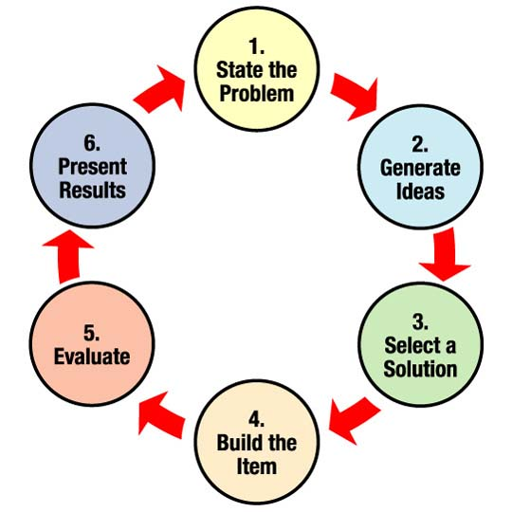
- Did you have to “iterate” (make changes to the program, etc.) to make it work?
How many iterations did you have to perform?

