What Is Bluetooth? Worksheet Answer Key
Part 1
- What is an electrical connection?
An electrical connection is the link or bond that passes electricity between two or more things.

- Give two examples of electrical connections.
Example answers: The link between a remote control garage door opener and a garage door. The link between a Wii remote and a Wii.

- What is the difference between wired and wireless connections?
What is an advantage of using wireless connections?
In a wireless connection, electricity is not passed through a physical wire, but instead travels through the air (or another medium) as waves. A wireless connection has the benefit that the communicating devices do not have to be physically connected, allowing for greater freedom and movement.

- What is the name of the wireless electrical connection that the NXT can make?
Bluetooth

Part 2
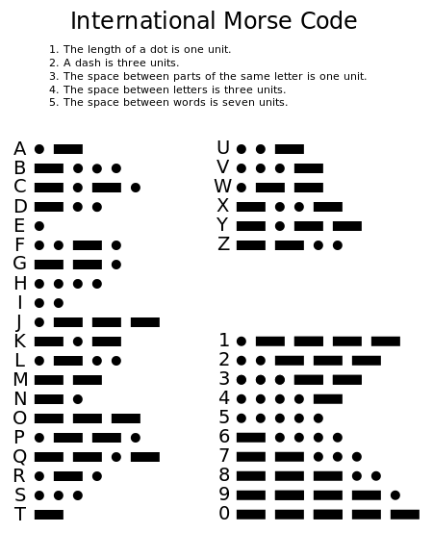
Here are some examples:
(Note: a slash / is used between words)

“Hello” in Morse code is:
.... . .-.. .-.. ---
“How are you?” is:
.... --- .-- / .- .-. . / -.-- --- ..-
Write the Morse code for the following:
- “This is fun”
- .... .. … / .. … / ..-. ..- -.
- “Thank you”
- …. .- -. -.-/ -.-- --- ..-
- “I love you”
.. / .-.. --- …- . / -.-- --- ..-
- “Move on”
-- --- …- . / --- -.

Source of Morse code chart: http://en.wikipedia.org/wiki/Morse_code

