Alkane Resources Activity Project Notebook Answer Key

Assign Roles for Team Partners:

Captain: ______________________________________________
Captain reports any information to the teacher and keeps the team moving at the assigned pace.

Recorder: _____________________________________________
Recorder writes responses to all team activities once the team agrees on their responses.

Technologist: ____________________________________________
Technologist opens assigned web pages on their own device and makes sure everyone can see and interact with the web pages together.

Day 1: Problem-Finding
Consider your own background experience to answer these two questions:
What problems can we solve by using renewable resources?
(Answers will vary. Possibilities include: climate change, global warming, fuel shortage)

Can most cars currently use renewable fuel? Why or why not?
(Answers will vary. Possibilities include: cars were not built to use biofuels, there are not enough renewable fuels to replace gasoline)

Use the presentation slides and this video from CISTAR to answer these questions:
How much oil is used for transportation each day in the USA?
10,000,000 barrels
What percent of transportation fuel currently comes from oil?
90%

What percent of chemicals, including plastics, comes from oil?
>85%
What percent of transportation fuel and chemicals do we want to replace with renewable sources?
all of it, 100%

How long will it take to develop the technology to completely convert to renewable fuels?
It is projected we will be using only renewable fuels by 2060, or in about 40 years.

What resource found in the USA can replace imported oil?
Shale

How long is that resource projected to last?
100 years

Which light hydrocarbons are found in shale gas? Write their chemical formulas here.
CH₄, C₂H₆, C₃H₈, C₄H₁₀

What two main products are obtained by processing shale gas?
Fuel for transportation and petrochemicals

Which reaction will we be looking at during this project?
2C₂H₄ −−> C₄H₈
Evaluate your own current understanding of the problem: Light shale gases like ethane need to be converted into fuels and petrochemicals. How can that be done?
What do you KNOW about this problem?
Potential answers: I know that fossil fuels are nonrenewable resources, shale has gas that may be used as fuel, and Americans use 10,000,000 barrels of oil per day for transportation.

What do you NEED TO KNOW about this problem?
I need to know the reaction to convert light hydrocarbons into fuel.
Project Vocabulary: Discuss with your team the main differences, if any, between the meanings for these words that you wrote on your pre-assessment and their actual definition provided in the Project Glossary above. Then score each word from 1-3 for level of understanding.

1 – No understanding of this word
2 – Some understanding of this word
3 – Complete understanding of this word

Level of Understanding
(Answers will vary.) | element
(Answers will vary.) | compound
(Answers will vary.) | chemical reaction
(Answers will vary.) | hydrocarbon
(Answers will vary.) | alkane
(Answers will vary.) | monomer
(Answers will vary.) | oligomerization
(Answers will vary.) | renewable resource
(Answers will vary.) | nonrenewable resource

Alkanes
Alkanes are compounds that contain only carbon and hydrogen atoms, so they are in a larger class of chemical compounds called hydrocarbons. Alkanes only have single bonds between carbon atoms. Other types of hydrocarbons may also contain double or triple bonds between carbon atoms. The bonds between carbon and hydrogen are always single bonds.

Day 2: Investigating Hydrocarbons
Each group has been assigned an alkane compound to investigate using WebMO.

Name of your alkane: ___________________________________________
propane
2-methyl propane
butane
2-methyl butane
pentane
2-methyl pentane
hexane
2-methyl hexane
heptane
octane

Chemical formula of your alkane: _________________________________________
propane C₃H₈
2-methyl propane C₄H₁₀
butane C₄H₁₀
2-methyl butane C₅H₁₂
pentane C₅H₁₂
2-methyl pentane C₆H₁₄
hexane C₆H₁₄
2-methyl hexane C₇H₁₆
heptane C₇H₁₆
octane C₈H₁₈

How many carbon atoms are in your alkane? _______________________________________
propane 3
2-methyl propane 4
butane 4
2-methyl butane 5
pentane 5
2-methyl pentane 6
hexane 6
2-methyl hexane 7
heptane 7
octane 8

How many hydrogen atoms are in your alkane? ____________________________________
propane 8
2-methyl propane 10
butane 10
2-methyl butane 12
pentane 12
2-methyl pentane 14
hexane 14
2-methyl hexane 16
heptane 16
octane 18
Create a model of your alkane using WebMO.
  - Go to WebMO Demo Server: https://www.webmo.net/demoserver/cgi-bin/webmo/login.cgi

  - Log in with these credentials:
    - Username: guest
    - Password: guest

  - Type <enter>

  - Across the top should read “New Job”, “Refresh”, “Download”, etc.

  - Select “New Job”.

  - Click “Create New Job”. This will go to the “Build Molecule” page.

  - Click the blank screen once for each carbon atom in the molecule.

  - Move the cursor between clicks so the carbon atoms are in a line.

Image(s) created with WebMO software, www.webmo.net

  - Draw a chemical bond between each of the atoms: Click and hold the cursor on the first atom and drag the cursor to the next atom. Control-Z will reverse any mistakes.
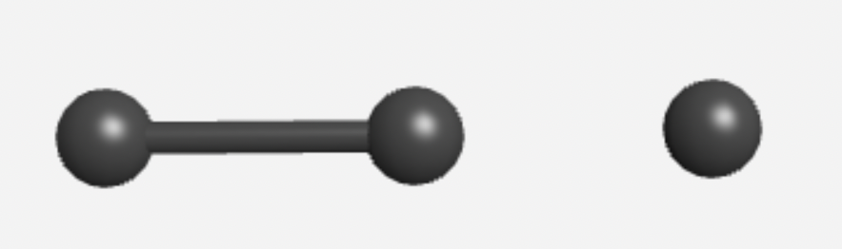
Image(s) created with WebMO software, www.webmo.net

  - Select “Build”, then select H for hydrogens.

  - Click the blank screen once for each hydrogen atom, spreading them evenly around the carbon atoms.

  - Draw a chemical bond between each hydrogen and the nearest carbon atom.

  - Under “Cleanup”, select “Geometry” to correct the shape of your molecule.
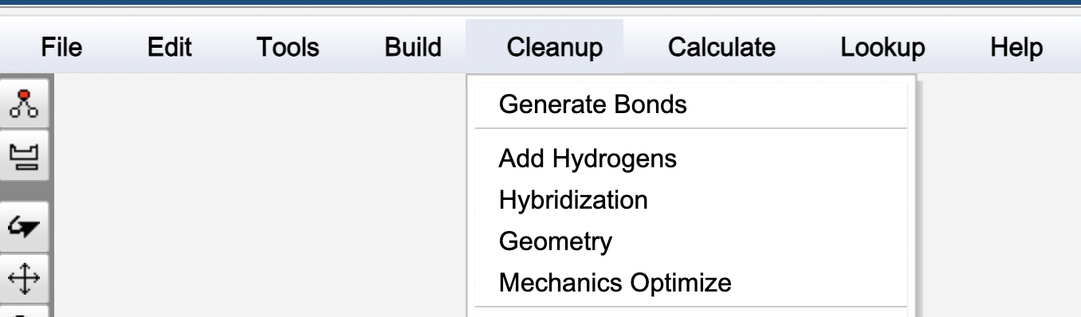

  - Under “Lookup”, select “Molecule Info” and record the following information about your molecule:

Stoichiometry:
propane C₃H₈
2-methyl propane C₄H₁₀
butane C₄H₁₀
2-methyl butane C₅H₁₂
pentane C₅H₁₂
2-methyl pentane C₆H₁₄
hexane C₆H₁₄
2-methyl hexane C₇H₁₆
heptane C₇H₁₆
octane C₈H₁₈

IUPAC Name:
propane propane
2-methyl propane 2-methylpropane
butane butane
2-methyl butane 2-methylbutane
pentane pentane
2-methyl pentane 2-methylpentane
hexane hexane
2-methyl hexane 2-methylhexane
heptane heptane
octane octane

Molar Mass:
propane 44.10 g/mol
2-methyl propane 58.12 g/mol
butane 58.12 g/mol
2-methyl butane 72.15 g/mol
pentane 72.15 g/mol
2-methyl pentane 86.18 g/mol
hexane 86.18 g/mol
2-methyl hexane 100.20 g/mol
heptane 100.20 g/mol
octane 114.23 g/mol

Day 3: Problem-Solving
      - From your experience using WebMO, brainstorm for ideas to convert ethane into larger molecules. Write at least two ideas here.
We need to add more carbon atoms.
We could stick two ethane molecules together.

- Find the definition for oligomerization in the Project Glossary in the Introduction slides. Do your best to write that definition in your own words here:
Answers will vary.

Let’s think about how oligomerization could be used to make butylene C₄H₈ from ethylene, C₂H₄.

- Get a set of gumdrops and toothpicks. Decide as a group which colors represent carbon and hydrogen atoms.

- Fill in the table with the number of carbon and hydrogen atoms for both ethylene and butylene.

C₂H₄  Note: ethylene has a double bond between the carbon atoms |  | C₄H₈  Note: butylene has a double bond between the first two carbon atoms
carbons | hydrogens | carbons | hydrogens

- Use the gumdrops to model ethylene and butylene molecules.

- Use the extra gumdrops to model how ethane can be converted into octane.

- Set up the models with an arrow from the starting products to the ending products. When complete, check your reaction model using the rubric below.

[Reactants] --> [Products]

Gumdrop Reaction Rubric | No  (0 points) | Sort of  (1 point) | Yes  (2 points)
The reactants are clearly on the left side of the arrow and the products are clearly on the right.
Ethylene and butylene molecules are depicted with one double bond (two toothpicks between atoms)
The reactants contain one or more ethylene molecules, and the products contain one or more butylene molecules
Both sides of the reaction have the same number of hydrogen atoms
Both sides of the reaction have the same number of carbon atoms

Total Score: ___________

- Correct your reaction model until it has a score of at least 8 points before your captain asks me to come check it.

- Take a photo of your model reaction and add it here if using this worksheet digitally.
