App Inventor CheatSheet
Listing of blocks and functions:
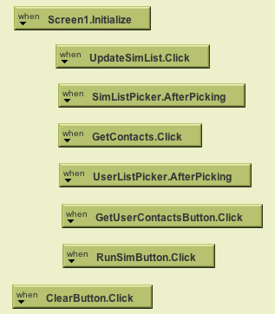
These blocks in the upper left-hand corner deal with the startup of the program and allow the buttons to work. THEY SHOULD NOT BE CHANGED! Your algorithm should not need to use any of these blocks.

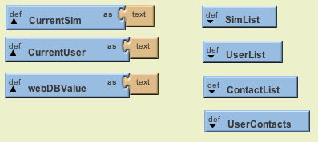
These blocks in the upper center of the screen set up definitions used to store the data received from the server. THEY SHOULD NOT BE CHANGED! You should not need any of these blocks or definitions, as the program will be converting them to an easier format. (See next set of blocks.)
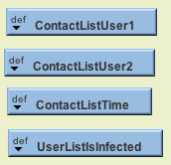
These blocks contain a list of the two users coming into contact, the time they came into contact and a list of which users are infected. In UserListIsInfected, User01 is listed first, User02 is listed second, and so on. Uninfected users show as “false” and infected users are “true.”

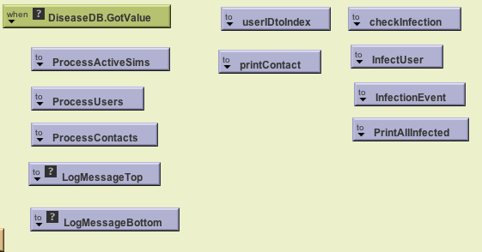
The first four blocks are used to handle the incoming simulation data. LogMessageTop and Bottom allow you to post text in the box as needed. checkInfection tells whether a user is infected or not. Infection event is a way to make a message to log an infection. PrintAllInfected outputs all infected users in a list.
Basic How To:
You need to design an algorithm that tracks an infection through contacts. All contacts are in chronological order and the easiest way is to step through each contact, determine if the infection is passed on and mark whether a user is now infected or not. After this, you can print out a list of the infected users.
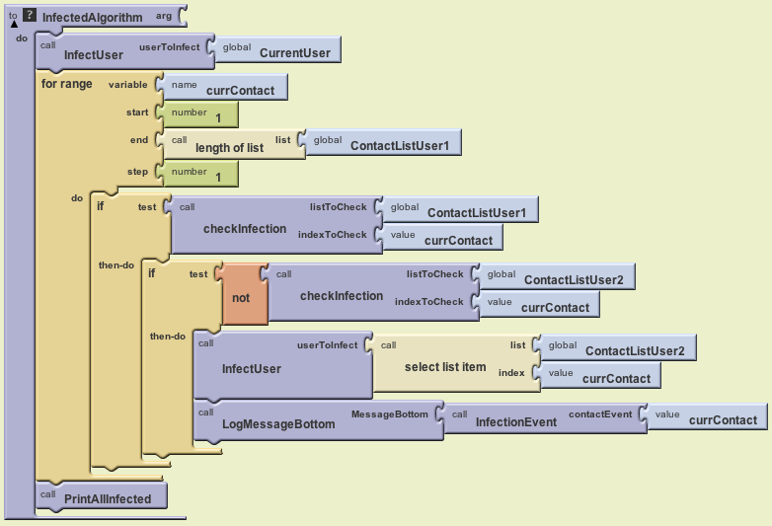
Explanation of provided algorithm:

- Start with an infected user (selected on screen)
- Use the “for range” block to go through the contacts in order
  - Use the “if” to see if the first contact in a list is infected
    - “If” they are infected
      - see “if” the second user is NOT infected
        - “If” second user is not infected, infect them
        - Log this contact as an infection event
- Print out a list of infected users
Idiosyncrasies of the simple algorithm:
- Ignores that the second user could infect the first user.
  - Easy to add with an OR block
- Ignores the possibility that not all contacts will infect.
  - Easy to add with random # and cutoff on an IF block

