MIT’s App Inventor: General Information
ALL CONTENT IN THIS DOCUMENT IS FROM THE MIT APP INVENTOR SITE:
http://appinventor.mit.edu
It was compiled to give a brief overview of App Inventor and what it does.
What is App Inventor? (From the website: http://appinventor.mit.edu/explore/content/what-app-inventor.html)
App Inventor lets you develop applications for Android phones using a web browser and either a connected phone or emulator. The App Inventor servers store your work and help you keep track of your projects.
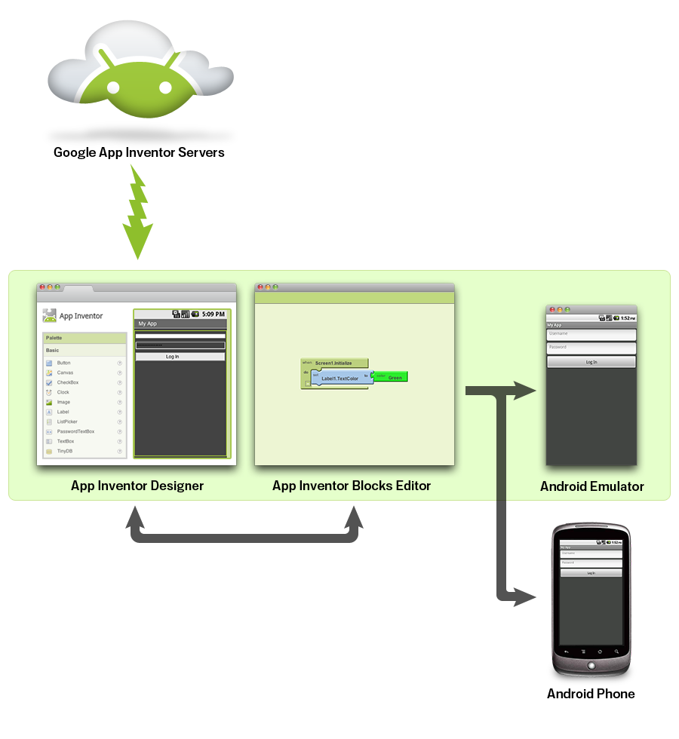
You build apps by working with:
- The App Inventor Designer, where you select the components for your app.
- The App Inventor Blocks Editor, where you assemble program blocks that specify how the components should behave. You assemble programs visually, fitting pieces together like pieces of a puzzle.
Your app appears on the phone step-by-step as you add pieces to it, so you can test your work as you build. When you're done, you can package your app and produce a stand-alone application to install.
If you don't have an Android phone, you can build your apps using the Android emulator, software that runs on your computer and behaves just like the phone.
The App Inventor development environment is supported for Mac OS X, GNU/Linux, and Windows operating systems, and several popular Android phone models. Applications created with App Inventor can be installed on any Android phone. (See system requirements.)
Before you can use App Inventor, you need to set up your computer and install the App Inventor Setup package on your computer.
The basic components for App Inventor are listed below. Each component has a list of properties (options) that can be changed depending on what options that the app designer prefers to provide to the user. A list of the components and their options can be found at the website below.
http://appinventor.mit.edu/explore/content/basic.html
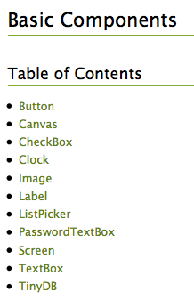
The specific components that work with Lego MindStorm robots can be found in the screenshot below. The link can be used to access specific property (options) for each component.
https://appinventor.mit.edu/explore/content/legomindstorms.html
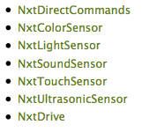
The blocks that are available to use for the creation of apps can be found at the following website: http://appinventor.mit.edu/explore/content/reference-documentation.html Scroll down the page and click on the individual type of block that you are interested in. Another page will open with specific information about the type block and its properties.
