Dramatic Networks Activity Instructions
Step 1: Data Collection
Track the interactions between characters in a play. The goal is to interpret who a character is talking to in any given line. This allows you to take the role of a director of drama rather than a general reader. Record the results of the interactions in an Excel spreadsheet.
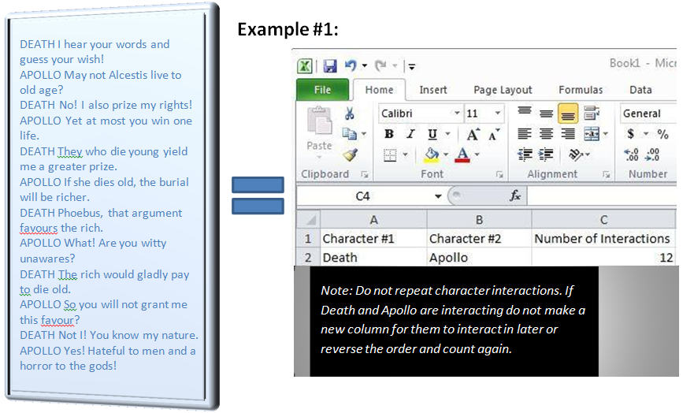

Notice that not all interactions are between just two characters. Sometimes you must decide if a character is speaking to one other character or a group of characters. If a character is speaking to a group and only one character responds, only record 1 interaction between the first character and the group and 2 between the character and the second character who responds. In example #2, notice how the principal switches who he is speaking to and how the numbers of interactions correspond to this shift in focus.
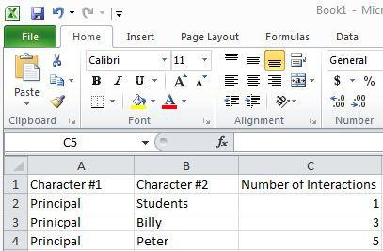
Example #2:

Principal: Students are to attend a mandatory meeting the first day of school.
Billy: I have a doctor’s appointment. Principal: Your parents already spoke to me Billy. You are excused.
Peter: Can I be excused because I
don’t want to go? Principal: No Peter. Peter: Please? Principal: No!

Step 2: Data Application
Use the open source program Cytoscape to look closer at the networks you created.
- If your computer does not have the Cytoscape program, obtain it at this website: http://www.cytoscape.org/
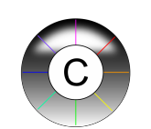
- Click “Download Cytoscape now” and follow the instructions to download it.
- The Cytoscape icon looks like this:
Instructions:
- Open Cytoscape.
- Click File > Import > Network from table (Text/MS Excel).
- Click on the Select File(s) button > select the Excel file you created from where you saved it on the computer.
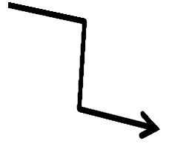
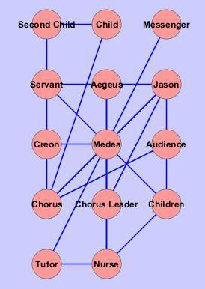
- Select the interaction relationship. Set Source Interaction to the column containing the first character. Set Interaction Type to the column containing the number of interactions between character #1 and character #2. Set Target Interaction to the column containing character #2.
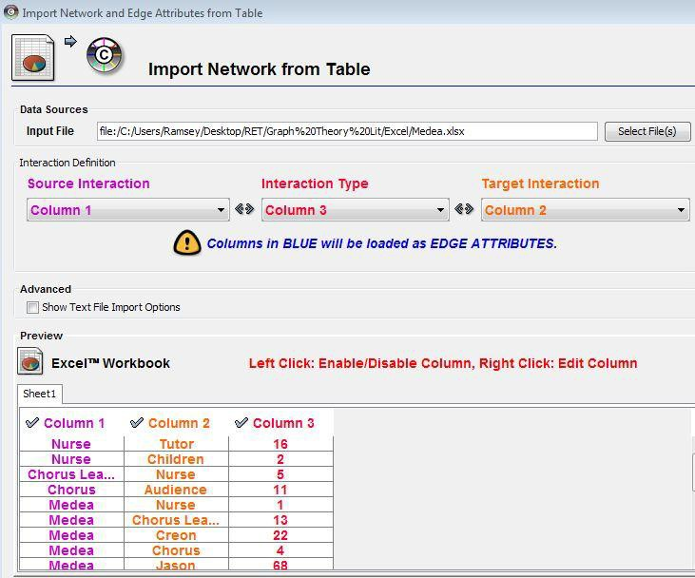
- Click Import and Cytoscape
renders a rough version of the
network that looks like this:

- In order to make the data useful, click on the Plugins menu at the top of the page > select Network Analysis > click on Analyze Network.
- Select the Treat Network as Undirected > click OK.
- Select Visualize Parameters, which alters the nodes and connections.
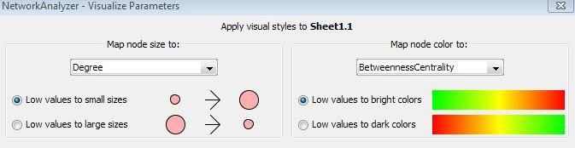
- Set the Map node size to “degree.”
This represents the characters that do the
most communicating as larger nodes.
- Set the Map node color to
“BetweennessCentrality.” This changes to
warmer colors the characters (nodes) that do the
most communicating with great numbers of other characters.
- Set the layout: Click in the Layouts menu > select Cytoscape Layouts
> select the Attribute Circle Layout option > set it to “degree.”
This generates a final product that looks somewhat like this
example from Medea (on the right).
- As necessary, use your mouse to spread out the nodes so that they
do not block each other.
Now you have a visual representation of the relationships
between the characters in your play.

