Trigonometry via Mobile Device Activity –
Post-Activity Quiz – Answer Key

Directions
Using the illustration and description below, prepare well-written statements — including all necessary trigonometric equations — to answer the following questions.
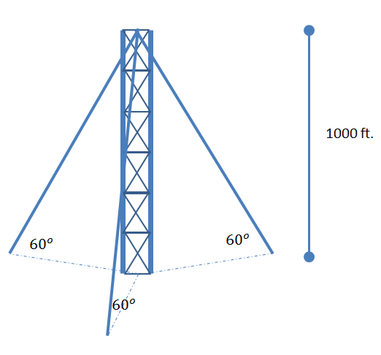
A 1000 ft. radio tower is to be supported by three evenly spaced guy wires.
Each wire will make a 60 degree angle with the ground.

Questions
- Approximately how many feet of cable will be needed to construct the tower?
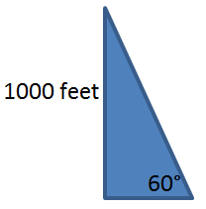
Each guy wire will make a triangle with as shown in the figure. Solving for the hypotenuse, which represents the length of the guy wire, we get
$\sin\left(60°\right)=\frac{1000}{h} ⇒ h= \frac{1000}{sin⁡(60°)} ⇒ h≈1154.7 ft$
Multiplying by 3, we get the total number amount of cable:
$$Total wire length=3*h≈3*1154.7=3464.1 ft$$

- How far will each wire be away from the tower?
To find the how far each wire is from the base of the tower, we can use a tangent ratio:
$$\tan\left(60°\right)=\frac{1000}{k} ⇒ k= \frac{1000}{tan⁡(60°)} ⇒ k≈577.35 ft$$
- What is the total surface area on the ground needed to build the tower (in other words, what is the area of the triangle formed on the ground by the wire anchors)?
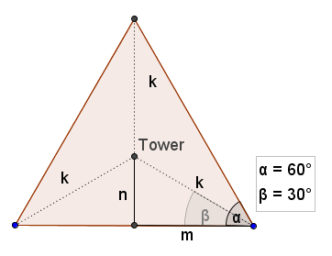
To find the area needed to build the tower, we picture the tower and wires from above and assume common spacing of all the wires which will create an equilateral triangle with angle measures as shown:

- If we use the standard formula for finding area of a triangle ($A=\frac{1}{2}*b*h$), we will need to find m and n as shown in the diagram and use the fact that $b=2*m$ and $h=n+k$, where $k=577.35$ from our previous work.

- So, to find m and n, we can set up the following trigonometric equations:

$$\sin\left(30°\right) = \frac{n}{k} ⇒\sin\left(30°\right)= \frac{n}{577.35} ⇒ 577.35*\sin\left(30°\right)=n$$

$$⇒ 288.675 ft≈n$$

$$\cos\left(30°\right) = \frac{m}{k} ⇒\cos\left(30°\right)= \frac{m}{577.35} ⇒ 577.35*\cos\left(30°\right)=m ⇒ 500 ft≈m$$

So the total area is $A≈\frac{1}{2}*\left(2*500\right)*\left(288.675+577.35\right)=433012.5$ square feet.

