Python Calculus Activity Handout
Answer Key
Step 1 Python code:
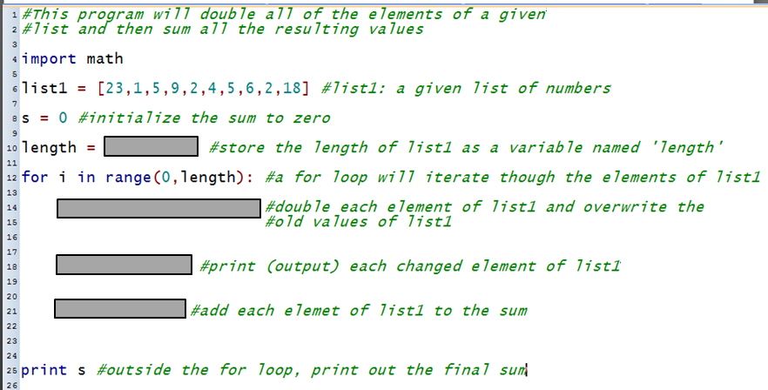

Step 1 Python code ANSWER (missing code is provided)
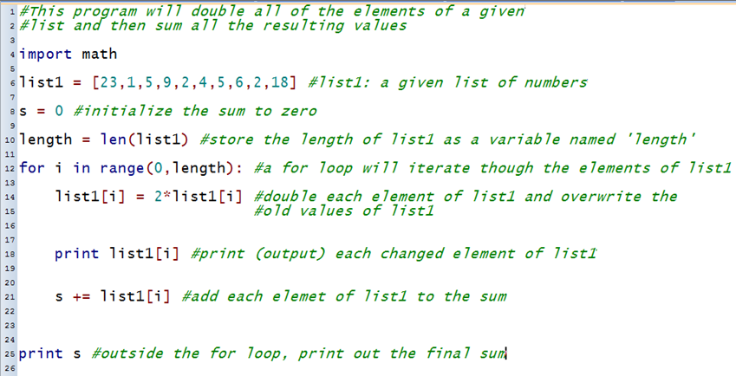

Answer Key
Step 2 Python code:
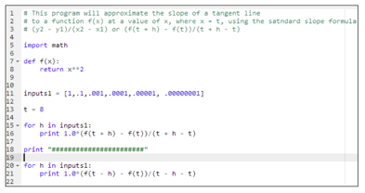

Step 2 Python code ANSWER (missing comments are provided)
