Making the Connection Lesson Assessment Answer Key
Writing Assessment
- Explain the concepts of vertex/node and edge as they relate to graph theory.

A vertex is a fundamental unit that makes up the graph. In a social network, each node represents a person. In a communication network, each node represents a device, base station or relay station. Nodes are connected by edges, which show that two nodes are related. In a social network, the presence of an edge between two nodes denotes that the two people know each other. In a communication network, an edge means that data travel between connected nodes.

- Explain how engineers represent relationships using graph theory.

Computer engineers use graphs to represent the connections between the various hardware elements in computers. A graph of these relationships shows paths that data can traverse in a computer. Software engineers use graphs to represent the control flow of a program, how functions interact, etc.

- How do engineers apply graph theory in their jobs?

Graph theory can be used to represent the relationships present between objects. Social networks, such as Facebook, Twitter, etc., can be represented using graphs with nodes and edges. Software engineers use this information to suggest friends and target advertising to users. Communication and network engineers use graph theory to show the relationships between physical hardware, such as routers, access points, hubs, etc. By looking at graphs, engineers can see weak points in the network and diagnosis network problems.

Performance Assessment
- Given the graph below, create a vertex list, adjacency matrix and adjacency list. In addition, create a depth first search (DFS) and a breadth first search (BFS) for the same graph.

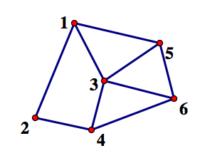

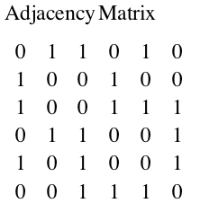
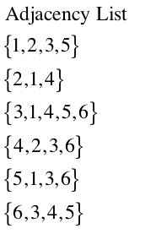
Answers:

Vertex list: 1, 2, 3, 4, 5, 6

DFS: 1, 2, 4, 3, 5, 6

BFS: 1, 2, 3, 5, 4, 6

