Controlling the Curiosity Rover

1) Create a list of moves that the rover (currently facing right) will have to execute to get from the landing site (X) to the alluvial fan area (Y)(must face to the left).
Command choices: forward (F), backwards (B), left (L), right (R), stop (S)

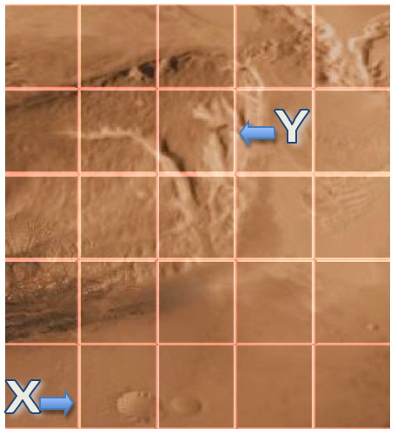
Moves List:

2) Use the mobile device and Rover App to test moves list on app rover.

3) Redesign moves list as needed to improve app rover path.

Revised Moves List:

4) Test moves list on EV3 rover to see if simulation fits reality.

5) Redesign moves list as needed to improve EV3 rover path.

Revised Moves List:

6) Explain how you applied the design process in this experience by detailing each step in the process.

Analysis

Design

Implementation

Testing

Evolution

