Twizzlers Linear Regression Pre-Activity & Worksheet
Answer Key
Procedure
- Obtain a Twizzler from your teacher.
- Use a ruler to measure the Twizzler length in centimeters (cm). Record in the data table below.
- Take a small bite out of the Twizzler.
- Measure the new length of the Twizzler in cm and record below.
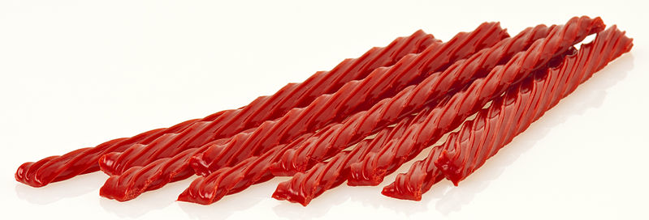
- Continue steps 3-4 until the Twizzler is gone.
- Answer the analysis questions.
Bite Number | Licorice Candy Length (cm)
0 | Measurements will vary
1
2
3
4
5
6
7
8
9
10
11
12
13
14
15
Analysis Questions
- What is the independent variable? (We will graph this on the x-axis.)
Bite number
- What is the dependent variable? (We will graph this on the y-axis.)
Licorice length
- Did the length of the Twizzler bite change between bite 1 and bite 2?
Answers may vary; most likely yes
- Did the length of the Twizzler bite change between bite 3 and bite 4?
Answers may vary; most likely yes
- Would you expect all bites to be the same length? Why or why not?
No, because it seems impossible to make each bite the same without a using a ruler and marking it

- On a piece of graph paper, create a scatter plot.
Put bite number on the x-axis and Twizzler length on the y-axis.
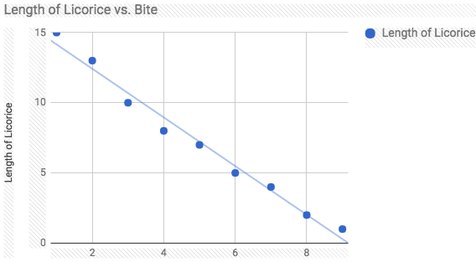

- Does the relationship appear to be linear? Why?
Yes, the relationship appears to be linear because it seems to be decreasing in similar intervals after each bite.
- Is the relationship increasing or decreasing? How do you know?
The relationship is decreasing because the length of the licorice is getting smaller with each bite.
- Whether the relationship appears to be linear or not, perform a linear regression of the form y = mx + b. Write the regression equation below.
y=-1.7x+15.9 If done by hand, may be y=-2x+16
- The value of b represents the y-intercept of the regression equation.
What is your b value? Be sure to include units!
15.9 cm
- What does the y-intercept tell you in this situation?
The length of the Twizzler before a bite was taken out of it.
- What would you expect the y-intercept of your graph to be? What variables could account for this difference in the expected y-intercept and the actual y-intercept of your regression equation?
I would expect it to be 16.5 cm. The line of best fit may not have been drawn perfectly.
- The value of m represents the slope (or rate of change) of the regression equation.
What is your m value? Be sure to include units!
slope is -1.7 cm/bite
- Use the regression equation to predict the number of bites it would take you to eat 5 cm of licorice.
6 bites
- Use the regression equation to determine the amount of licorice you could eat in 7 bites.
About 11 cm

