**Dyeing to Design Pre/Post-Quiz Answer Key**

1. The table below shows Cobi’s hours of exercise and weight loss each week.

|  |  |
| --- | --- |
| Hours of exercise | Weight loss (pounds) |
| 1.3 | 0.5 |
| 3 | 2.8 |
| 5 | 3.5 |
| 2 | 2.5 |
| 4 | 3 |

1. 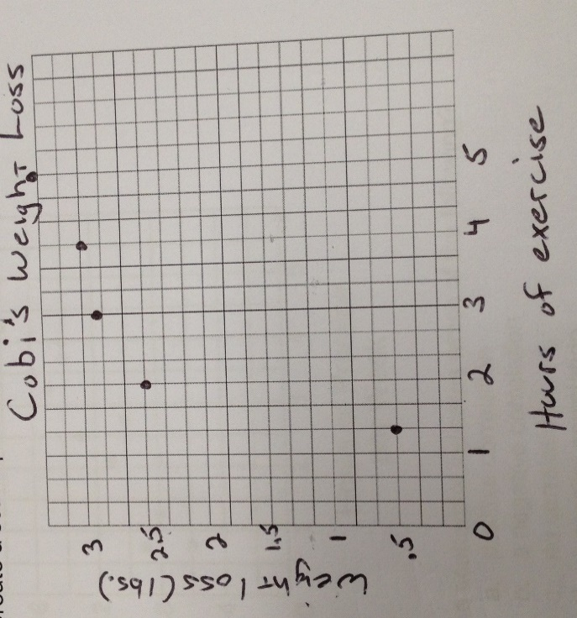 Create a scatterplot from the data in the table.
2. What type of correlation did you find between hours of exercise and weight loss?

Positive, more exercise then there’s more weight loss.

1. Which of the following is an example of a solution?
   1. Cement
   2. Kool-Aid
   3. Smog
   4. Coffee

3. Calculate the concentration of a solution with 5ml of solute combined with 35ml of solvent.

solute / solvent = concentration 🡪 5ml / 35ml = 0.143 x 100 = 14.3% concentration

1. The coaches of a group of debate teams answered a survey about hours of debate, team practice and number of team wins. The graph shows the results of this survey.



1. The scatterplot indicates which of the following?
   1. positive correlation
   2. a negative correlation
   3. no correlation
   4. a parallel correlation
2. Based on these results, if a team practices four hours per week next season, which is the best estimate of the number of debates the team can expect to win?
   1. 20
   2. 16
   3. 12
   4. 1