Engineering Journal Answer Key

Complete as instructed.

Questions to keep in mind throughout this process.

- What is clean cooking? Is clean cooking important? Why/Why not?

- What does the family structure look like in the US?

- What does cooking at home look like in the US?

- What does the family structure look like in Kenya?

- What does cooking at home look like in Kenya?

- Is knowledge of culture important to scientific innovation? If so, how? Provide an example.
- What are engineers doing at Burn Design Lab in Vashon, Washington?

- What United Nations Sustainable Development Goals are met by you and the Burn Design Lab working on the clean cookstoves? How do they make the world a better place?

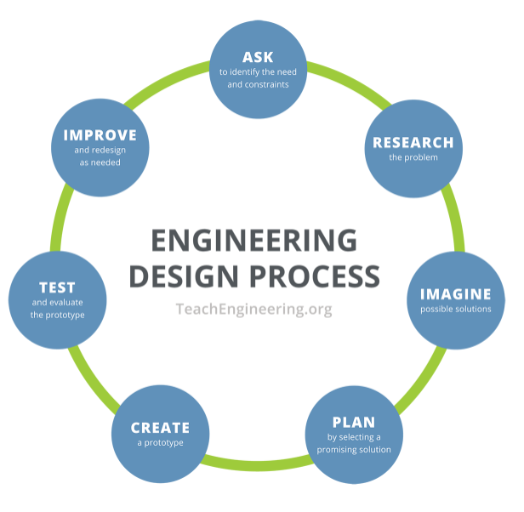
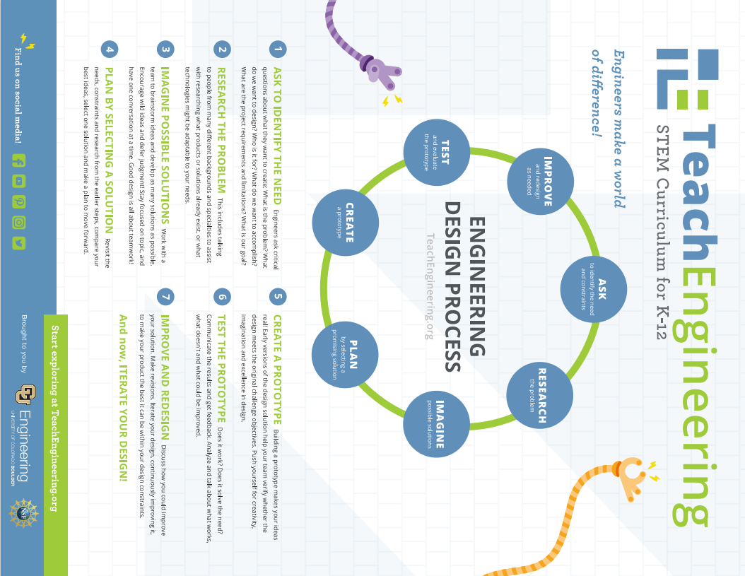

Ask - Complete the T-Chart and Identify the constraints.
What do you know about clean cooking? | What do you need to know about clean cooking in order to build a cookstove?
What is clean cooking?
What is a cookstove?
What is it made of?
How is it built?

Constraints: Watch
- Cookstove Design #1: https://www.youtube.com/watch?v=uKpar5nvCns
- Cookstove Design #2 :https://www.youtube.com/watch?v=o_JLfPrLqOo
- Cookstove Design #3: http://www.youtube.com/watch?v=rvddmcl6iDo
- Cookstove Design #4: https://www.youtube.com/watch?v=deCzUOZyII8

As a class, decide on what cookstove can constraints your class must follow. Some options include: only one can per cookstove, two cans of the same size, two cans of different sizes, etc. Note: In order to get usable scientific data, every group must use the same number of and same sized cans.

Reminder,

Research - Read the articles and answer
Part A. Burn Design Lab
Go to www.burndesignlab.org/about

  - What do they design? Cookstoves

  - Scroll down to “A Local Solution for a Global Problem.” According to the World Health Organization (WHO), how many people use open fires to heat their homes and cook?
3 billion
  - What is one of the BDL aims?
To save lives, reduce deforestation, promote economic empowerment of women
  - Scroll down to “How We Work.” What are the 5 parts of the (Engineering Design) cycle that BDL engages in?
Prototype, testing, user research, feedback, development
  - Click “Mission” (at the top). Watch the video? BDL works with partners in other countries. What knowledge do the people in these countries bring?
Their knowledge of culture; local markets; in country production, sales and distribution
  - What is one country BDL partners with?
Kenya, Guatemala, Ghana, and Uganda
  - What university in Ghana partners with BDL?
KNUST (Kwame Nkrumah University of Science and Technology)

Go to https://www.burndesignlab.org/blogs/success-stories-aller-stove. Read the blog.
- What did Juana Pedro, President of the Women’s Committee at Buena Vista, say?
In the past I ran the stove all day because it took a long time to heat up. Now I have to work at my store/invest in my small business.

- What did Juan Juan De Francisco say?
She used to get up at 5 am to start cooking and was in the kitchen almost the entire day. Now everything cooks faster.
- What did Teresa Francisco say about the cookstove with relationship to her eyes?
She no longer gets smoke in her eyes
- What did Teresa Francisco say about the cookstove with relationship to her children?
It prevents children from getting burned. With the old way, coals used to fall on the floor where her
children played.
Part B. Cookstoves
Watch
- Nigeria's Okey Esse Creates Clean Cooking Power Stove | Tech Trends - YouTube:https://www.youtube.com/watch?v=sgAunt6omjs

Watch 3 of the 4 videos listed below
- How Clean Cookstoves Improve Lives - YouTube: https://www.youtube.com/watch?v=Yu5SdH2_0JU&t=9s
- Clean Cookstoves: “Black Inside, Three Women’s Voices”:https://www.youtube.com/watch?v=qm9ODkF4VRo
- Clean Cookstove Project in Kenya: https://www.youtube.com/watch?v=L65htWQ4EmE&t=72s

Designing cleaner stoves for the developing world: https://www.youtube.com/watch?v=Z0XrARfLfuk

- What is clean cooking?
Cooking that does not cause indoor air pollution
- What are the benefits of clean cooking versus using an open fire to cook?
Women’s health improves, children don’t get burned, it uses less fuel, it takes less time
- What 3 United Nations Sustainable Development Goals are being met by this work?
3, 5, and 7
- Is clean cooking important? Why/Why not?
Yes, many women and children’s health is being harmed by cooking on an open flame. Their homes, eyes, and lungs fill with smoke. Millions of people die each year due to dirty cooking. Also, these women spend a lot of time and energy carrying heavy loads wood. These women need time to work on their businesses, walk their children to school, and spend time with their families.

Part C. The United Nations Sustainable Development Goals
- Go to https://www.un.org/sustainabledevelopment/student-resources/
- Scroll down to “Frieda.”
- Read the digital book and note the colorful boxes in the illustrations.
- What is Goal #3?
Good Health and Well Being
- What is Goal #5?
Gender Equality
- What is Goal #7?
Affordable and Clean Energy
- What is Goal #10?
Reduced Inequalities
- What is Goal #11?
Sustainable Cities and Communities
- What is Goal #17?
Partnerships for the Goals
Part D. Culture and Innovation
Watch: https://www.youtube.com/watch?v=J3Zsj4Lfs_o
- Half of the two million people who die are children under the age of ____5____. This is the equivalent of these children smoking 2 ___packs of cigarettes_____ per day.
- What were two problems with the stove made by the large British oil company?
It required expensive fuel pellet and people didn’t want to pay for it. It required electricity.
- Technology + _____culture_____
- So many attempts to improve the lives of people in poverty fail because they do not take a ______user______ centered approach and they fail to take into account how real people live (their real behaviors) and _______cultural_______ preferences.
- A design consideration that needed to be made was that people in different regions cook different _____foods_______.
- In Guatemala, people make tortillas, so they need a _____large______ cooking surface.
- In Ghana, they stir large ___pots________ of stew so they need a ____sturdy______ stove that won’t topple.
- What are two reasons why we shouldn’t just give these stoves away?
People don’t want charity. People want to pay for them. Also, if the stoves are given away and they break down, people will go back to cooking over an open fire. It creates a culture of dependence. It causes those in the community who build such things to miss out on business–get squeezed out by large corporations.
- In order to market the stoves effectively, what is one thing the company has to do?
Respect the hierarchies in the cultures. Get the village leaders on board. Market them through a village member, possibly women. They are excellent promoters of products.
- Is knowledge of culture important to scientific innovation (design)? If so, why? Provide an example.
Yes. Otherwise people won’t use the product. The large British oil company designed a cookstove but it was terrible because the fuel was expensive and it required electricity.

Part E. Life in Kenya
https://www.youtube.com/watch?v=NhkqcflxtiI&t=5s
- Describe the family and home in this video.
Mother, father, grandmother, baby, toddler, aunties/friends. The home is modern and clean. The yard is beautiful.
- Describe the food in this video.
Eggs were cooked inside. They had potatoes or some type of stew outside. It kind of looked like a picnic.
- The person who did the cooking was of which gender?
Female
- Where was the cooking done? What was used to cook the food?
The cooking was done inside the kitchen. The eggs were cooked in frying pan on a stove just liek in the US.
An Indigenous Community in Kenya: the Luhya people: https://www.youtube.com/watch?v=kQVUYmiEREA
African Village Life/Cooking The Most Appetizing Kenyan village Food - YouTube:https://www.youtube.com/watch?v=8v7qZv-D2JE
- Tell two things that surprised you about what you saw.
Open
- Describe the foods and things used or cooking. Is the food mostly processed food or natural plants, crops, meat, etc.?
The cooking was done outside over an open flame in metal pans or ceramic pots. The food was not very processed. It was fresh plants, meat, fish, etc. There were leaves/greens, fish, onions, grains, stone/ceramic bowls, baskets, flour, millet, sorghum, maize, sweet potatoes, busa, fish, onions, oil, ugali, and rice. Stones were sometimes used in the cooking.
Another Indigenous Kenyan People Group:
https://www.youtube.com/watch?v=ThcppnztYpw
https://www.youtube.com/watch?v=NorrsBsOnZ0
- Describe the values these men and their community operate with.
Love of school; love of family/wanting the children to grow up around their extended family; being strong/a protector of the family and community/a warrior; inherited values of responsibility, respect, courage, and wisdom; keeping the community together; take care of the family and the community; womens‘ empowerment; benign strong enough to embrace change (kill taboos that affect you negatively); that schools can be built quickly unlike in the US
- What can you say about (Masai) Kenyan families based on these videos?
The families spend time with each other. The one man quickly built a school in his community because he wanted his children to be educated and to grow up around their extended family. The father and mother and extended family are present in the childrens’ lives. Women and girls are becoming increasingly important.
Life in Nairobi, Kenya
https://www.youtube.com/watch?v=dI0WovGPD6c
https://www.youtube.com/watch?v=pLYXOMCkFHQ
https://www.youtube.com/watch?v=Q32aZTNP1JE
- Tell two things that surprised you about life in Nairobi, the capital city of Kenya.
Open
- Describe what you see in the backgrounds of these videos.
Modern, fancy homes and apartments; nice pools; lots of modern buildings; beautiful skyscrapes/landscapes→modernity
- Describe the food in these videos?
Hamburger and fries
https://www.youtube.com/watch?v=ChyPpnQaBs0
- Tell 4 things you think of when you hear the term Africa.
Open–But hopefully students will realize that Kenya and Africa contains many complex cultures and lifestyles
- Based on all the videos you’ve seen, what can you ascertain (guess/say/assume) about Kenyan families?
It seems like a lot of families have fathers in the homes. There are fewer single parent homes. Being with family–including extended family–is important. Extended family lives near. Women do all/most of the cooking. In some communities, there is a great need for clean cookstoves. The families eat meals together.

Imagine (Individual Brainstorm) - Draw a detailed sketch of your design. Be sure to include the number size, and shapes of any holes or openings. Share/Show your file with(to) your teacher. Have your teacher initial your packet/file and record your points in the gradebook.
Teacher Initials:_______

Plan (Group Decision) - Sketch your team's final design. Include a statement detailing why you picked this design. Take your packet/computer to your teacher. Have your teacher initial when you finish and record your points in the gradebook.
Teacher Initials:_______

Build Prototype - Build your prototype. Paste two pictures (or provide two sketches) from different angles of your prototype below.

Test Prototype - Upload a picture or provide a sketch of your team testing your prototype while you do Cookstove Lab I:Testing the Cookstove.

Evaluation of Data: Class Discussion - Record the trends observed in the class data that were discussed in the class discussion and your thoughts on your redesign. Take your packet/computer to your teacher. Have your teacher initial when you finish and record your points in the gradebook.
Trends:

____________________________________________________________________________________________
Redesign Thoughts:

Teacher Initials:_______

Redesign Plan - Describe the changes decided upon and sketch your team’s new cookstove. Have your teacher initial your packet.
Teacher Initials:_______

Redesign Build - Upload a picture or provide a detailed sketch of your team’s redesigned cookstove. Take your packet/computer to your teacher. Have your teacher initial when you finish and record your points in the gradebook.
Teacher Initials:_______

Testing the Redesign - Upload a picture or provide a sketch of your team doing Cookstove Lab II:Testing the Redesign.

Reflection - Copy your answers from your Redesign Lab below. Take your packet/computer to your teacher. Have your teacher initial when you finish and record your points in the gradebook.
- Did your redesign have a longer or shorter boil time?

- What are your thoughts as to why?

- If you could redesign it again, what would you do?

Teacher Initials:_____

Extra Credit
Go to Student Resources - United Nations Sustainable Development (https://www.un.org/sustainabledevelopment/student-resources/ ). Scroll down to 170 Actions to Transform Our World. Read the digital book. Choose 4 Goals. Choose one action you, your friends, our class, etc could do for each goal.

Goal Number | Goal | Action

