Posterior

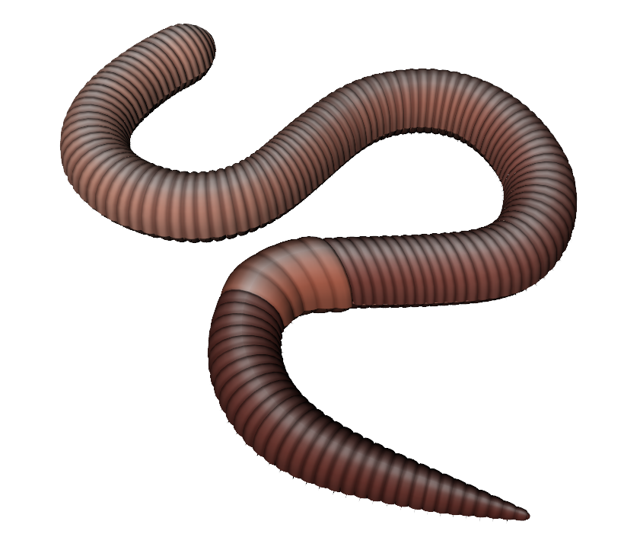
Segments

Clitellum

Anterior

Prostomium

- Which parts of the worm have tiny bristle-like structures that help them move through the compost?
- Which end of the worm is pointier than the other end?
- Which part of the worm creates the material that forms earthworm cocoons?
- What is the first body segment called?
- From which part on the worm do castings come from?

