Floods

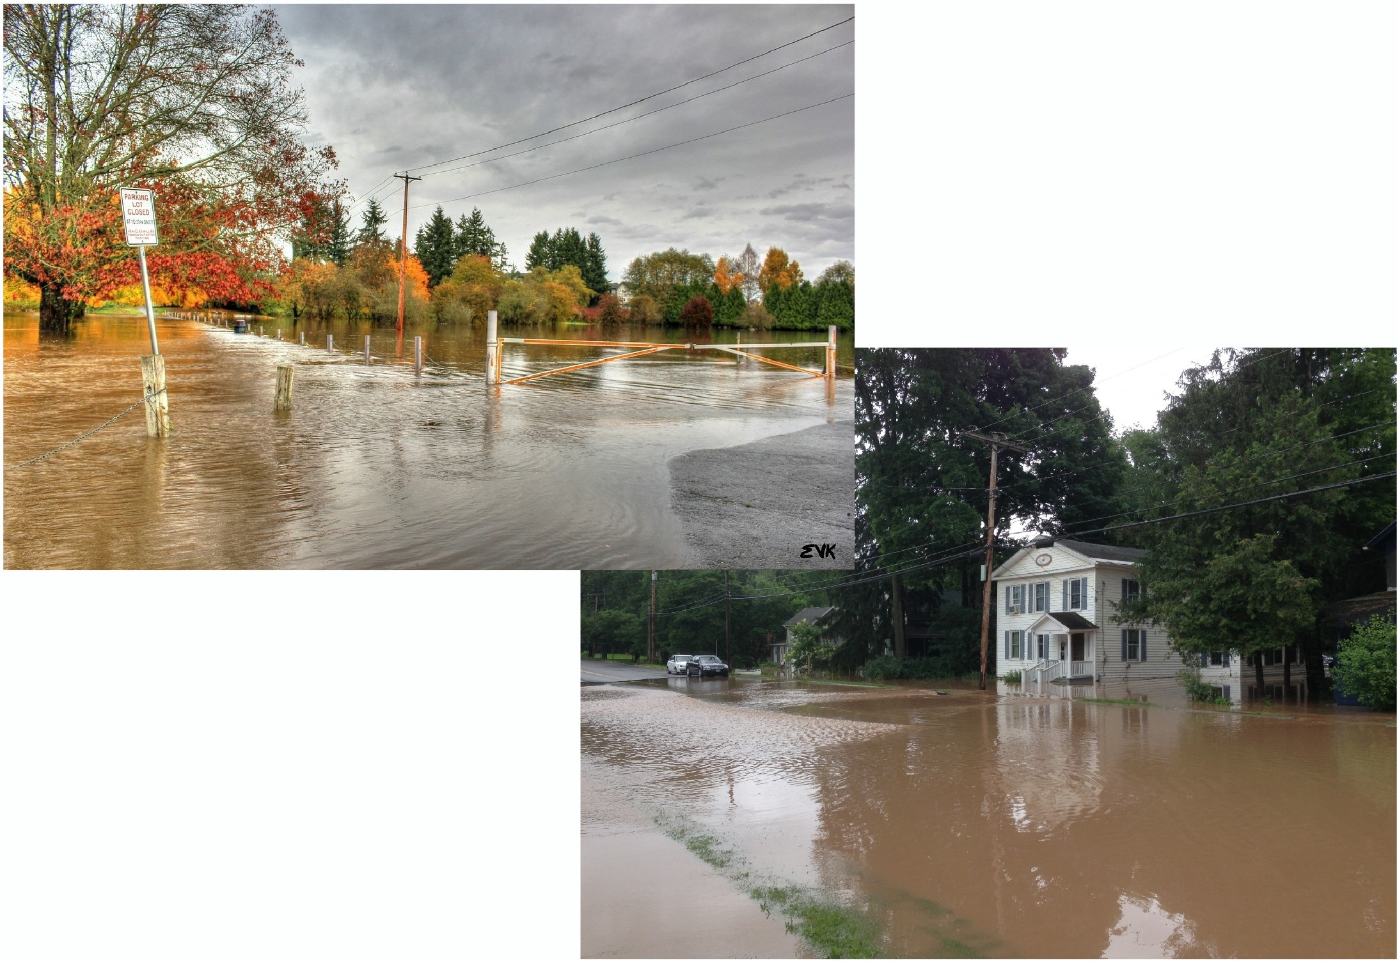
Floods can be caused by very heavy rains, snow that melts too fast, ocean waves that come on shore, rivers that overflow, or dams that break. Floods can occur anywhere that water overflows onto land that is normally dry. This happens when water is coming in faster than it can be absorbed back into the ground. Floods can happen suddenly or slowly over days or weeks. Moving water from floods can sometimes be strong enough to carry away cars, houses, and other things in its path. People should avoid walking or driving in flood waters. They should also stay away from power lines. Water naturally fills in low areas first, so if there is a bad flood people need to move to higher ground.

