**Recycling Sort Pre-Assessment Answer Key**

*Trash or Recycle?*

Instructions: Sort by deciding if each picture can be recycled or is waste and goes in the trash.

Trash

Recycle

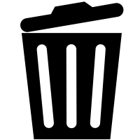



wood/stick



chips wrapper

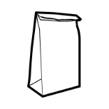

paper bag

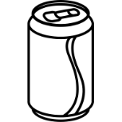

aluminum can



frying pan

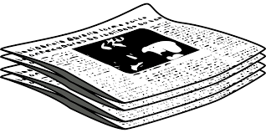

newspaper

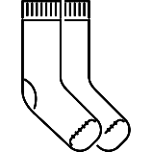

socks/clothing

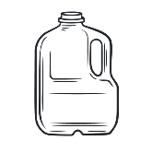

plastic milk jug



glass jar

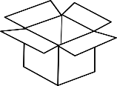

cardboard box

Reduce - Reuse – Recycle

Instructions: Sort the sentences by deciding if it is an example of reducing, reusing, or recycling.

Reuse

Recycle

Reduce

Trading, donating or selling toys instead of throwing them away.

Throwing away paper scraps into the correct bin.

Using less water and electricity.

Composting food scraps to make fertilizer.

Using reusable forks and spoons instead of plastic utensils.

Collecting plastic bottles, glass jars, soda cans, and cardboard.

I can save the Earth by…

Answers vary by student.

