Solar Dryer and Heat Transfer Worksheet

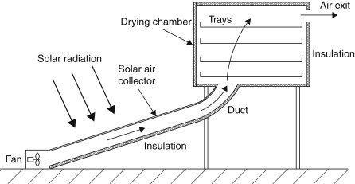
Instructions: Below is an example of a food solar dryer. From the drawing, where is conduction, convection and radiation applied or used?

- Conduction

- Convection

- Radiation

