Lines and Circles Guided Practice:
Teacher Instructions
Overview
- Together, as a class, go through the Lines and Circles Guided Practice (exercises 1-22) described below.
- Then have student teams conduct on their own one or both of the assignments on the GeoGebra Basics Practice handout: Spheres Student Independent Practice, Rapa-Nui Student Independent Practice.
- Require students to answer the independent practices questions and turn them in for grading.
Teacher Tips and Notes
The Lines and Circles Guided Practice is a very basic introduction to the GeoGebra geometry software and covers the necessary elements to perform the independent practices that students are asked to do next. The purpose of these practices is to help students understand the basic elements used in the GeoGebra Measuring Interface, which simulates expensive, high-resolution microscope imaging software.
Specifically, the purpose of the Rapa-Nui Independent Practice is to give students practice measuring distances between specific points, while the Spheres Independent Practice is intended to give them practice measuring the radius of a circle.
For more information, refer to the following activity attachments: GeoGebra Measuring Interface Manual, and Graphing Data and Statistical Analysis with Excel Practice.
It is highly recommended that instructors use a computer with a projector to clearly show students every step and exercise. Decide how to monitor and verify students’ progress in the guided practice. If desired, modify the values and questions in the Lines and Circles practice. Once students have familiarized themselves with GeoGebra basics, let them work by themselves in teams on the Spheres and Rapa Nui practices.
If you have no experience with GeoGebra, it is highly recommended that you take the time to do the practice yourself first, become familiar with the commands, and understand the little tricks. Feel free to make changes in the exercises or include new ones. You may also go more in depth by watching the GeoGebra channel at YouTube: https://www.youtube.com/user/GeoGebraChannel.
For the Rapa-Nui and Spheres independent practices, be sure that the student computers have copies of the EaterIsland.jpg and MarbleSpheres.jpg picture files that must be used as backgrounds in these practices; the two jpg files may be found in the zip file. Students are asked to perform different measurements on these pictures. It is very important that the scale factor calculation be correct in order to transform their on-screen measurements into real scale measurements.

Lines and Circles Guided Practice Instructions (Led by Teacher)
Once students have a GeoGebra session open, go through the next exercises with them, step by step. Have an image ready to be inserted as the background in exercises 18-22.
- Display the background grid on the graphing window.
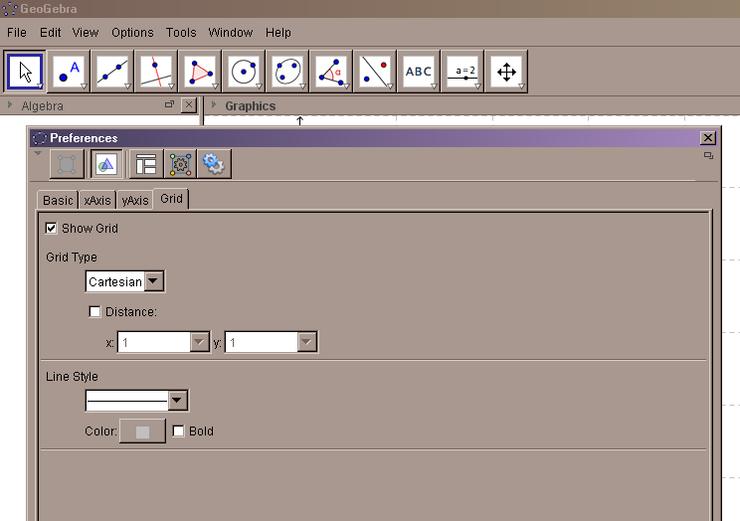
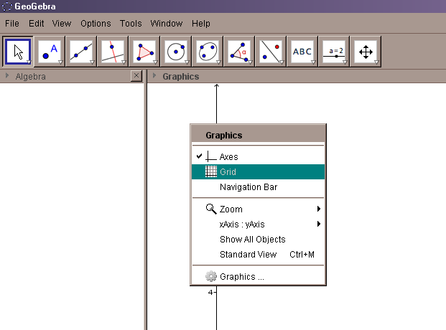

Drawing Pad
Alternatively:
- Place cursor on Drawing Pad
- Press mouse right button
- In displayed menu select Graphics
- Select Tab Grid
- Click in Show Grid box
- Close Preferences Menu

- Place cursor on Drawing Pad
- Press mouse right button
- In displayed menu select Grid

- Change the Graphing Window dimensions to: xMin: -1, xMax: 15, yMin: -1, yMax: 10.
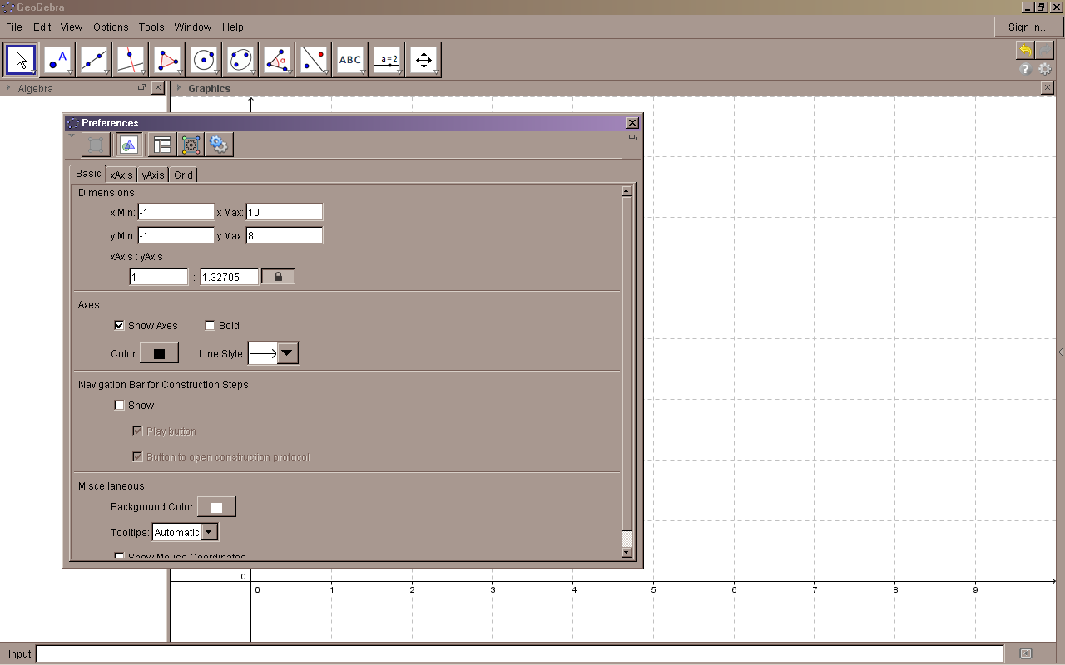

- Place cursor on Drawing Pad.
- Press right mouse button.
- In displayed menu, select Graphics.
- Select tab Basic
- Introduce values in xMin, xMax, yMin, and yMax boxes.
- Close Preferences.

- Draw a point on the drawing pad, or graphing view, with coordinates (1, 6).
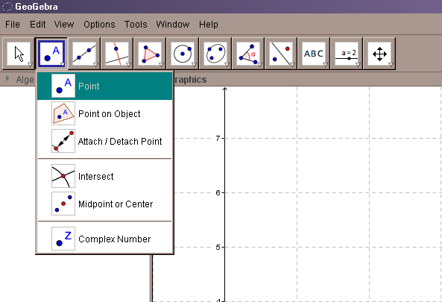
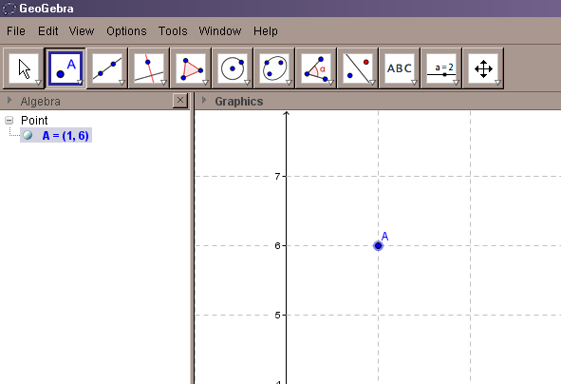

Click in Drawing pad on the place you want to draw the point. You will see in the Algebra view the coordinates and name of the new point.
On the Toolbar, select Point icon.
From the displayed tools, select Point.

- Change the coordinates of your point to (4, 3)
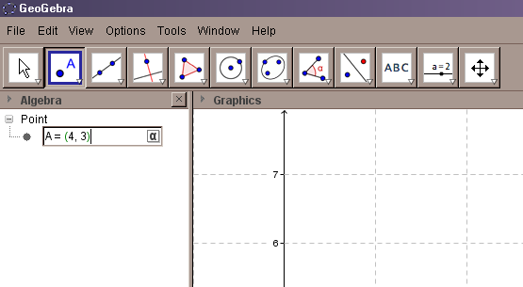
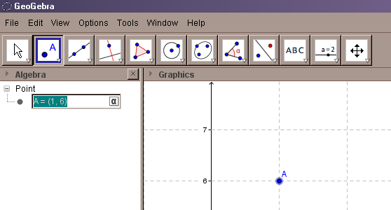

- Type in the new coordinates
- Press Enter
- In Algebra View, double click on point A

- Label this point: Point1.
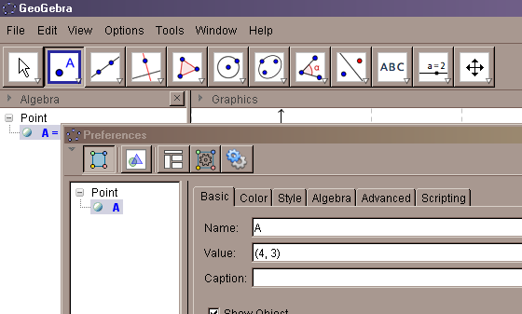
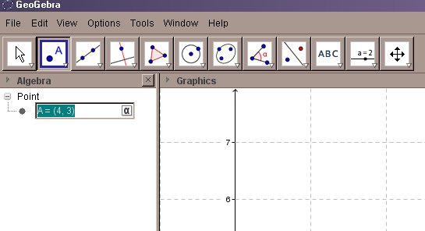

- In Algebra View, double click on A = (4,3)
- Delete A and write the new name
- Press Enter

- In Algebra View, place cursor on A = (4, 3).
- Press right mouse button and on displayed menu select Object Properties.
- In box Name, type the new name. Close Preferences window.
Alternatively:

- Using the mouse, translate this point to (2.5, 5.5). (Hint: Watch the Algebra window.)
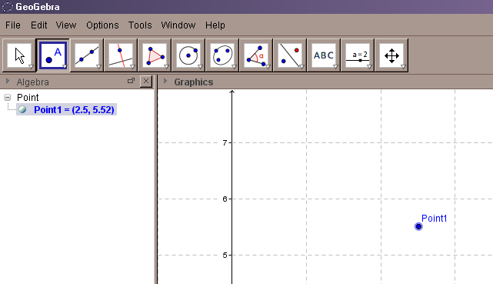

- In the Graphing view, place cursor on Point1.
- Press left mouse button and drag the point to the desired position on the plane (2.5, 5.5).
- In the Algebra view, watch the new coordinates of the point.
- Release the left button when you reach the desired position.
- If not possible to place the point in the desired coordinates, modify the point coordinates as you did in exercise 4.

- Draw another point at (1, 1) and label it as Point2.

Repeat procedures in exercises 3 and 5.

- Find the distance between Point1 (2.5, 5.5) and Point2 (1, 1). What is this distance equal to?
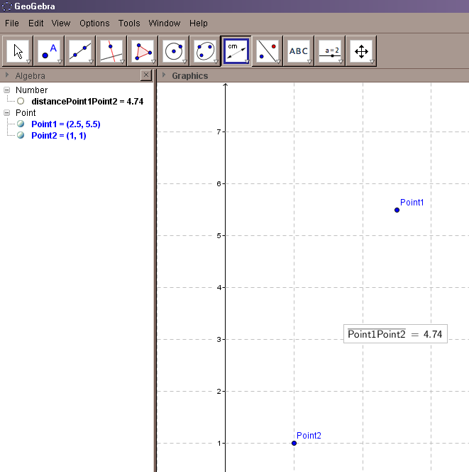
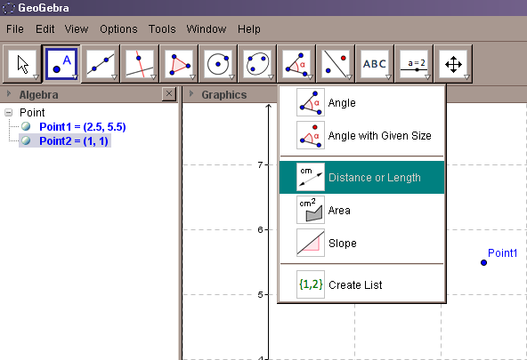

- On Toolbars, click on Angle icon display menu button.
- Select option Distance or Length.

- In Graphing View, click on Point1 (left mouse button).
- Click on Point2.
- Distance between Point1 and Point2 is displayed on Graphing view and in Algebra view.

- Display the distance with four decimal places. What is this distance equal to now?
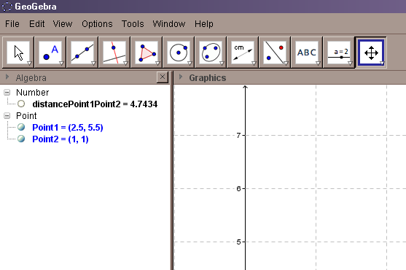
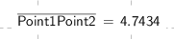
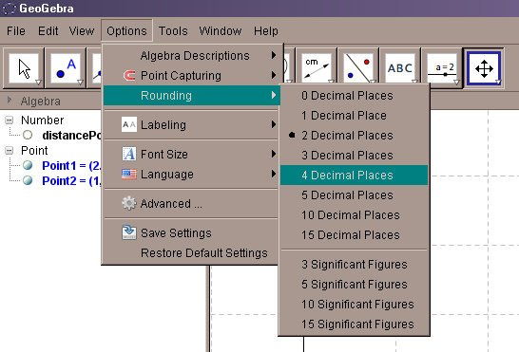
Four decimal places

- On Menu bar, select Options.
- In Options ► select Rounding.
- Select four decimal places.

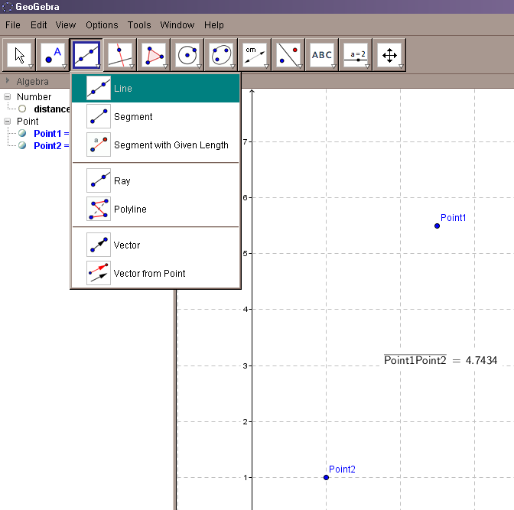
- Draw a line passing through the points.

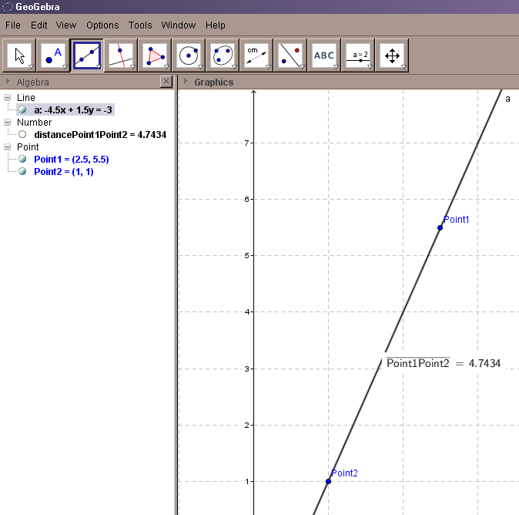

- On Toolbars, click on Line icon display menu button.
- Select option Line.
- In Graphing view, click on Point1 (left mouse button).
- Click on Point2.
- Line equation is displayed in Algebra view.

- Change the color of the line drawn in exercise 10 to red.
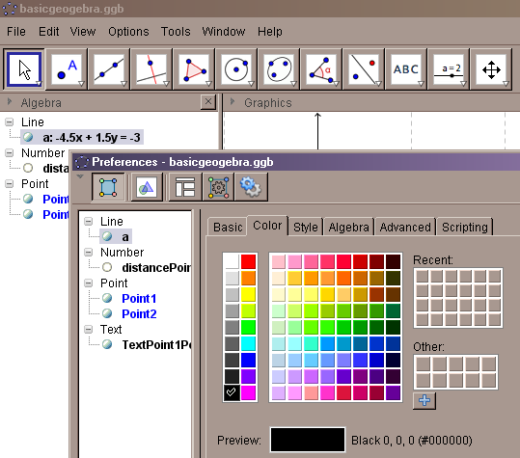
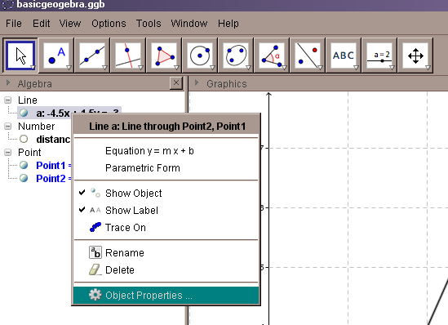

- In Algebra View, place cursor on line equation a:
- Press right mouse button.
- On displayed menu, select Object Properties.
- On displayed window, select color tab.
- Select desired color, then close window.

- Find the slope of the line.
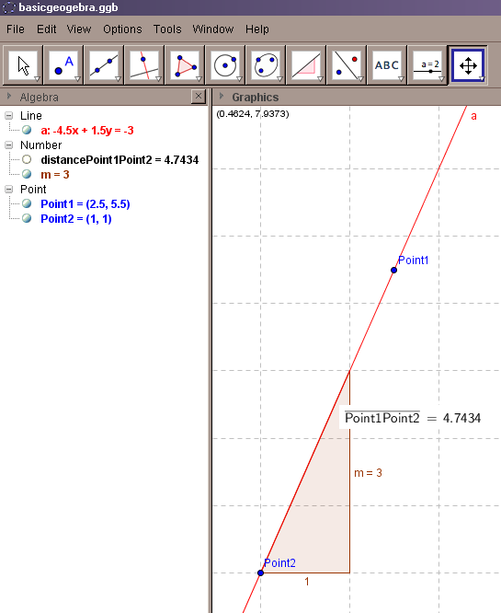
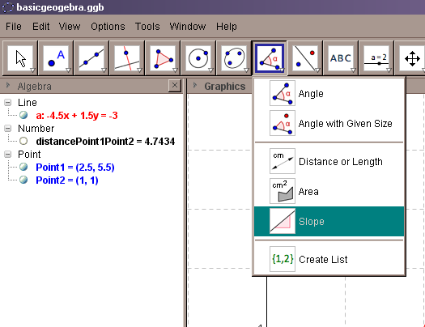

- On Toolbars, click on Angle icon display menu button.
- Select option Slope.
- In Graphing view, click on line a (left mouse button).
- Slope of the line will be displayed.

- Delete line a and all the elements drawn.
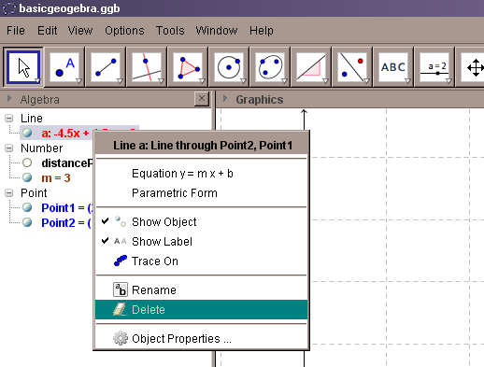
- In Algebra View, click on object to delete (left button).
- Press right mouse button.
- On displayed menu select Delete.

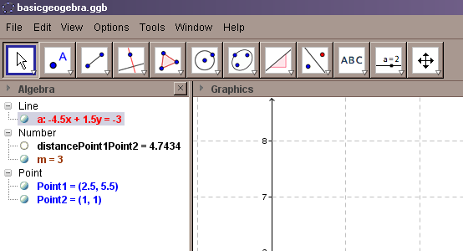

Alternative procedure:
- In Algebra View, click on object to delete (left button).
- Press on keyboard Delete.

- Draw a line segment from point (0, 2) to (2, 7). What is this segment length?
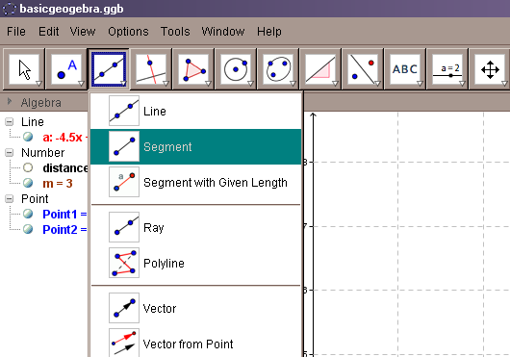
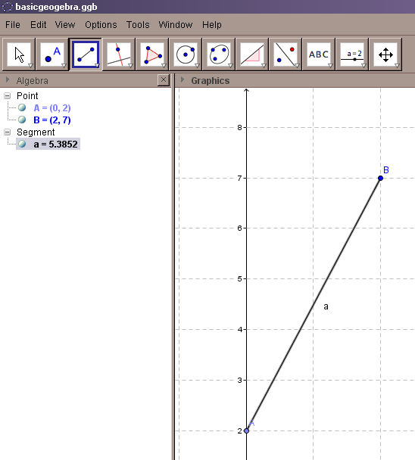

Segment length

- On Toolbars, click on Line icon display menu button.
- Select option Segment.
- In Graphing view, click on point (0, 2) (left mouse button).
- Click on point (2, 7).

- Drag and drop segment end (0, 2) to the coordinates (-1, 4). What is the length now?

Repeat procedures in exercise 6.

- Draw a circle passing through the points (0, 5), (0, 2), (2, 4). What is the radius of this circle?
What is its center?
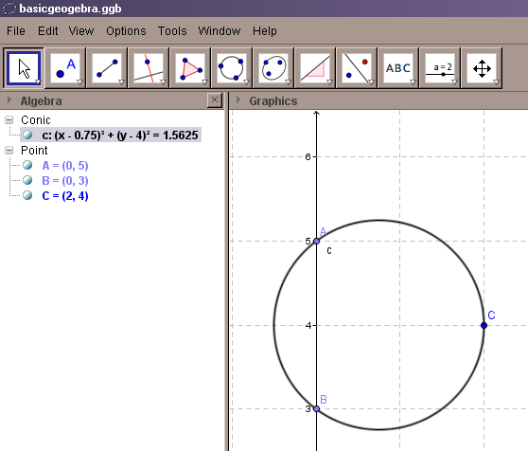
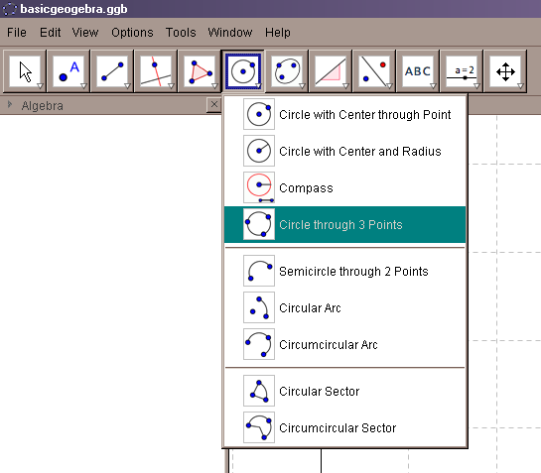

- On Toolbars click on Circle icon display menu button
- Select option Circle through 3 Points
- In Graphing view, click on (0, 5) (mouse left button)
- Click on (0, 2)
- Click on (2, 04)

Circle Equation
Center (0.75, 4)
r² = 1.5625
r = 1.25

- Drag the point (0, 3) to (3, 5). What is the radius now?
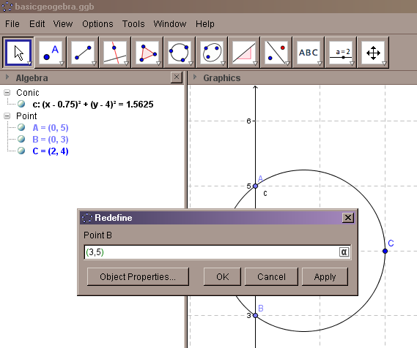
A point defined as a point on one of the axes, cannot be dragged as another point on the plane.

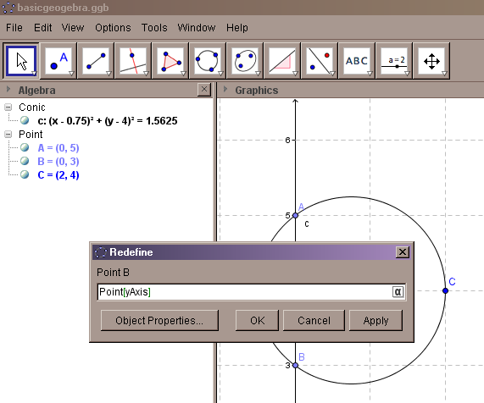

- In Algebra View, double click on point B = (0, 3):
- On Redefine window, delete Point[yAxis], and type new coordinates (3,5).
- Click OK.

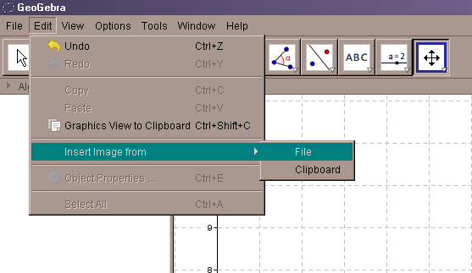
- Insert a picture file.
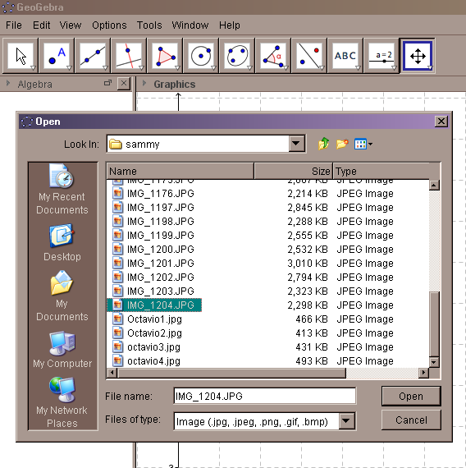

- On Menu bar select Edit.
- In Edit ► Insert Image from.
- Select File.
- Browse and double-click on the image file.

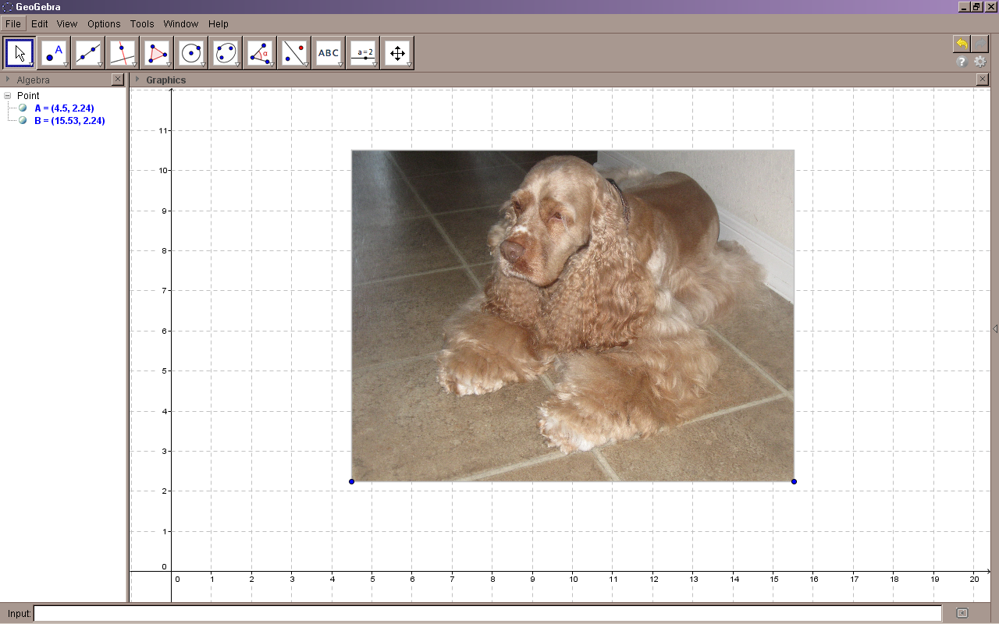

An inserted image from file or clipboard will be placed in the same section of the Graphing view.
Two points will be automatically assigned to each image: lower left and lower right; these points, displayed in Algebra view, define the relative position of the image with respect to the coordinate axis

- Translate picture inserted in exercise 18 to the origin.
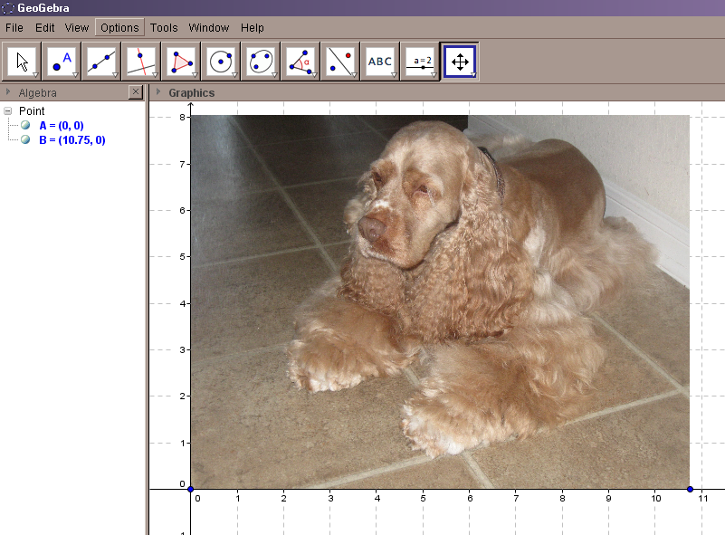
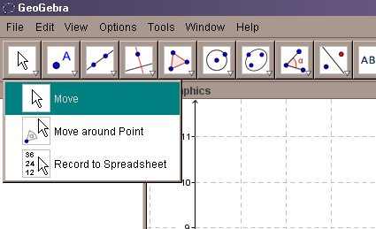

- On Toolbars, click on Move icon display menu button.
- Select option Move.
- In Graphing view, click on picture, keep left mouse button pressed, and drag image toward the origin.
- Place the lower left point of the image on the origin.
- Release left button.
- Check in Algebra view that the new coordinates of the lower left point are (0, 0).

- Set pictures as Background.
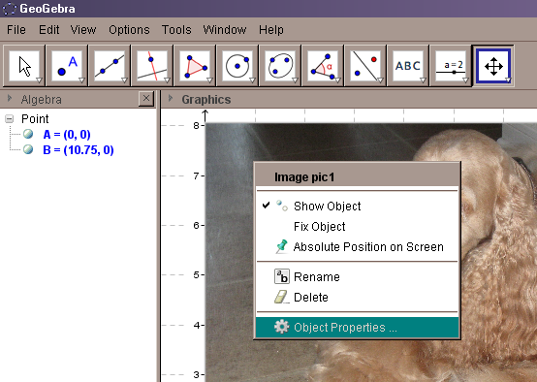
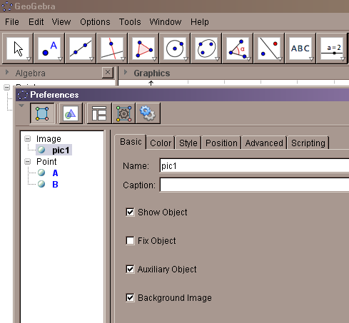

- In Graphics view, right click on image.
- On displayed menu, select Object Properties.
- On Preferences window Basic tab, click on Background Image box.
- Close Preferences window.

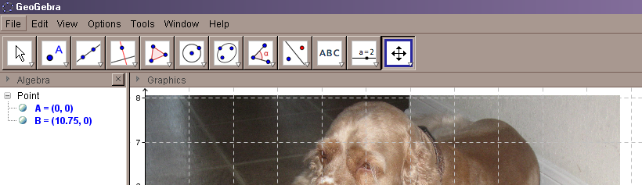

An image is a background when the gridlines are above the image.

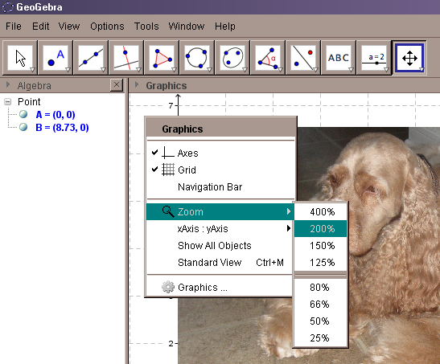
- Zoom the inserted picture 200%.
Alternative procedure if you have a mouse with a scroll wheel:
- On image, place cursor on image.
- Zoom in by spinning the wheel backwards.
- Zoom out by spinning the wheel forwards.

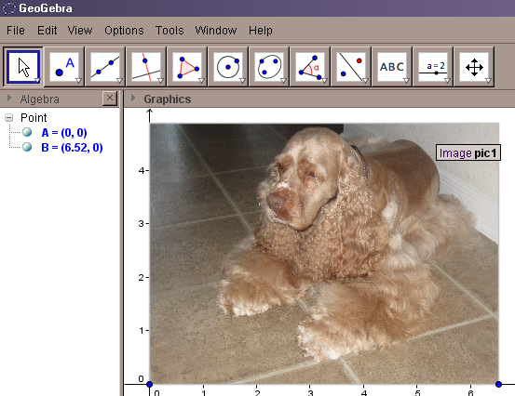

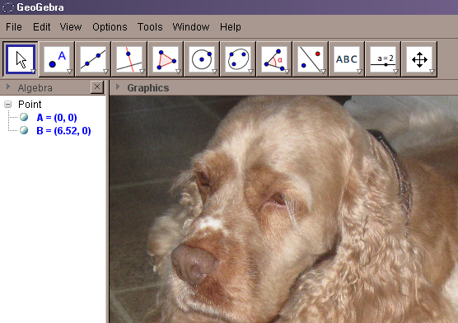

- On Graphics view, outside the image, right mouse click.
- On displayed menu select Zoom.
- Select Zoom percentage.
- Image zoom will be centered at the Graphics view point where you right click.

- Image zoom will be centered at the point on the image where you place the cursor.

- Using the Segment tool, measure something on the picture.

