Project Rubric

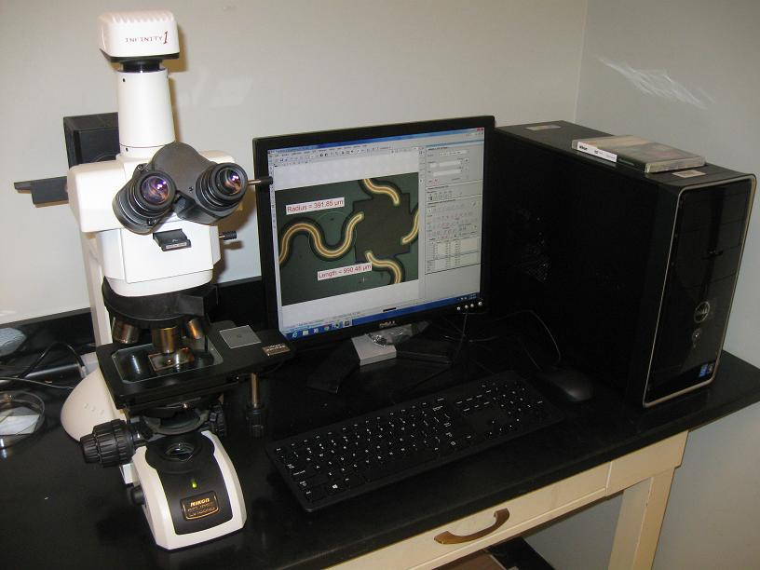
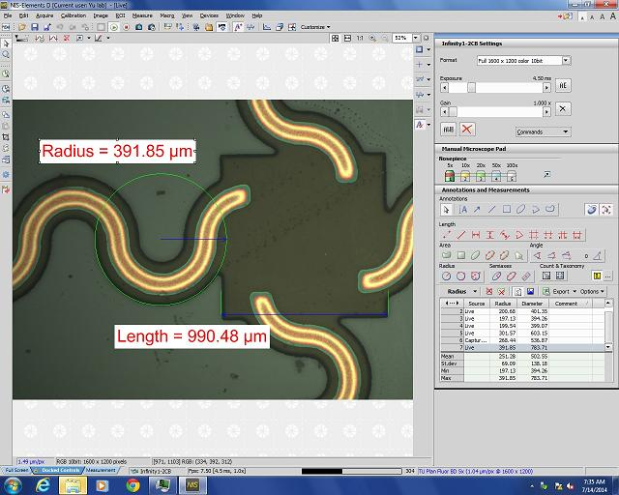
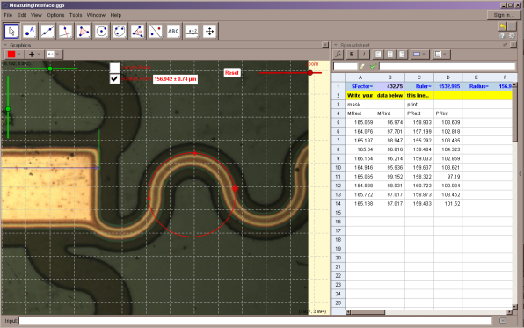
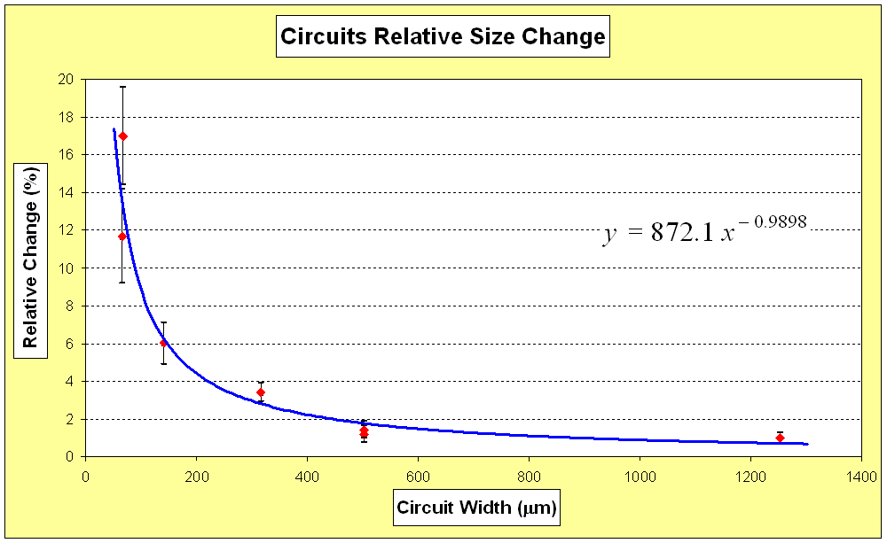

Project Overview
This project was designed and developed in the Wearable Electronics Laboratory of the Mechanical Engineering Department at the University of Houston’s Cullen College of Engineering. The purpose is to apply in a real-world, state-of-the-art research problem, the concepts learned in an AP Statistics course: to verify if the fabrication process affects significantly an original circuit’s dimensions defined during the design process.
A basic knowledge of GeoGebra geometry software and Microsoft® Excel® is required. GeoGebra is used to make measurement on nano-circuit images, and Excel is used for graphing and statistical results analysis.
Project Guidelines
- Because of the project workload, it will be accomplished by teams of three students each.
- Students work on two nano-circuit picture sets: circuit original masks (designs) and fabricated printed circuits.
- Students select samples from these pictures and open them with GeoGebra to perform measurements on the circuit elements using a special interface designed specifically for this. Students may work with paired samples or independent samples.
- The collected measurements are exported to Excel®, and using its graphical and mathematical capabilities, the data is graphed, compared and statistically analyzed.
- Students create a PowerPoint® slide show or a video (mp4, wma, mpeg) to present project results.
- Teams present to the rest of the class their results, analyses and conclusions.
- Help is available for the math and final presentation preparation, during afterschool tutorial time.
- All the project activities are part of the final grade. If two or all three team members justifiably miss any of these activities, arrange with the instructor for a makeup session before the project deadline.

Project Checklist
Activities, Results and Analysis | Points |  | Evaluation
- GeoGebra Basics Practice (optional) | 10
- Excel Practice (optional) | 10
- Pre-Activity Test | 10
- Project Results Report | 60
a. Project title and student names | (5)
b. Project description, including objective, procedures and resources used | (5)
c. Collected data | (5)
d. Graphs of paired data and differences | (5)
e. Calculated data statistics | (5)
f. Statistical analysis performed; hypothesis testing conclusions | (10)
g. General graph for different circuits widths (shared team data) | (5)
h. Log-log general graph for different circuits widths (shared team data) | (5)
i. Linear correlation of graph in (h) (shared team data) | (5)
j. Non-linear correlation for graph (g) (shared team data) | (5)
k. Project conclusions | (5)
- Excel file with obtained data, graphs and statistical analysis | 10
Total Points:

Results Presentation |  | Points |  | Evaluation
- Slide show containing information and results listed in points 4a-k |  | 60
- In-class results presentation:  Presentation proficiency, proficient answers to audience questions |  | 30
- Students’ professional look |  | 10
 | Total Points:

Note: Students creating slide presentations or videos (mp4, wma, mpeg) with recorded explanations
are exempt from steps 7 and 8. Videos are worth 40 points for the results presentation.

Notes: | - No project will be accepted after the due date: [Date here ____________________________]  - Estimated time to perform this project is 10 class sessions (plus afterschool work) and is your final test grade and 70% of your sixth six-week period grade.

Alternative Project Checklist (without GeoGebra Basics Practice and Excel Practice)
Activities, Results and Analysis | Points |  |  | Evaluation
- Pre-Activity Test | 10
- Project Results Report | 80
a. Project title and student names | (5)
b. Project description, including objective, procedures and resources used | (5)
c. Collected data | (5)
d. Graphs of paired data and differences | (5)
e. Calculated data statistics | (5)
f. Statistical analysis performed; hypothesis testing conclusions | (10)
g. General graph for different circuits widths (shared team data) | (5)
h. Log-log general graph for different circuits widths (shared team data) | (5)
i. Linear correlation of graph in (h) (shared team data) | (5)
j. Non-linear correlation for graph (g) (shared team data) | (5)
k. Project conclusions | (5)
- Excel file with obtained data, graphs and statistical analysis | 10
Total Points:

Results Presentation |  | Points |  | Evaluation
- Slide show containing information and results listed in points 2a-k |  | 60
- In-class results presentation:  Presentation proficiency, proficient answers to audience questions |  | 30
- Students’ professional look |  | 10
 | Total Points:

Note: Students creating slide presentations or videos (mp4, wma, mpeg) with recorded explanations
are exempt from steps 5 and 6. Videos are worth 40 points for the results presentation.

Notes: | - No project will be accepted after the due date: [Date here ____________________________]  - Estimated time to perform this project is 10 class sessions (plus after-school-work), and is your final test grade and 70% of your sixth six-week period grade.

Project Results Report Rubric
 |  | Below Standard | Met Standard | Above Standard
a. | Project title and student names | - Incomplete student names, project name and/or date | - Student names, project name, date displayed | - Student names, project name, date displayed  - Attention-catching animation/graphics
b. | Project description including objective, procedures and resources used | - Missing or incomplete problem description  - Missing or incomplete outline procedures used  - Missing or incomplete outline of results obtained | - Correct description of the problem to solve, clear outlining of main procedures, resources used and results obtained | - Brief , complete and correct description of the problem to solve, clear outlining of main procedures, resources used and results obtained  - Eye-catching animation/graphics  - Figures to help understanding
c. | Collected data | - Incomplete or missing data displayed to support explanations  - Data incorrectly formatted, labeled or separated  - Data displayed in difficult-to-read font | - Complete data or necessary portions displayed to support explanations  - Data formatted in a readable font; clearly labeled and separated | - Relevant portions of the data included to support or clarify procedures  - Data formatted in readable font; clearly labeled and separated  - Complete data sets organized in an accessible way (custom shows) for seamless presentation
d. | Graphs of paired data and differences | - Incomplete or missing graphs  - Incomplete data in graphs  - Incorrectly labeled graphs | - All required graphs displayed  - Graphs displaying complete data  - Graphs correctly labeled: title, axes, units, legends, scales | - All required graphs displayed  - Graphs displaying complete data  - Graphs correctly labeled: title, axes, units, legends, scales  - Appropriate graph size; readable text  - Graphs formatted in a professional way
e. | Calculated data statistics | - Calculator syntax instead mathematical equations  - Missing equations to compute statistics  - Missing values and calculations  - Results with incorrect/missing units | - Displaying required equations to compute statistics  - Displaying values used in calculations and equations  - Displaying correct results; units boxed and in correct units | - Displaying required equations to compute statistics  - Displaying values used in calculations and equations  - Displaying correct results; units boxed and in correct units  - Proficient use of equation editor  - Calculation process animation

Project Results Report Rubric (continued)
 |  | Below Standard | Met Standard | Above Standard
f. | Statistical analysis performed; hypothesis testing conclusions | - Missing or incomplete correct null and alternate hypothesis statement  - Level of significance (α) assumed missing  - Missing p-value associated with the sample(s)  - Missing level of significance and p-value comparison  - Missing, incomplete or incorrect hypothesis testing conclusion  - Missing or incorrect test conclusion in terms of the original problem | Statistical analysis includes:  - Correct null and alternate hypothesis statement  - Level of significance (α) assumed  - p-value associated with the sample(s)  - Level of significance and p-value comparison  - Hypothesis testing conclusion  - Test conclusion in terms of the original problem | Statistical analysis includes:  - Correct null and alternate hypothesis statement  - Level of significance (α) assumed  - p-value associated with the sample(s)  - Level of significance and p-value comparison  - Hypothesis testing conclusion  - Test conclusion in terms of the original problem  - Eye-catching analysis animation
g. | General graph for different circuits widths (shared team data) | - Incomplete or missing graph  - Graph displaying incomplete data  - Graph incompletely/incorrectly labeled | - Graph displayed  - Graph displaying complete data  - Graph correctly labeled: title, axes, units, legends, scales | - Graph displayed  - Graph displaying complete data  - Graph correctly labeled: title, axes, units, legends, scales  - Table with data values  - Appropriate graph size; readable text  - Graph formatted in a professional way
h. | Log-log general graph for different circuits widths (shared team data) | - Incomplete or missing graph  - Graph displaying incomplete data  - Graph incompletely/incorrectly labeled | - Graph displayed  - Graph displaying complete data  - Graph correctly labeled: title, axes, units, legends, scales | - Graph displayed  - Graph displaying complete data  - Graph correctly labeled: title, axes, units, legends, scales Table with data values  - Appropriate graph size; readable text  - Graph formatted in a professional way

Project Results Report Rubric (continued)
 |  | Below Standard | Met Standard | Above Standard
i. | Linear correlation of graph in (h) (shared team data) | - Incomplete or missing graph  - Graph displaying incomplete data  - Graph incorrectly labeled  - Incomplete or missing correlation equation and coefficient of determination | - Graph displayed  - Graph displaying complete data  - Graph correctly labeled: title, axes, units, legends, scales  - Correlation equation and coefficient of determination on graph | - Graph displayed  - Graph displaying complete data  - Graph correctly labeled: title, axes, units, legends, scales  - Correlation equation and coefficient of determination on graph  - Table with data values  - Appropriate graph size; readable text  - Graph formatted in a professional way
j. | Non-linear correlation for graph (g) (shared team data) | - Incomplete or missing graph  - Graph displaying incomplete data  - Graph incorrectly labeled  - Non-linear correlation equation missing | - Graph displayed  - Graph displaying complete data  - Graph correctly labeled: title, axes, units, legends, scales  - Non-linear correlation equation and coefficient of determination on graph | - Graph displayed  - Graph displaying complete data  - Graph correctly labeled: title, axes, units, legends, scales  - Non-linear correlation equation and coefficient of determination on graph  - Brief procedure to obtain equation  - Appropriate graph size, readable text  - Graph formatted in a professional way
k. | Project Conclusions | - Missing or incomplete project conclusion  - Conclusion not supported with the correct statistical terminology  - Missing or poor conclusion within problem context | - Conclusion includes relevant hypothesis, procedures and results  - Well-stated description and correct use of statistical terminology  - Conclusion complete and in problem context | - Conclusion includes relevant hypothesis, procedures and results  - Well-stated description and correct use of statistical terminology  - Conclusion complete and in problem context  - Eye catching animation/graphics  - Illustration, graphs and/or figures to help understanding
 | Overall Report | - Unformatted slides  - Font choices are difficult to read | - Slides formatted using professional PowerPoint template designs  - Most of the text in readable font, size (> 24 pt) and color | - Slides formatted with topic-related background and graphics of students’ own design  - All text in readable font, size (> 24) and color  - Eye-catching slide transitions

Project Results Report Presentation
 | Non-Professional | Quite professional | Professional
Body Language | - Read notes or slides  - No audience eye contact  - Lacks confidence during the entire presentation  - Unnatural and distracting movements or gestures (fidgeting or nervous) | - Read some notes or slides  - Some audience eye contact  - Some distracting movement and gestures  - Some confidence and poise, but still appearing somewhat nervous | - Little or no reading of slides or notes  - Eye contact with audience  - Natural gestures and no distracting movements  - Appears confident during the entire presentation
Voice | - Speaks too softly to be understood  - Speaks too quickly or slowly  - Frequently use of words or sounds such as: Okay, so…, you know…, uh, umm, I mean…  - Not using correct technical language and formal English | - Speaks clearly most of the time  - Sometimes speaks too quickly or slowly  - Speaks loudly enough for most of the audience  - Occasionally uses words or sounds such as: Okay, so…, you know…, uh, umm, I mean…  - Uses correct technical language and formal English during most of the presentation | - Speaks clearly during the entire presentation  - Speaks at uniform volume, and normal pace, not too quickly or slowly  - Speaks loudly enough for everyone to hear  - Rarely or does not use words or sounds such as: Okay, so…, you know…, uh, umm, I mean…  - Uses correct technical language and formal English during the entire presentation
Overall Presentation | - No main idea present; wrong or incomplete  - Ideas presented in the incorrect sequence  - Missing important steps in the development  - Missing, incorrect or incomplete introduction and/or conclusion  - Poor presentation time management  - Did not correctly answer audience question(s) | - Main idea present, but not proficiently explained  - Ideas presented in the correct order but lack connections or missing important points  - Introduction and conclusion, present, but not effective  - Presentation done in the allotted time, but time poorly distributed among topics or ideas  - Answers most questions correctly and in context | - Main idea presented in a clear and effective way  - Ideas presented in the correct order, emphasizing main points and in context  - Effective introduction and conclusion  - Presentation done in the allotted time, and time proficiently distributed on topics or ideas  - Answers audience questions correctly and in context, with relevant information and examples
Students’ Visual Impression (Look) | - Wearing clothes inappropriate for the occasion | - Wearing semi-formal clothes | - Wearing clothes appropriate for the occasion (professional job interview)

