Instructions: Turning Your Spreadsheet of Information into a Google Earth Layer
- Log into your iGoogle account.
- On a separate tab or internet window, open the blog http://fonvillegk12.blogspot.com.
- Click link #1 “Spreadsheet Mapper 2.0 by Google” on blog for March 4, 2010 entry.
- Scroll down on the Spreadsheet Mapper 2.0 page to the “Getting Started” section and click on the link for “Starter Spreadsheet”.
- Click on link that says “Yes, make a copy.”
- Click on the file name of the Google spreadsheet document that opens and change it to “Monster Mapping File.”
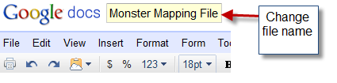.
- Scroll down and change the name of “Name/Organization” under BASIC INFORMATION from “Our Organization” to “Cryptid Research Group.”
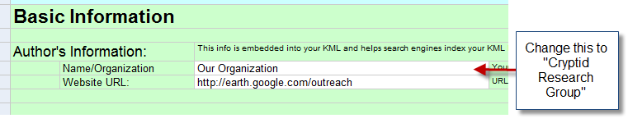
- In the upper right corner online spreadsheet, where it says SHARE, click on it, and select PUBLISH AS WEB PAGE. A section on the page says “Sheets to Publish,” below that click on “Start Publishing.” Then copy the link in the box below.
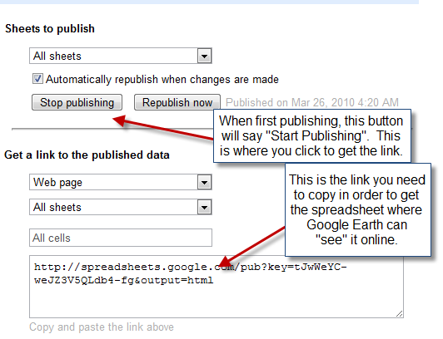
- Paste the link into cell C75, which is white in the spreadsheet.
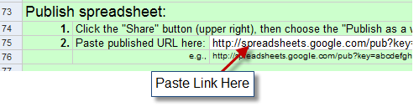
- Open Google Earth.
- Copy the link on the Google spreadsheet from cell C80.
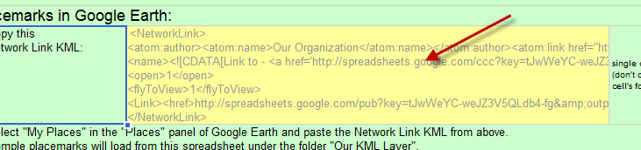
- In Google Earth, right click in the “Places” window on the “My Places” item and select paste. Your spreadsheet will be now be the Places table of contents, and the map will zoom to an area in California that has a bunch of colored place markers.
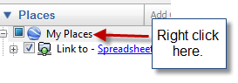
- Go back to the Google Mapper spreadsheet online and click on the down at the bottom where it says “PlacemarkData.” The spreadsheet will change to a new sheet.
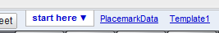
- Erase all of the text that is already in the cells from cell C11 to cell S22. These are placemarker examples that Google has left, but you don’t need them.
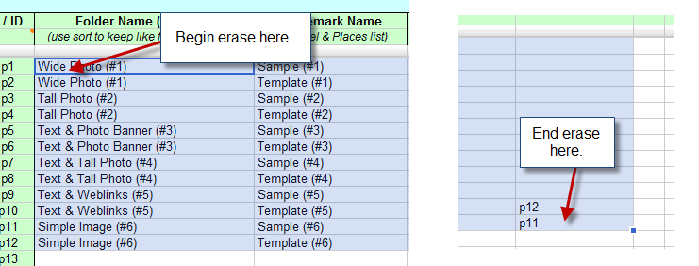

- Change the value in the TEMPLATE # cell (H10) to 4.
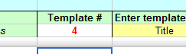
- Use the column labels that are shown in the spreadsheet in row 9 and 10 to paste in YOUR DATA from the cryptid spreadsheet that you have already created. To do this, select the column for example in your EXCEL spreadsheet titled “Creature/Mystery” (open it if it is not open now), but don’t copy the name of the title. In your spreadsheet, this will begin with cell B9.
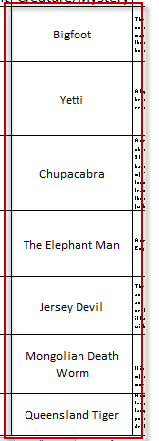
- Paste that into the GOOGLE MAPPER SPREADSHEET “Title,” which is in column I.
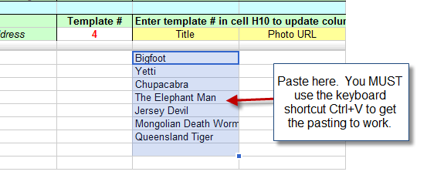
- Now do the same thing for all of your other data columns. The way that your spreadsheet data matches with the Google Mapper spreadsheet is as follows.
- Location Placemark Name
- LatitudeLatitude
- LongitudeLongitude
- DescriptionParagraph 1
- What is known of its existenceParagraph 2
- Picture LinkPhoto URL
- Read More LinkLearn More URL
- In the “Template #” column, be sure to make every entry 4 to mark the Google Mapper template type that you are using. Do not put a value in the table for any line except for the ones that have cryptid data in them.
- When you have all of the data, make sure to SAVE the Google Spreadsheet. In your Google Documents Spreadsheet go to File > Save. If it already says “Saved,” then it is saved and you don’t need to do anything else to save it.
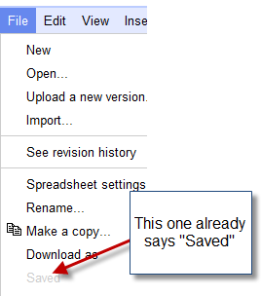
- You’re almost done. You first need to REPUBLISH your spreadsheet. To do this, go again to the upper right corner of the Google Docs spreadsheet and click on Share > Publish as Web Page > Republish Now.
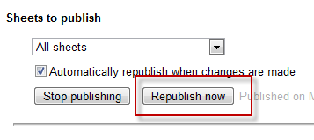
- The last step you need to do is REFRESH your link in Google Earth. Go back to Google Earth. Go to the Places window again. Right click where it says “Link to-Spreadsheet” and select “Refresh.” Google Earth should not load all of your points as it zooms to show them. Good job if you made it!
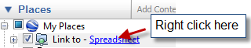

- To prove you are finished, save a new WORD DOCUMENT on the server called PROOF OF CRYPTID MAP with a screen shot that has one of your cryptid bubbles showing. To take a screen shot, press CTRL+PRT SC. Then select paste in your empty word document. he paste should look like this. Pick any cryptid you want for your screen shot.
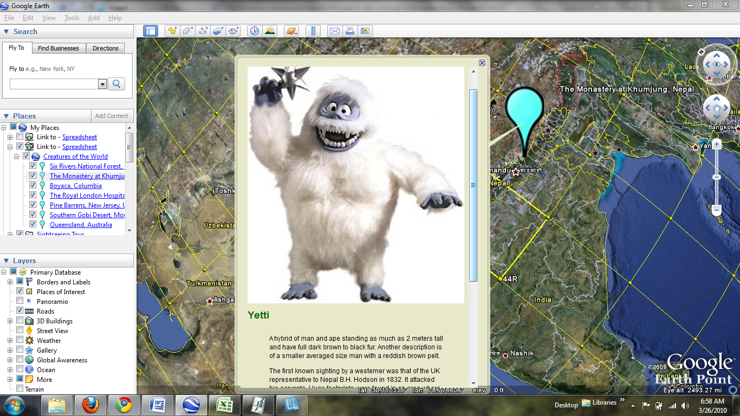
- Type your name at the top of the document and answer two questions by typing. Answer the following TWO QUESTIONS:
  - What interesting thing did you learn about Cryptids by doing this map that you did not already know?
  - What did you like/dislike/learn about creating your own map in Google Earth from this exercise?
- Show your map to the teacher and we’ll mark you off with a perfect score.

