Piezoelectric Quiz Answer Key
- Provide a brief explanation of the piezoelectric effect and the converse piezoelectric effect.
The piezoelectric effect converts mechanical energy into electrical energy.
The converse piezoelectric effect converts electrical energy into mechanical energy.

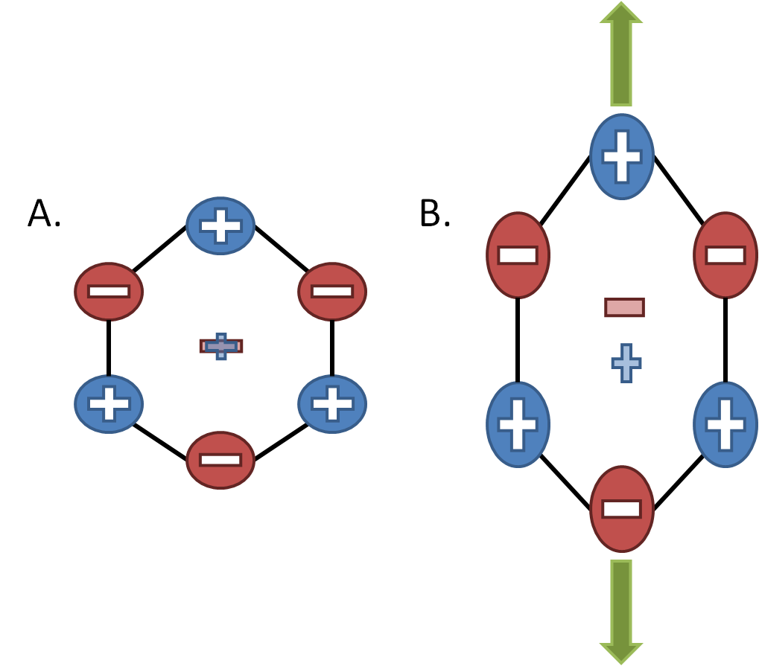
- Make a drawing to illustrate what causes the piezoelectric effect at the atomic level.
(Hint: Think about the placement of charges in the atoms of the material.)

- List three possible (conceptual or real) applications of piezoelectric materials.
Example answers: Sensors, actuators, speakers, artificial muscles, energy harvesting (piezoelectric sidewalks, clothes, roads, cars, etc.), light-up shoes, and many other possible applications.

Bonus Question: Explain your own, unique idea(s) for using piezoelectric materials.
Answers will vary.

