Investigating Friction Worksheet

In this investigation, we are going to examine how surface roughness affects friction. There will be three parts to this inquiry: We will investigate the effect of (1) surface roughness, (2) puck mass, and (3) solid additives by letting a puck slide down a slope.

Read the full set of instructions before attempting the experiments. Before every experiment, discuss the expected outcome.

Surface Roughness
- Locate the slopes that are covered with different grit sandpaper.
- Let the puck slide down each surface. Ensure that the pucks are not being pushed down.
- Measure the time it takes for the puck to travel the distance of A to B.
- Record your data in the corresponding table.
- Repeat each measurement three times.

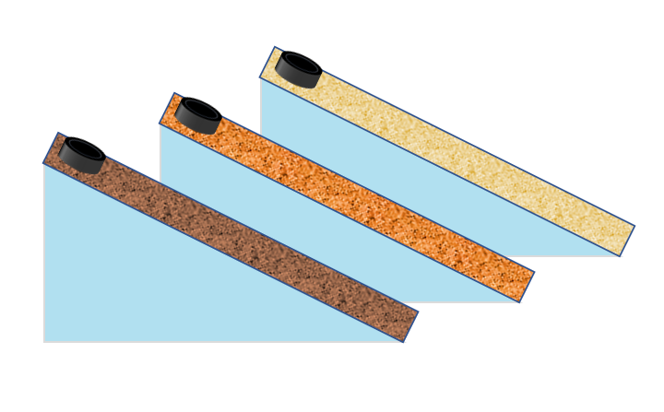

Mass
- Repeat the previous experiment. This time, use the puck with the larger mass.

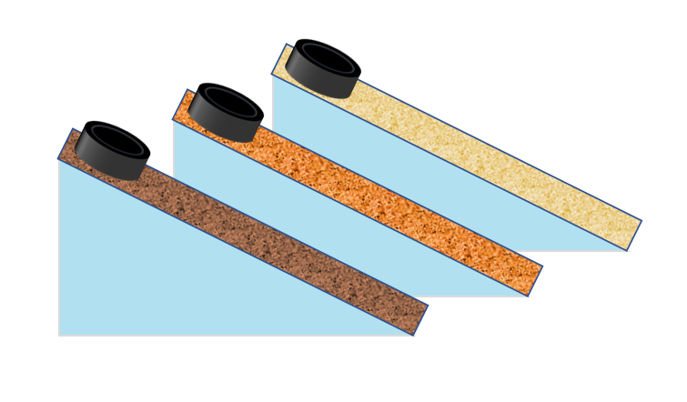

Solid Additives
- Sprinkle your choice of solid additive on each ramp.
- Repeat the experiment with three different solid additives.
- Clean the surface when switching additives.

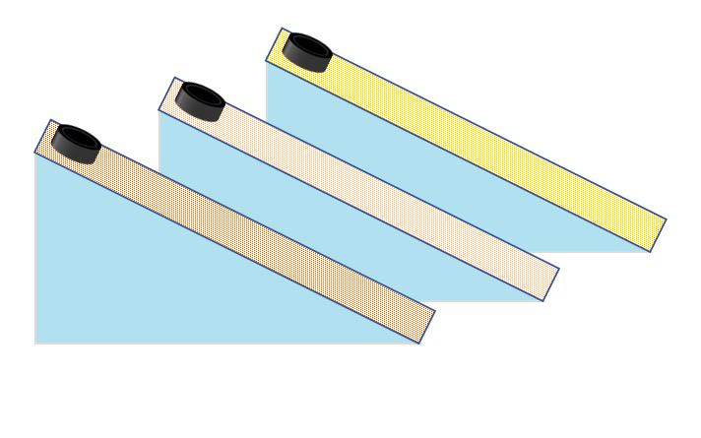

Datasheet (surface roughness)
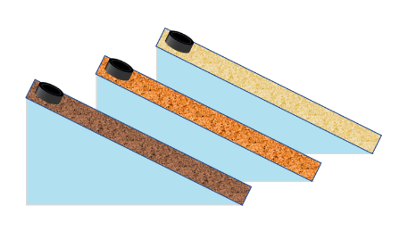
Puck mass (kg) =
Distance between A and B (m) =
 | Time between A and B (s) | $average speed= \frac{distance}{time}$ m/s
1 |  |  | Sandpaper grit =
2
3
average
1 |  |  | Sandpaper grit =
2
3
average
1 |  |  | Sandpaper grit =
2
3
average

Datasheet (Mass)
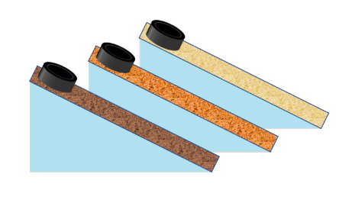
Puck mass (kg) =
Distance between A and B (m) =
 | Time between A and B (s) | $average speed= \frac{distance}{time}$ m/s
1 |  |  | Sandpaper grit =
2
3
average
1 |  |  | Sandpaper grit =
2
3
average
1 |  |  | Sandpaper grit =
2
3
average

Datasheet (Solid additives)
Puck mass (kg) =
Distance between A and B (m) =
 | Time between A and B (s) | $average speed= \frac{distance}{time}$ m/s
1 |  |  | Solid additive =
2
3
average
1 |  |  | Solid additive =
2
3
average
1 |  |  | Solid additive =
2
3
average

Conclusions
Based on your data, answer the following questions:

- If a surface has more friction, it takes ________ time for the puck to slide down a certain distance.
  - more
  - less

- In your investigation, which grit sandpaper has more friction?

- If you want a rougher surface, which grit sandpaper would you choose?
  - 80
  - 120

- What is the effect of puck mass on the descent time?

- How did the solid additives change friction?

- Summarize three things you learned from this investigation.

- Can you use this experimental setting to investigate another factor that alters friction? Describe how.

