Group 1
Testing the Selectivity of Common Polymers Lab Procedures
Intro: In this lab activity, you will test the selectivity of dialysis tubing/cell membrane with iodine and starch.
Assignment: Molecules to test: iodine and starch
Materials: 1- 250 ml beaker, 10 cm of dialysis tubing (that has been soaking in water), pipette, string, scissors
Note: All molecules you are testing are already prepared in solution and can be found labeled on the front lab bench.
Procedures: Follow the procedures below when creating your polymer setup.
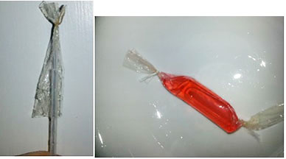  Dialysis tubing | To prepare your dialysis tubing samples, soak the dialysis tubing in water for a few minutes.  After a short water bath, manipulate the ends of the dialysis tubing open. Secure one open end of the DIALYSIS TUBING by TWISTING it shut and tying with a double-knotted string.  Use a pipette to add the starch solution, then TWIST the open end shut and secure it with a double-knotted string. Carefully place the filled dialysis tubing in the 250 ml beaker with 200 ml of iodine.

— — — — — — — — — — — cut — — — — — — — — — — —
Group 2
Testing the Selectivity of Common Polymers Lab Procedures
Intro: In this lab activity, you will test the selectivity of a grocery store bag with iodine and starch.
Assignment: Molecules to test: iodine and starch
Materials: 1- 250 ml beaker, grocery store bag CHECK FOR ANY HOLES, string, scissors
Note: All molecules you are testing are already prepared in solution and can be found labeled on the front lab bench.
Procedures: Follow the procedures below when creating your polymer setup.
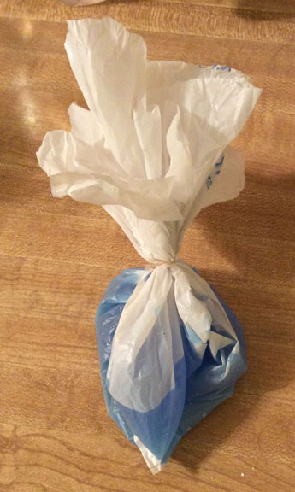 | Have one person hold the bag open and another person fill the bag with the starch solution.  Then TWIST the open end shut and secure it with a double-knotted string.  Carefully place the filled grocery store bag in your 250 ml beaker with 200 ml of iodine.

Group 3
Testing the Selectivity of Common Polymers Lab Procedures
Introduction: In this lab activity, you will test the selectivity of plastic wrap with iodine and starch.
Assignment: Molecules to test: iodine and starch
Materials: 1- 250 ml beaker, 30 x 30 cm square of plastic wrap, string, scissors
Note: All molecules you are testing are already prepared in solution and can be found labeled on the front lab bench.
Procedures: Follow the procedures below when creating your polymer setup.
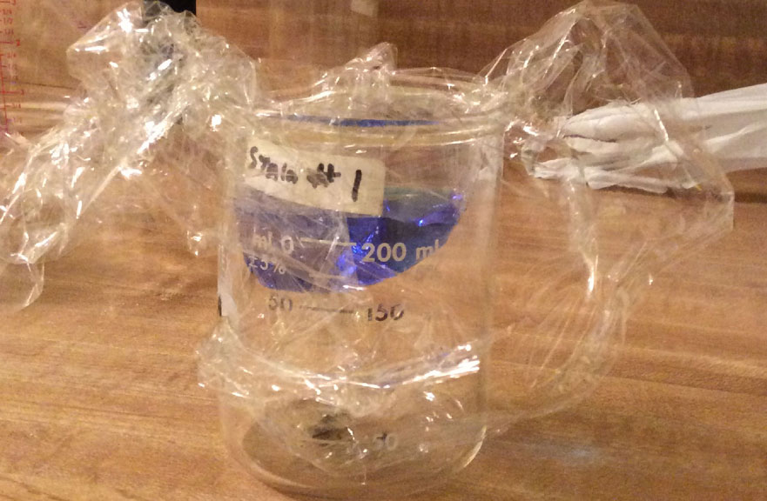  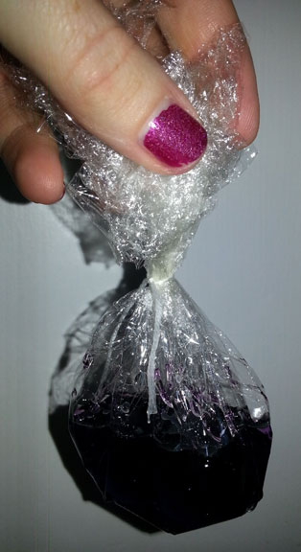 | Drape the plastic wrap over a beaker and carefully push the middle down into the beaker creating a bowl shape.  Make sure the sides of the plastic wrap are above the rim of the beaker.  Carefully pour the starch solution into the plastic wrap.  Carefully pull the plastic wrap up and out.  Twist the opening shut and secure it with a double-knotted string.  Carefully place the filled plastic wrap in the 250 ml beaker with 200 ml of iodine.

— — — — — — — — — — — cut — — — — — — — — — — —
Group 4
Testing the Selectivity of Common Polymers Lab Procedures
Intro: In this lab activity, you will test the selectivity of a grocery store bag with iodine and starch.
Assignment: Molecules to test: iodine and starch
Materials: 1- 250 ml beaker, 1 zipper bag
Note: All molecules you are testing are already pepared in solution and can be found labeled on the front lab bench.
Procedures: Follow the procedures below when creating your polymer setup.
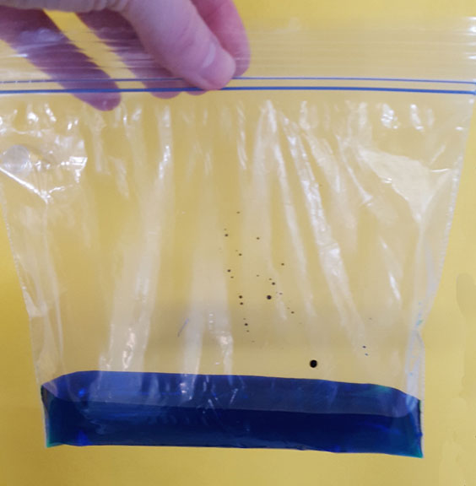  Zipper bag | Have one person hold open the bag and another person fill the bag with 30 ml of starch solution.  Close the zipper bag.  Carefully place the filled zipper bag in the 250 ml beaker with 200 ml of iodine.

Group 5
Testing the Selectivity of Common Polymers Lab Procedures
Intro: In this lab activity, you will test the selectivity of dialysis tubing/cell membrane with food coloring.
Assignment: Molecules to test: food coloring
Materials: 1- 250 ml beaker, 10 cm of dialysis tubing (that has been soaking in water), pipette, string, scissors
Note: All molecules you are testing are already prepared in solution and can be found labeled on the front lab bench.
Procedures: Follow the procedures below when creating your polymer setup.
Dialysis tubing | To prepare your dialysis tubing samples, soak the dialysis tubing in water for a few minutes. After a short water bath, manipulate the ends of the dialysis tubing open. Secure one open end of the dialysis tubing by TWISTING it shut and tying with a double-knotted string.  Use a pipette to add the food coloring solution then TWIST the open end shut and secure it with a double-knotted string.  Carefully place the filled dialysis tubing in the 250 ml beaker with 200 ml of tap water.

— — — — — — — — — — — cut — — — — — — — — — — —
Group 6
Testing the Selectivity of Common Polymers Lab Procedures
Introduction: In this lab activity, you will test the selectivity of a grocery store bag with food coloring.
Assignment: Molecules to test: food coloring
Materials: 1- 250 mL beaker, grocery store bag CHECK FOR ANY HOLES, String, and Scissors.
Note: All molecules you are testing are already prepared in solution and can be found labeled on the front lab bench.
Procedures: Follow the procedures below when creating your polymer setup.
Have one person hold the bag open and another person fill the bag with the food coloring solution.
Then TWIST the open end shut and secure it with a double-knotted string.
Carefully place the filled grocery store bag in the 250 ml beaker with 200 ml of tap water.

Group 7
Testing the Selectivity of Common Polymers Lab Procedures
Introduction: In this lab activity, you will test the selectivity of plastic wrap with food coloring.
Assignment: Molecules to test: food coloring
Materials: 1- 250 ml beaker, 30 x 30 cm square of plastic wrap, string, scissors
Note: All molecules you are testing are already prepared in solution and can be found labeled on the front lab bench.
Procedures: Follow the procedures below when creating your polymer setup.
Drape the plastic wrap over a beaker and carefully push the middle down into the beaker creating a bowl shape.
Make sure the sides of the plastic wrap are above the rim of the beaker.
Carefully pour food coloring solution into the plastic wrap.
Carefully pull the plastic wrap up and out.
Twist the opening shut and secure it with a double-knotted string.
Carefully place the filled plastic wrap in the 250 ml beaker with 200 ml of tap water.

— — — — — — — — — — — cut — — — — — — — — — — —
Group 8
Testing the Selectivity of Common Polymers Lab Procedures
Intro: In this lab activity, you will test the selectivity of a grocery store bag with yellow marker dye.
Assignment: Molecules to test: yellow marker dye
Materials: 1- 250 ml beaker, 1 zipper bag
Note: All molecules you are testing are already prepared in solution and can be found labeled on the front lab bench.
Procedures: Follow the procedures below when creating your polymer setup.
Zipper bag | Have one person hold the bag open and another person fill the bag with 30 ml food coloring solution.  Close the zipper bag.  Carefully place the filled zipper bag in the 250 ml beaker with 200 ml of tap water.

Group 9
Testing the Selectivity of Common Polymers Lab Procedures
Intro: In this lab activity, you will test the selectivity of dialysis tubing/cell membrane with blue marker dye.
Assignment: Molecules to test: blue marker dye
Materials: 1- 250 ml beaker, 10 cm of dialysis tubing (that has been soaking in water), pipette, string, scissors
Note: All molecules you are testing are already prepared in solution and can be found labeled on the front lab bench.
Procedures: Follow the procedures below when creating your polymer setup.
Dialysis tubing | To prepare your dialysis tubing samples, soak the dialysis tubing in water for a few minutes.  After a short water bath, manipulate the ends of the dialysis tubing open.  Secure one open end of the dialysis tubing by TWISTING it shut and tying it with a double-knotted string.  Use a pipette to add tested blue marker dye solution then TWIST the open end shut and secure it with a double-knotted string.  Carefully place the filled dialysis tubing in the 250 ml beaker with 200 ml of tap water.

— — — — — — — — — — — cut — — — — — — — — — — —
Group 10
Testing the Selectivity of Common Polymers Lab Procedures
Introduction: In this lab activity, you will test the selectivity of a grocery store bag with blue marker dye.
Assignment: Molecules to test: blue marker dye
Materials: 1- 250 ml beaker, grocery store bag CHECK FOR ANY HOLES, string, and scissors.
Note: All molecules you are testing are already prepared in solution and can be found labeled on the front lab bench.
Procedures: Follow the procedures below when creating your polymer setup.
Have one person hold the bag open and another person fill the bag with the blue marker dye solution.
Then TWIST the open end shut and secure it with a double-knotted string.
Carefully place the filled grocery store bag in the 250 ml beaker with 200 ml of tap water.

Group 11
Testing the Selectivity of Common Polymers Lab Procedures
Introduction: In this lab activity, you will test the selectivity of plastic wrap with blue marker dye.
Assignment: Molecules to test: blue marker dye
Materials: 1- 250 ml beaker, 30 x 30 cm square of plastic wrap, string, scissors
Note: All molecules you are testing are already prepared in solution and can be found labeled on the front lab bench.
Procedures: Follow the procedures below when creating your polymer setup.
Drape the plastic wrap over a beaker and carefully push the middle down into the beaker creating a bowl shape.
Make sure the sides of the plastic wrap are above the rim of the beaker.
Carefully pour the blue maker dye into the plastic wrap.
Carefully pull the plastic wrap up and out. Twist the opening shut and secure it with a double-knotted string.
Carefully place the filled plastic wrap in the 250 ml beaker with 200 ml of tap water.

— — — — — — — — — — — cut — — — — — — — — — — —
Group 12
Testing the Selectivity of Common Polymers Lab Procedures
Introduction: In this lab activity, you will test the selectivity of a grocery store bag with blue marker dye.
Assignment: Molecules to test: blue marker dye
Materials: 1- 250 ml beaker, 1 zipper bag
Note: All molecules you are testing are already prepared in solution and can be found labeled on the front lab bench.
Procedures: Follow the procedures below when creating your polymer setup.
Zipper bag | Have one person hold the bag open and another person fill the bag with 30 ml of blue marker dye solution.  Close the zipper bag.  Carefully place the filled zipper bag in the 250 ml beaker full of 200 ml of tap water.

Group 13
Testing the Selectivity of Common Polymers Lab Procedures
Intro: In this lab activity, you will test the selectivity of dialysis tubing/cell membrane with yellow marker dye.
Assignment: Molecules to test: yellow marker dye
Materials: 1- 250 ml beaker, 10 cm of dialysis tubing (that has been soaking in water), pipette, string, scissors
Note: All molecules you are testing are already prepared in solution and can be found labeled on the front lab bench.
Procedures: Follow the procedures below when creating your polymer setup.
Dialysis tubing | To prepare the dialysis tubing samples, soak the dialysis tubing in water for a few minutes.  After a short water bath, manipulate the ends of the dialysis tubing open.  Secure one open end of the dialysis tubing by TWISTING it shut and tying it with a double-knotted string.  Use a pipette to add yellow marker solution then TWIST the open end shut and secure it with a double-knotted string.  Carefully place the filled dialysis tubing in the 250 ml beaker with 200 ml of tap water.

— — — — — — — — — — — cut — — — — — — — — — — —
Group 14
Testing the Selectivity of Common Polymers Lab Procedures

Introduction: In this lab activity, you will test the selectivity of a grocery store bag with yellow marker dye.
Assignment: Molecules to test: yellow marker dye
Materials: 1- 250 ml beaker, grocery store bag CHECK FOR ANY HOLES, string, scissors
Note: All molecules you are testing are already prepared in solution and can be found labeled on the front lab bench.
Procedures: Follow the procedures below when creating your polymer setup.
Have one person hold the bag open and another person fill the bag with the yellow marker solution.
Then TWIST the open end shut and secure it with a double-knotted string.
Carefully place the filled grocery store bag in the 250 ml beaker with 200 ml of tap water.

Group 15
Testing the Selectivity of Common Polymers Lab Procedures
Introduction: In this lab activity, you will test the selectivity of plastic wrap with yellow marker dye.
Assignment: Molecules to test: yellow marker dye
Materials: 1- 250 ml beaker, 30 x 30 cm square of plastic wrap, string, scissors
Note: All molecules you are testing are already prepared in solution and can be found labeled on the front lab bench.
Procedures: Follow the procedures below when creating your polymer setup.
Drape the plastic wrap over a beaker and carefully push the middle down into the beaker creating a bowl shape.
Make sure the sides of the plastic wrap are above the rim of the beaker.
Carefully pour yellow marker dye solution into the plastic wrap.
Carefully pull the plastic wrap up and out.
Twist the opening shut and secure it with a double-knotted string.
Carefully place the filled plastic wrap in the 250 ml beaker with 200 ml of tap water.

— — — — — — — — — — — cut — — — — — — — — — — —
Group 16
Testing the Selectivity of Common Polymers Lab Procedures
Intro: In this lab activity, you will test the selectivity of a grocery store bag with yellow marker dye.
Assignment: Molecules to test: yellow marker dye
Materials: 1- 250 ml beaker, 1 zipper bag
Note: All molecules you are testing are already prepared in solution and can be found labeled on the front lab bench.
Procedures: Follow the procedures below when creating your polymer setup.
Zipper bag | Have one person hold the bag open and another person fill the bag with 30 ml of marker dye solution.  Close the zipper bag.  Carefully place the filled zipper bag in the 250 ml beaker with 200 ml of tap water.

