Top Inventions of the Year

Excerpted from: https://time.com/collection/best-inventions-2020/#design

Steadier Power Chairs
LUCI / $8,445
Preorder at luci.com
Power wheelchairs can be a lot more dangerous than they look. The devices, which weigh up to 400 lb., are prone to tips and collisions, sometimes resulting in serious injuries like broken bones. Barry Dean, a songwriter in Nashville, saw this firsthand when his daughter Katherine, who lives with cerebral palsy, suffered leg and arm injuries when her chair tipped over. So Dean and his engineer brother created LUCI ($8,445), a power-chair accessory that uses sensors to monitor the chair’s environment. As riders steer their chair with a joystick, LUCI collects data that determines safe paths and modifies the chair’s response, like slowing down before an unexpected drop-off or halting to prevent a collision. An associated app, the MyLUCI portal, allows users to track and share data such as their chair’s charging status and location. The power-chair accessory will be available at mobility clinics in the U.S. in November. —Paulina Cachero

A More Comfortable Socket
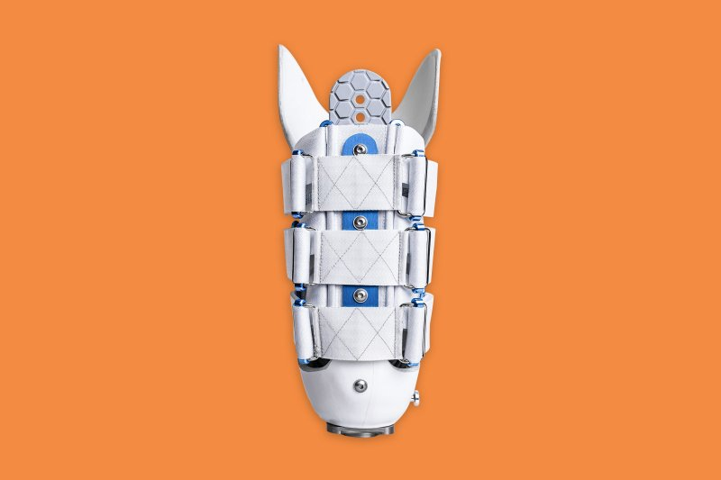 Socket-less Socket
Martinbionics.com
Thanks to microprocessors and robotics, artificial limbs have hit new heights of innovation. But the socket— the molded plastic piece that attaches prosthesis to person—hasn’t made such major strides. Until now. The Socket-Less Socket replaces the often uncomfortable molded plastic fittings of more standard prostheses with a custom set of straps and bindings that can be tightened or loosened as needed. “It’s the difference between wooden clogs and carbon-fiber shoes,” says Martin Bionics founder Jay Martin. Traditional sockets offer one hour of comfort before they need to be removed to adjust padding, cool down or address areas of rubbing. The Socket-Less Socket stays comfy for more than three. Covered by Medicaid and most insurance carriers (depending on the policy, co-pays range from zero to about $2,000), the device costs about the same as the old plastic sockets it seeks to replace. —Marjorie Korn

A Refuge for Bees
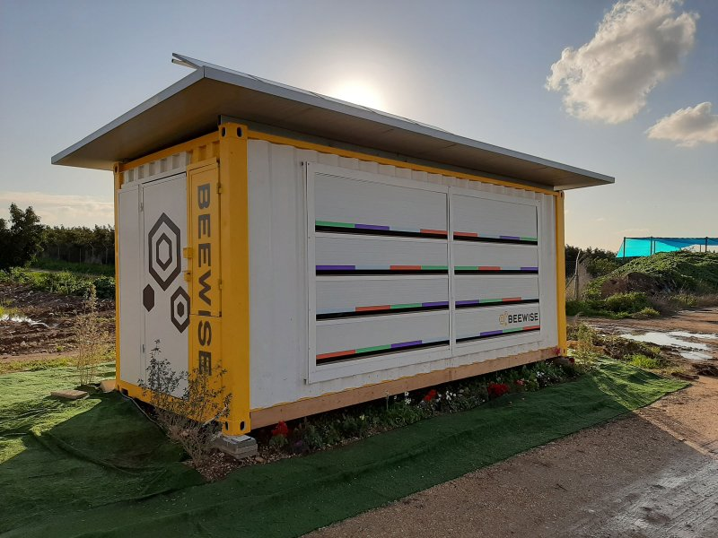
Beewise Beehome / $15 a month
Available early 2015
An astonishing 40% of bees die every year as a result of disease, pesticides and climate change—in part because busy commercial beekeepers miss warning signs. That’s where Beewise, an artificial-intelligence-powered hive, comes in. Using precision robotics, computer vision and AI, a Beehome—which costs $15 a month and might host 2 million bees—monitors the insects 24/7. When a hive is exposed to, say, parasites or experiences irregular temperatures, its internal systems respond immediately by applying pesticides, for example. Use of the smart technology can double pollination capacity and honey production, while decreasing colonies’ mortality rate. “Not only do bees not die,” says Saar Safra, Beewise’s CEO. “They thrive.” —Mélissa Godin

The Smartphone that Puts Privacy First
Augmedics xvision
Contact augmedics.com for more information
It all started when Augmedics CEO Nissan Elimelech got a superhero-inspired idea: Wouldn’t it be cool if surgeons had X-ray vision? Several years of R&D produced the next best thing: xvision, a headset that uses augmented reality to turn a patient’s CT scan into a 3-D visualization that helps guide a spinal surgeon through operations in which every millimeter counts. The headset superimposes a 3-D image of a patient’s spine over their body, allowing surgeons to (almost) see what’s under the skin without ever looking away from the operating table. Cleared by the FDA in December 2019, the device is already in use at top U.S. hospitals like Johns Hopkins and Rush University Medical Center. —Jamie Ducharme
A Greener Running Shoe
Allbirds Tree Dasher / $125
Order at allbirds.com
Running shoes are incredibly wasteful, relying heavily on oil-based synthetics like plastic. The Allbirds Tree Dasher is made almost entirely from natural materials, with a carbon footprint estimated at almost a third lower than that of the average sneaker. But using eucalyptus, merino wool, castor-bean oil and sugarcane isn’t just about “stuffing nature into a performance shoe and hoping that it doesn’t degrade the performance,” says Jad Finck, Allbirds’ vice president of innovation and sustainability. Instead, these materials actually boost performance: the eucalyptus fibers are cooling, the wool regulates temperature, and the sugarcane midsole provides performance cushioning. And while the Tree Dasher is not meant for marathons, the shoes— priced at $125—are well suited for a weekend jog or a morning dash to the grocery store. —Sanya MansoorSince the prototype first appeared on Kickstarter earlier this year, ~63,000 backers have contributed $13.3 million to make it a reality.
Futuristic Fashion
Vollebak Full Metal Jacket / $1,095
Available at vollebak.com
Can a jacket fight a virus? The answer might be yes—especially if it’s made of copper, an element proven to kill particles from viruses like influenza A and bacteria like E. coli. The Full Metal Jacket ($1,095), an innovative garment recently released by experimental clothing company Vollebak, may offer a glimpse into our sartorial future. About 65% of the lightweight jacket’s total material is composed of microscopic copper fiber that, if laid out in a straight line, would cross 11 km (6.8 miles). Although the Full Metal Jacket isn’t tested and wasn’t intended for defense against the coronavirus, Vollebak co-founder Steve Tidball hopes it will nonetheless serve as inspiration for a day when more of our clothing is made of materials that can also protect us. — Jason Cipriani

The Germ Trapper
FEND by Sensory Cloud, Inc. / $60
Available at hellofend.com
Every day, you inhale countless potentially infectious particles. If one gets past the mucus lining in your upper airway and enters the lungs, you could get sick. When you exhale respiratory particles, others are also put at risk. For more than a decade, Harvard aerosols expert David Edwards has been working on what he calls the nasal “equivalent to washing your hands” to reduce these risks. He thinks he’s found it in FEND ($60), a drug-free salt- and calcium-based nasal mist that strengthens the mucus lining, helping it trap and flush out tiny pathogens. In a preliminary study, people who used FEND exhaled about 75% fewer aerosol particles than those who didn’t, suggesting it could be a worthy addition to the disease-prevention arsenal, along with handwashing, masking and social distancing. —Jamie Ducharme
Hands-Free Brushing
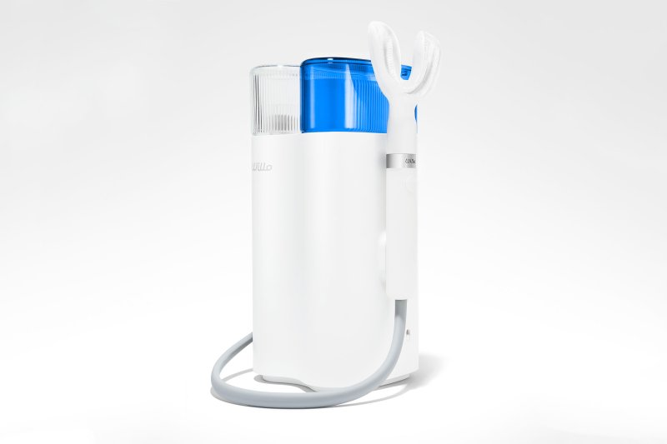
Willo / $199
Available at pillpack.com
Created by a French dentist, Willo makes even the fanciest electric toothbrushes seem analog. Slip the nylon-bristle-lined silicon tray into your mouth, form a seal with your lips and turn it on. The $199 device—set for release in early 2021—pumps in water and specially formulated toothpaste, then pulls it from the tray through a tube into a sink. No rinsing required. The undulating bristles do the work of a team of toothbrushes, and the pumping action, which feels like a gum massage, is effective at removing plaque. Willo syncs with an app, so it knows how consistently you’re brushing. Missed a day? It’ll clean your pearly whites a little longer tomorrow. —Marjorie Korn

The Ultimate Cooler

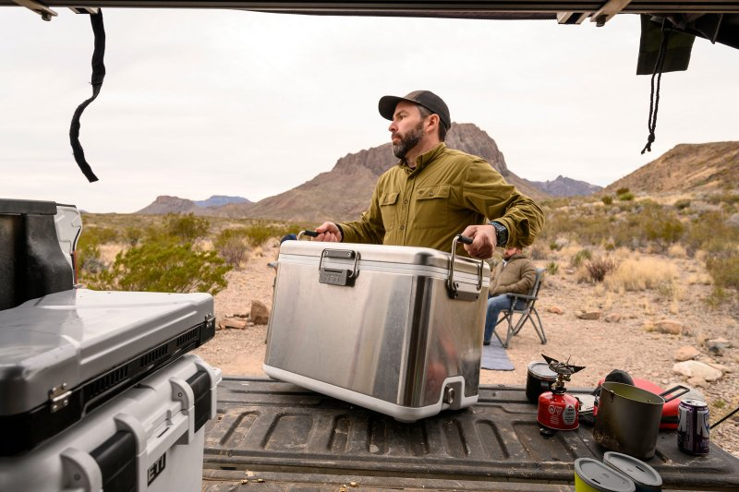
YETI V Series / $800
Available at YETI.com
Lamenting that the gorgeous stainless-steel ice chests of midcentury have been cost-engineered nearly out of existence, the team at Texas-based YETI decided to build their own, sparing no expense: the stainless-steel-clad YETI V Series, an $800 hard-sided cooler that weighs 35 lb. empty and can keep 46 cans of beer chilly for many, many days after your last tailgate guests have left. Its secret is vacuum-insulated panels, which keep the internal temperature lower for longer, yet allow for more space inside. “Over the course of several engineering builds, we probably destroyed over a hundred samples,” says YETI manager Evan Goldberg. The result might just last for decades. — Jesse Will

A Crib That Calms
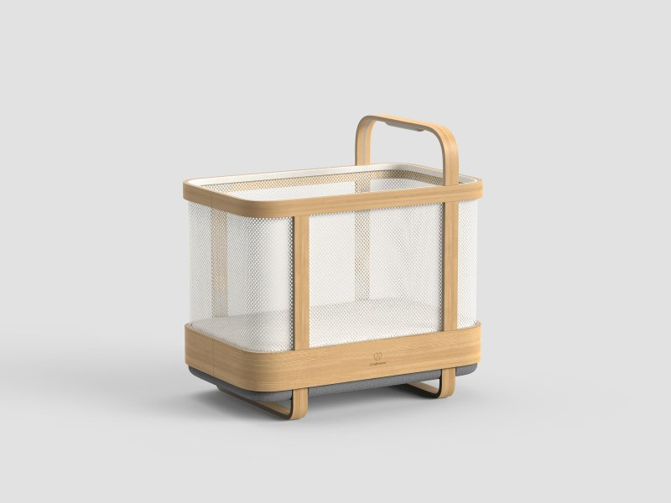
Cradlewise Smart Crib / $1,500
Preorder at cradlewise.com
Roughly 60% of 6-month-olds fail to sleep through the night. Enter Cradlewise ($1,500), an AI-powered smart crib and bassinet. Most self-rocking cradles respond when a baby cries, but Cradlewise uses sensors to detect a child’s first stirrings. Based on the baby’s sleep schedule, the crib then determines whether to soothe them back to sleep with bouncing motions or to let them wake up. —J.R. Sullivan
The Smart Hard Hat
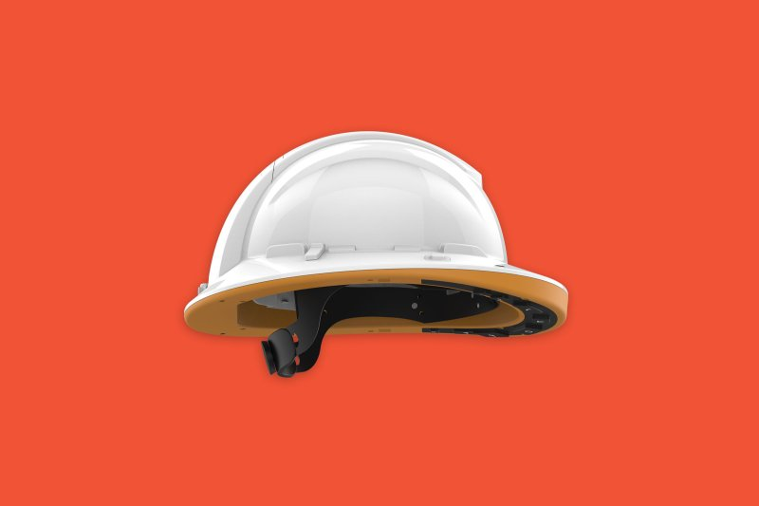
Guardhat HC1 Communicator / Starting at $1,500
guardhat.com
For centuries, the humble hard hat has protected workers from head injuries. But industrial workers also face other dangers at work sites, where heavy machinery, confined spaces and hazardous materials can lead to injuries and even deaths. Guardhat’s new tech-enabled hard hat, the HC1 Communicator, can help keep those workers safe. The Communicator monitors the wearer’s location in real time; allows them to make hands-free video and audio calls; and detects their proximity to hazardous materials, temperatures and moving equipment. Starting at $1,500, the high-tech hat isn’t cheap—but for teams looking to feel more secure while hard at work, it may be well worth it. —Mariah Espada

A Smoother Skate
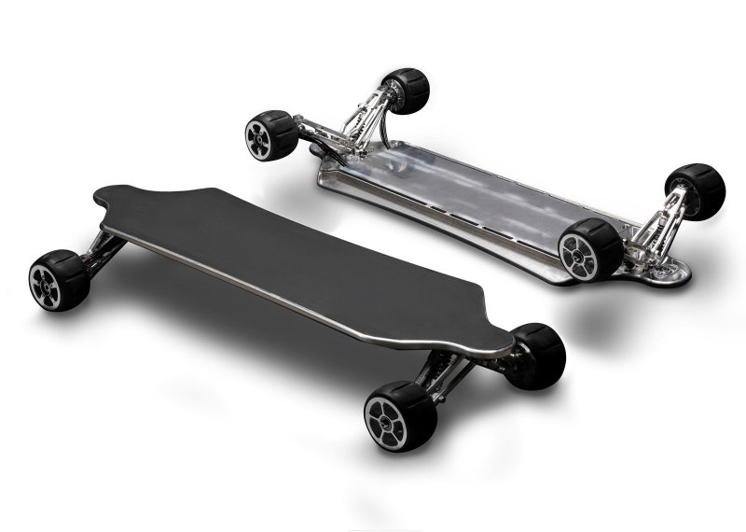
Hunter Board / Starting at $1,949
Available at hunterboards.com in January 2021

Electric skateboards do not lack for speed—but turn onto a bumpy road, and a smooth ride can fast become a smooth face-plant onto the sidewalk. Thanks to an independent suspension system, which helps absorb vibrations before they reach your feet, the Hunter Board ($1,949) makes even bumpy cobblestones light work.“In the end, that translates into confidence,” says Pedro Andrade, Hunter’s CEO. With a pair of motors that can hit speeds of up to 34 m.p.h. and a battery designed for replacement on extra-long rides, the board’s extra stability comes in handy. —Patrick Lucas Austin

The Robot Suit
Sarcos Robotics Guardian XO Full-Body Powered Exoskeleton / $8,500 monthly lease
Contact the team at sarcos.com
Decades after RoboCop filled moviegoers’ heads with cyborg-suit fantasies, science has finally delivered: next year, the Salt Lake City firm Sarcos Robotics will release the Guardian XO—one of the first commercially available full-body powered exoskeletons ($8,500 monthly lease). The exoskeleton—an earlier iteration of which was recognized in TIME’s 2010 list of Best Inventions—is effectively a wearable robot shell that enables wearers to lift as much as 200 lb. It’s designed to prevent on-the-job injuries by reducing the strain of manual labor, and boasts as much as six hours of battery life. —J.R. Sullivan

Light Up the Campsite
Yakima CBX Solar/ $1,299
Available at yakima.com
A camping trip no longer means going completely off the grid with Yakima’s new CBX Solar rooftop cargo box. Topped with durable Sunflare solar panels, the $1,299 carrier is equipped with two USB ports and can power your campsite on an overnight trip or keep your devices charged—without having to use your car battery. “We were seeing people add solar panels to their cargo boxes, and wanted one that looked a little more polished,” says Evan Hampton, Yakima’s senior category manager. “It gives you a way to power your Bluetooth speaker at a trailhead before or after a hike or après-ski at the parking lot of a resort.” Plus, with 16 cu. ft. of storage space, the CBX Solar has more than enough room to hold your skis, snowboards, hiking gear or that last duffel you can never quite manage to squeeze into the trunk. —Simmone Shah

A Biodegradable Grill
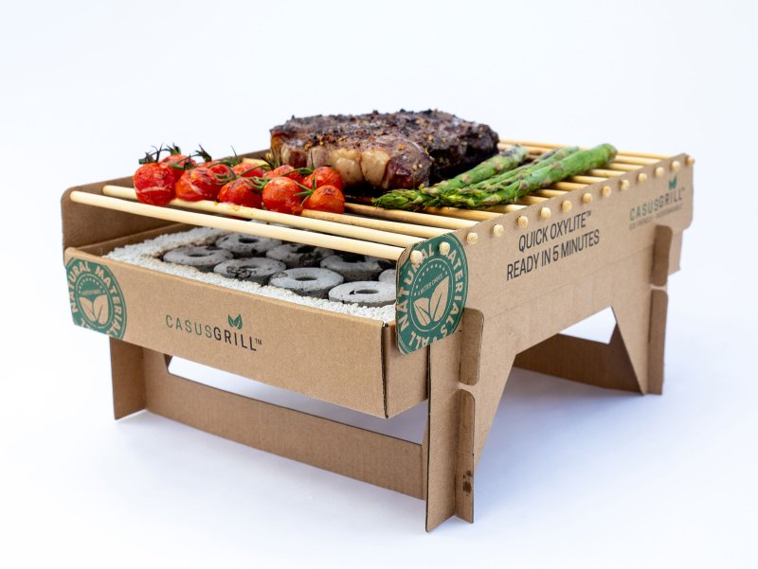CasusGrill / $20
Available at CasusGrill.com

Disposable foil grills may be fun for BBQ sessions on the fly, but they wreak havoc on the environment. The cardboard, bamboo and lava-stone CasusGrill ($20), on the other hand, is fully biodegradable. The single-use grill is the brainchild of Carsten Nygaard Brogger, who created the device and perfected its unusual flame-free bamboo charcoal in his Copenhagen kitchen. Light four corners of the briquette grid and the coals will smolder, ashing over within minutes and hitting 600°F without a blaze. After its 60-minute cooking time is up, simply dig a hole and bury the Casus. Your memories of a picnic will linger longer than the grill does underground. —Jesse Will
The Ultimate Indoor Garden
j
Gardyn / $799 with additional monthly fee
Available at mygardyn.com
If you want a garden but lack a backyard, consider a Gardyn instead. The AI-powered vertical indoor-growing system lets you choose from 32 fruits, vegetables, greens, herbs and flowers that will ripen right in your living room. Load the seedpods into Gardyn ($799, with an additional monthly fee for membership and seed delivery), and its companion app monitors light, humidity and soil saturation, keeping tabs on growth via cameras to let you know when the crops are ready. Getting kids to eat a salad is a lot easier when they harvest the greens themselves, so feel free to ask them to chip in and help nurture your new garden: founder FX Rouxel made Gardyn with parents (and the family dinner table) in mind. —Marjorie Korn

