Worksheet: Windshield Wipers, Pacemakers and RC Circuits

PART 1: Use the PhET simulation Circuit Construction Kit: AC to design and test simple voltage divider series and parallel circuits.
PART 2: Identify the components in an RC circuit; compare the behavior of series and parallel RC circuits; and construct and test an RC circuit using the PhET simulation
PART 3: Describe the nature of capacitors

OBJECTIVE - Design and test various circuits to fit the engineering constraints of the challenge and verify the expected relationships between voltage and current graphically.

BACKGROUND - Circuits are the paths that electricity can take to perform a desired task (work.) Electricity can be stopped by using a switch to open and close the circuit. Electricity can be described by its various features voltage - its force (measured in volts), current-the rate electricity flows(measured in amps) and the resistance in the circuit - the friction it experiences (measured in ohms).

PART 1 - PRE-ACTIVITY - Familiarize yourself with the simulation
PROCEDURE:
Use the following simulation to design the circuits described in each of the challenges.
Select the Lab tab 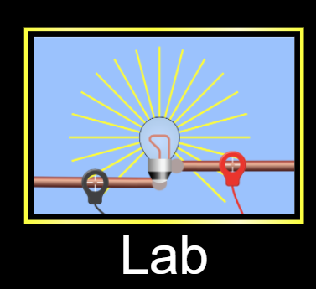

You will change this to start or stop the simulation.

Use the voltmeter and ammeter to gather data 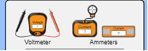and
the voltage chart and current chart to view your results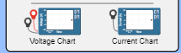

Answer any questions in the challenge to record your observations and analysis.

ENGINEERING CHALLENGE #1 - Single (series) circuit

Create a circuit using 1 battery, 1 switch, two resistors, and 1 wire.
If all circles at the end of the parts(components) turn black, you have correctly attached them.

Close the switch to create a closed circuit if the blue charges move (current flows.)

YOU SUCCEEDED in this challenge.!!!

Insert a screenshot of your circuit. Label it “Series Circuit”

Can you rearrange the parts(components) of your circuit to create multiple paths for the electricity to flow through all the parts?___________

On the same screen, complete Engineering Challenge #2 so you can compare the circuits.

ENGINEERING CHALLENGE #2 - Multiple path (parallel) circuit
Create a circuit using 1 battery, 1 switch, two resistors, and 3 wires so the electrons flow (electricity moves) through each resistor separately and continues to flow only if the switch is closed.

If all circles at the end of the parts(components) turn black, you have correctly attached them.

After closing the switch (creating a closed circuit), if you remove just one resistor at a time and the blue charges keep moving (current flows), YOU SUCCEEDED in this challenge.!!!

Insert a screenshot of your circuit. Label it “Parallel Circuit”

ANALYSIS
How does electron flow differ going through the components of a series and a parallel circuit?___________

COMPONENTS (PARTS)
SWITCH
What position must the switch be to allow the electricity to flow?__________

BATTERY
Click on the battery in one of your circuits (so a yellow frame appears) to answer the following:
(REMEMBER to close the circuit before answering)
How does clicking on this button change the flow of electrons? ___________
How does changing the voltage change the flow of electrons?___________

RESISTOR
Click on a resistor in one of your circuits(so a yellow frame appears) to answer the following:
(REMEMBER to close the circuit before answering)

How does changing the resistance change the flow of electrons? ___________

ANALYSIS
Does maximizing the resistance in ONE resistor change the motion of electrons in the same way in both circuits you created? Explain your observations.__________

Compare the results of changing the resistance of ONE resistor to 0 ohms in each circuit you created. Explain your observations.__________

PROBES
Place the tips of the probes of the voltmeter in the black circles on each component (part) both circuits.
The ? disappears once you find the correct location.

What do you note about the readings if you reverse the red and black probes on the voltmeter locations?___________.

Record your readings
Voltage across | Battery | Resistor 1 | Resistor 2 | Wire
In _______ Circuit
In _______ Circuit

Move the ammeter probe (the ) over the center of wire or components (parts) on both circuits.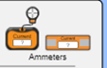
The ? disappears once you find the correct location.

Record your readings:
Current in | Battery | Resistor 1 | Resistor 2 | Wire
In _______ Circuit
In _______ Circuit

Describe the difference in current readings when resistors are in a series circuit or a parallel circuit.__________________________

CHARTS
Like the probes, note the voltage chart is created with two probes since voltage is measured across components (parts). The current chart is created with one probe since current is in components of circuits.

Place the probes of the charts in the same locations as you did the probes on the voltmeter and ammeter and observe the shape of the graph as you open and close the switch on each circuit..

Insert screenshots of graphs from both circuits include these labels.

- Chart name:
- Circuit observed: Series
- Component measured.
- Number of times the switch was opened and closed.
- Insert screenshots of graph here

Chart name:__________
Circuit observed: Parallel
Component measured.__________
Number of times the switch was opened and closed.__________
Insert screenshots of graph here

Chart name:__________
Circuit observed: Series
Component measured.__________
Number of times the switch was opened and closed.__________
Insert screenshots of graph here

Chart name:__________
Circuit observed: Parallel
Component measured.__________
Number of times the switch was opened and closed.__________
Insert screenshots of graph here

ANALYSIS
Describe the shape of the graph drawn in both the voltage and current charts.
__________
PART 2 - RC Circuits

ENGINEERING CHALLENGE #3
Create a circuit using 1 battery, 1 switch, 1 resistor, 1 capacitor, 1 lightbulb and 2 wires.

If all circles at the end of the parts(components) turn black, you have correctly attached them.

When you close the switch (creating a closed circuit), IF the blue charges move (current flows) you have correctly attached the components. REMEMBER to build the circuit with the switch open until you are ready to test the circuit.

BLOW OUT UPGRADE: Insert a screenshot of your circuit where the battery catches on fire and the light explodes.

What happened to the capacitor in this circuit?___________

RC Series Circuit -

Testing series RC Circuit
Insert a screenshot of a series circuit using ONLY the supplies listed above. Remember the electricity can only flow through one path, While building the circuit keep the switch open until you are ready to test the circuit. It is okay to keep rebuilding the circuit to make your observations if it is too hard to see everything at once.

Record observations after the circuit is closed.:

OBSERVATION
Current
Lightbulb
Capacitor

Click on the battery to get the yellow frame and this window:

Describe two ways you could change the battery traits listed in the blue box to get the current moving again and the light to turn back on when the circuit is closed. ______________________________

MINI LESSON
Current that changes direction is called AC (alternating current.)
Current that only goes in one direction is called DC (direct current.)

RC Parallel Circuit -
Testing parallel RC Circuit

Normally, the parts of circuits are represented by symbols in an illustration called a schematic
Use this tab below the parts window on the left to identify the parts in this parallel circuit schematic.
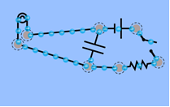

Identify the names of the components in the schematic above in the table below.

Symbol | Name
 | Wire

PROCEDURE

Build the parallel RC circuit illustrated above using pictures or symbols. REMEMBER to build the circuit with the switch open until you are ready to test the circuit. Observe the current as you open and close the switch.

Insert a screenshot of your circuit.

Using sentences describe the circuit you constructed.
____________________________________________

Why do you think it is called a RC circuit? ____________________________________________

CHARTS

Like the probes, note the voltage chart is created with two wires since voltage is measured across components (parts). The current chart is created with one wire since current is in components of circuits.

Place the wires of the charts in the same locations as you would the probes on the voltmeter and ammeter and observe the shape of the graph as you open and close the switch. You can use the voltmeter and ammeter to verify you are getting a reading before placing the probes for the charts in those locations, if needed.

Insert Screenshots of graphs from the circuit include these labels.

Chart name:___________
Circuit observed: Parallel
Component measured.___________
Number of times the switch was opened and closed.___________
Insert screenshots of graph here

ANALYSIS

Describe the shape of the graph drawn in both the voltage and current charts on the parallel circuit as you open and close the circuit.
__________

ACTIVITY 3 - Coulomb’s Law and Capacitors

Using this simulation, study the nature of capacitors.

Select this tab 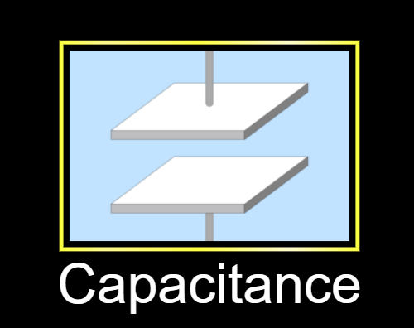

OBJECTIVE: Students will relate the nature of capacitors to Coulomb’s Law

BACKGROUND: Coulomb’s Law relates the magnitude of charges and distances between them to the electrostatic forces between them. The capacitance of a capacitor is the ratio of charge stored on the plates to the resulting voltage (potential difference) between the plates of the capacitor. Capacitance is directly proportional to the electrostatic force field between the plates.

PROCEDURE - Familiarize yourself with the simulation

Select Capacitance tab, Stored energy, Plate Charges, and Bar Graphs

- What are the units for Capacitance? ________________

- What are the units for Stored Energy?________________

- What type of circuit is used in this simulation?________________

- Does the simulation start with an open or closed circuit?_______________

- What is the effect of changing the distance between plates on capacitance?________________

- What is the effect of changing the plate area on capacitance?________________

- What is the effect of changing the voltage on the battery on capacitance?________________

Open the Circuit and observe the changes in capacitance. You select other changes and make observations to complete the table.

Change | Change in Capacitance
Decrease distance between plates
Decrease plate area
Increase battery voltage to 1.5 v

Coulomb’s Law states that increase in distance between plates decreases the electrostatic force between the charges. What data did you collect that supports this claim?________________

Coulomb’s Law states that an increase in charge increases the electrostatic force between the charges. Capacitance is directly proportional to the electrostatic force field between the plates. Voltage is a measure of electromotive force that pushes a current through a circuit.

Insert two screenshots where one shows few charges on the plates and the reading on the voltmeter and the second screenshot that shows many charges on the plates and the reading on the voltmeter. (Remember the probes must touch different plates to get a reading.) The ? disappears once you find the correct location.

ANALYSIS
Describe the pattern seen in the screenshots you inserted.____________________

Did the capacitance change for your two screenshots? ________

Was this an expected result? Why or why not?____________________

Insert two screenshots where you have only charged the distance between the plates and the reading on the voltmeter.Remember the probes must touch different plates to get a reading.) The ? disappears once you find the correct location.

ANALYSIS
Describe the pattern seen in the screenshots you inserted.____________________

Did the capacitance change for your two screenshots? ________

Was this an expected result? Why or why not?____________________

