Let’s Get Breezy!
Post-Activity Assessment Answer Key
- With a partner, create a flow chart to explain the formation of land and sea breezes.
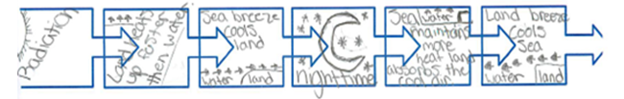

Give a 5-minute presentation on your flow chart. Revise if needed.
- Answer the following questions:
- What are disadvantages scientists or other researchers might face because of not having access to environmental remote sensors to collect data from remote locations?
Example answer: If researchers must travel to remote locations to collect data, it delays the collection and analysis of data. Remote locations may be hazardous to humans, such as areas with active volcanoes.

- Describe a situation in which you need to collect information quickly using a wireless device. Describe the type of information that you are trying to collect and describe a device that could be used to expedite the process of getting that information faster.
Example answer: Collecting homework information from a friend via a wireless cellular device or internet would be easier than walking to his house, ringing the door bell and waiting for him to answer.

- Based on today’s activity about wireless sensors, how can engineers help scientists and other researchers collect data quickly and accurately?
Example answer: By improving current technology to collect more accurate data faster. Or create new devices that would increase the reliability and accessibility of collecting data.

- How do you think engineers can improve their current remote wireless temperature probe design?
Answers will vary. Accept all logical responses that deal with the hardware or reliability of the temperature probe, and reduced interference with other sensors, etc.

- For what other real-world applications do you think it is important for engineers to design environmental remote sensors?
Answers may vary wildly. Example answer: Engineers could use environmental remote sensors to improve the way they collect seismic wave activity to study tsunamis or tectonic plate movements related to earthquakes.

