Catching the Perfect SAR Waves – Understanding the Problem
ANSWER KEY

- What is a wave?
A wave is a continuous oscillation of energy in space time.
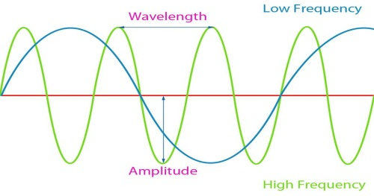
- Draw wave with a low frequency and one with a high frequency.

- List the seven electromagnetic radiation waves in order from low frequency to high frequency.
Radio, Microwave, Infrared, Visible, Ultraviolet, X-ray, Gamma Ray

- For each wave listed above, approximate the size of each wavelength in terms of an object.
Buildings, Humans, Honey Bee, Pinpoint, Protozoans, Molecules, Atoms

- What does the acronym RADAR stand for?
Radio Detection and Ranging
- Draw a diagram of how a radar system works. Use the keywords transmitter, receiver, antenna, target, and radar display to label your drawing.
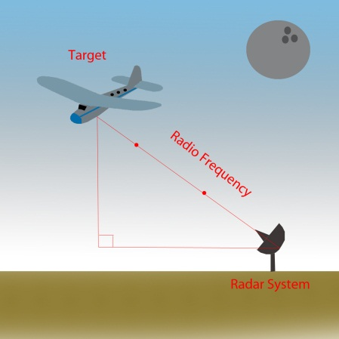

A Radar System is composed of an antenna, a transmitter, a receiver, and a display. The transmitter produces an RF pulse of energy that is propagated by the antenna. A receiver captures, amplifies, and demodulates the backscatters. The radar image is displayed on the indicator.
- What is the difference between Synthetic Aperture Radar and Inverse Synthetic Aperture Radar?
In the synthetic aperture radar model, the radar is mounted onto a flying
platform and sends radio waves to ground targets. For inverse synthetic
aperture, the radar is stationary and sends radio waves to moving targets.

- Fill in the missing word: Essentially, radar systems are ______________ calculating devices.
Distance
- The Pythagorean Theorem is only applied to what type of angles?

Triangles with one 90 degree angle – Right Triangles
- Give the formula for the Pythagorean Theorem, the representation of each variable, and what we can use it for.

a² + b² = c²
a, b are the short legs and c is the hypotenuse of a right triangle

- In your own words, restate the problem in slide number 11 (Rise to the Challenge).

We are NASA aviation engineers asked to construct, calibrate, and evaluate

the latest Radar system design within four days.

- List the engineering technologies that electrical engineers use to design SAR systems.

Electrical engineers use electronics, electromagnetics, and image processing technologies to design SAR systems.

- Given that SAR technology provides structural information to geologists and target information for military operations, what other functions may SAR technology provide? Consider a gulf coast oil spill.

SAR technology provides information on oil spill boundaries on water to environmentalists.

