Measuring Refraction: Thin Films Worksheet
Refraction Review Problems
- Light travels through a vacuum at a speed of 3 x 10⁸ m/s.
Determine the speed of light in the following materials:
- water (n = 1.333)
- crown glass (n = 1.52)
- cubic zirconia (n = 2.16)
- diamond (n = 2.419)
- A ray of light travels through air (n = 1.00) and approaches the boundary with water (n = 1.33). The angle of incidence is 45.0°. Determine the angle of refraction.
- During a physics lab, Ray Zuvlight observes a laser line passing through an unknown material towards a boundary with air with an angle of incidence of 24.5°. The light ray emerges into the air with an angle of refraction of 33.8°. Determine the index of refraction of the unknown material.
- Light in air approaches the boundary of oil at an angle of 36.1 degrees with respect to the normal. The light travels at a speed of 2.27 x 10⁸ m/s through the oil. Determine the angle of refraction.
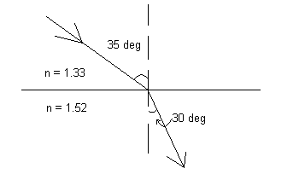
- Suppose light travels from water (n = 1.33) into crown glass (n = 1.52) at an angle of 35° relative to the normal. Draw the path of that the light ray will take in this scenario. Label each substance.

- Now suppose we mix another substance into the crown glass and change its composition. After doing so, we notice that the angle at which light is refracted in the crown glass has decreased. Did the index of refraction of the glass go up or down? Explain your answer.

When Biosensors Talk
- Look at your nail polish film from various angles. What do you see? In other words, what changes do you observe when you look at the film from different angles?

- What causes the film to look different when viewed from different angles?

- What would you expect to see if light was refracted inside our film at a different angle?

- What would happen to the colors we see if we made our sample thicker?

- What would happen to the wave pattern if we put another material in the pores on the sample’s surface? Hint: What parameter changes if I put something in the pores?

Final Problem
Suppose you have biosensor made from a porous thin film engineered to bind with a specific, potentially cancerous gene. You place the film in a sample solution with a patient’s DNA (which will bind to the film if the gene is present) then measure the reflectance, and notice that shorter wavelengths of light have a higher percentage reflectance than before exposing it to the patient’s DNA.
- Does the patient have the potentially cancerous gene? Explain your answer in complete sentences, and draw a labeled picture illustrating your explanation.

- Suppose light entered the sample from air (n = 1) at an angle of 30°. If the light was refracted in the film at an angle of 20°, what is the index of refraction of the film?

