Interpreting Graphs Worksheet Answer Key

1. Given the graph below, answer the following questions:
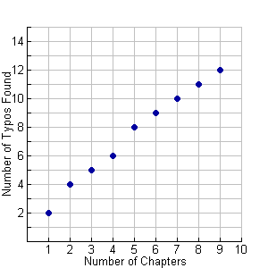

- What is the independent variable for this graph?

The independent variable is the number of chapters.

- What is the dependent variable for this graph?

The dependent variable is the numbers of typos found.

- What can you assume about the relationship between number of chapters in a book and the amount of typos found?

Based on the graph’s trend, I can assume that as the number of chapters in a book increases, the number of typos found in the book also increases.

- About how many typos would you assume to be in a book with 10 chapters?

Based on the graph, I would estimate about 13 typos in a book with 10 chapters.

2. Given the graph below, answer the following questions:
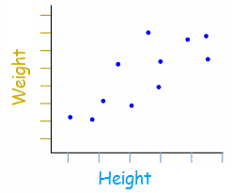

- What is the independent variable for this graph?
The independent variable is height.

- What is the dependent variable for this graph?
The dependent variable is weight.

- Write a two-sentence explanation for what the graph is attempting to describe.

The graph describes the relationship between a person’s height and a person’s weight. The graph’s trend shows that taller people tend to be heavier, while shorter people tend to weigh less.

- Assume that the increments for weight are 20 pounds, starting with 50 pounds, and the height increment is by 5 inches, starting with 50 inches. What would you expect a person to weigh if s/he was 80 inches tall?
Based on the graph, I would assume that a person that is 80 inches tall would weight about 220-230 pounds.

- Draw a line on the graph that you believe represents the best fit for weight and height.
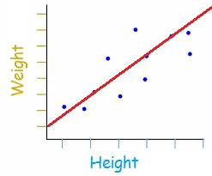

3. The graph below shows the relationship between students’ quiz averages over a semester and their final exam grades.

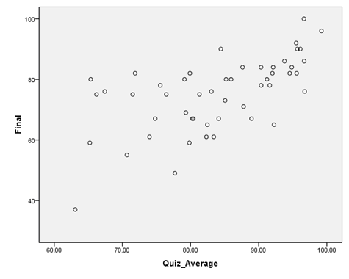

- What is the independent variable for this graph?

The independent variable is the quiz average.

- What is the dependent variable for this graph?

The dependent variable is the final exam grade.

- Write a two-sentence explanation for what the trend of the line is showing, given the two variables.

The graph’s trend shows the relationship between the quiz average for a student and the student’s grade on the final exam. In general, the trend of the graph shows that students with higher quiz averages score higher on the final exam.

- Provide at least three data points on the graph.

Example answer: Three data points include: (63, 36), (80, 60) and (95, 85).

- With a straight line, connect the data point at the far left with the data point at the top right. Does this line best represent the data? Explain.

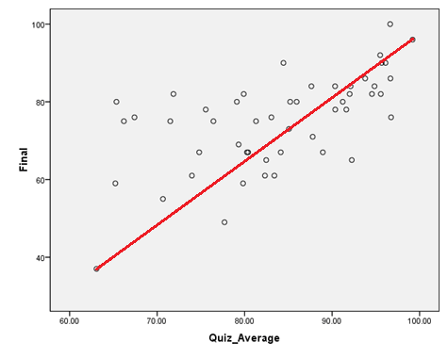

This line appears to be a relatively good best fit line. Although more data appears to be scattered above the line, which suggests that if the line was adjusted to have a slightly steeper slope or to have a greater y-intercept, it might be a better fit.

