Worksheet 1: Reference Diagram

Initial potential energy
Next potential energy max, note that it is lower than the initial point.

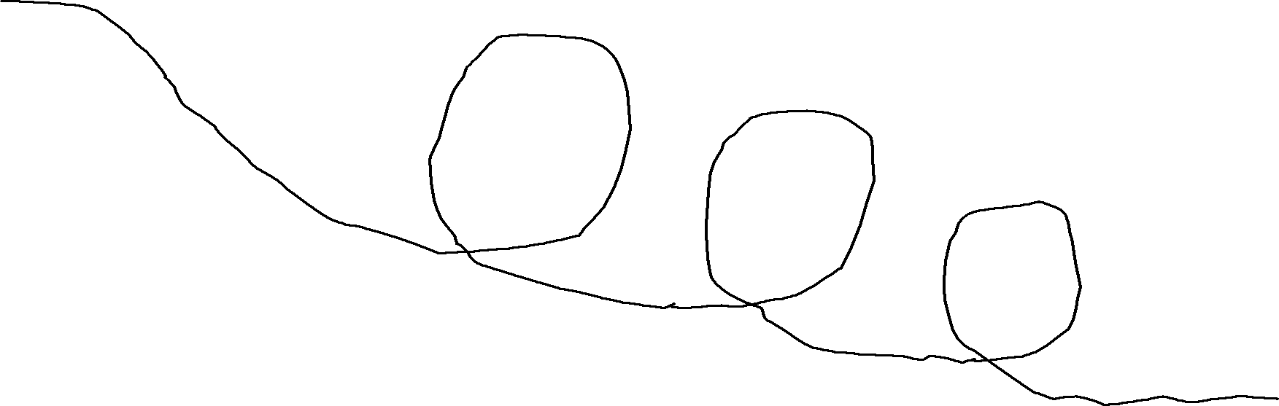

H
5

H
3

H
2

H
4

Kinetic
energy
point A
H
1

Kinetic
energy
point B

Ideal Kinetic Energy at point A KE = PE = (mass) x (H₁ – H₂) x (gravity)

Ideal Kinetic Energy at point B KE = PE at H₃ + KE at H₃
= (mass) x (H₃ – H₄) x (gravity) + (mass) x (velocity at H₃ )² / 2

If the marble has little or no velocity at H₃ then the kinetic energy is negligible and the kinetic energy at point B is a function of the potential energy, or height difference from the top of the previous loop-de-loop to the start of the next one.

