Portable Wheelchair Ramp Packet

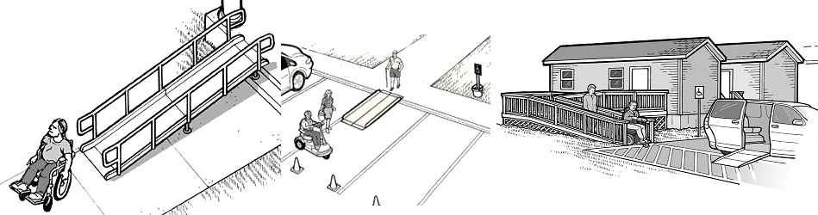
http://www.ada.gov/votingchecklist.htm; http://www.ada.gov/emergencyprepguide.htm

Define the following terms
Structural engineering: _______________________________________________
___________________________________________________________________
___________________________________________________________________
___________________________________________________________________
Universal design: ____________________________________________________
___________________________________________________________________
___________________________________________________________________
___________________________________________________________________
Assistive device: _____________________________________________________
___________________________________________________________________
___________________________________________________________________
___________________________________________________________________
Introduction
Your best friend has recently lost the ability to use his/her legs and now relies on a wheelchair for mobility. Her/his parents have added ramps to their house to make access easier, but it is very difficult for your friend to visit your home and the homes of other friends where ramps are not permanently installed.
Client Statement
Create a portable ramp that can make typical houses and other buildings temporarily handicap accessible. The ramp should be light, easy to transport, easy to operate, safe and versatile.
Problem Statement (Define the problem in detail) ___________________________________________________________________
___________________________________________________________________
___________________________________________________________________
___________________________________________________________________
___________________________________________________________________
___________________________________________________________________
Revised Problem Statement (Definition of the problem in detail including client modifications) ___________________________________________________________________
___________________________________________________________________
___________________________________________________________________
___________________________________________________________________
___________________________________________________________________
___________________________________________________________________

Functions (what the product does)
___________________________________________________________________
___________________________________________________________________
___________________________________________________________________
___________________________________________________________________
___________________________________________________________________
___________________________________________________________________
Objectives (What the product is)
___________________________________________________________________
___________________________________________________________________
___________________________________________________________________
___________________________________________________________________
___________________________________________________________________
___________________________________________________________________
Constraints (The product must or must not)
___________________________________________________________________
___________________________________________________________________
___________________________________________________________________
___________________________________________________________________
___________________________________________________________________
___________________________________________________________________

Background Research
As homework, use the internet to research current wheelchair ramp designs, wheelchair ramp standards, ramp materials, and other related topics. Record relevant material and the source websites.

Design Solutions (Sketch and describe 3 possible solutions)
Design #1 ___________________________________________________________________
___________________________________________________________________
___________________________________________________________________
___________________________________________________________________
___________________________________________________________________
___________________________________________________________________
___________________________________________________________________
___________________________________________________________________
___________________________________________________________________

Design #2 ___________________________________________________________________
___________________________________________________________________
___________________________________________________________________
___________________________________________________________________
___________________________________________________________________
___________________________________________________________________
___________________________________________________________________
___________________________________________________________________
___________________________________________________________________

Design #3 ___________________________________________________________________
___________________________________________________________________
___________________________________________________________________
___________________________________________________________________
___________________________________________________________________
___________________________________________________________________
___________________________________________________________________
___________________________________________________________________
___________________________________________________________________

Prototype Creation (describe why you chose the design you did)
___________________________________________________________________
___________________________________________________________________
___________________________________________________________________
___________________________________________________________________
___________________________________________________________________
___________________________________________________________________
Test Design
- Place the ramp prototype between two desks.
- Use the load applicator to apply increasing weights to your ramp.
- Apply weight to the middle of the ramp until the device holds the minimum required weight based on the problem statement.
Test Results
(Description of test results) __________________________________________________
___________________________________________________________________
___________________________________________________________________
___________________________________________________________________
___________________________________________________________________
___________________________________________________________________

Evaluation of Results (Was your design effective? How do you know?)
___________________________________________________________________
___________________________________________________________________
___________________________________________________________________
___________________________________________________________________
___________________________________________________________________
___________________________________________________________________
___________________________________________________________________
___________________________________________________________________
___________________________________________________________________

Future Recommendations (What you would recommend for future research)
___________________________________________________________________
___________________________________________________________________
___________________________________________________________________
___________________________________________________________________
___________________________________________________________________
___________________________________________________________________
___________________________________________________________________
___________________________________________________________________
___________________________________________________________________

