Wristwatch Design for the Visually Impaired
Activity – Engineering Design Process Packet – Sample
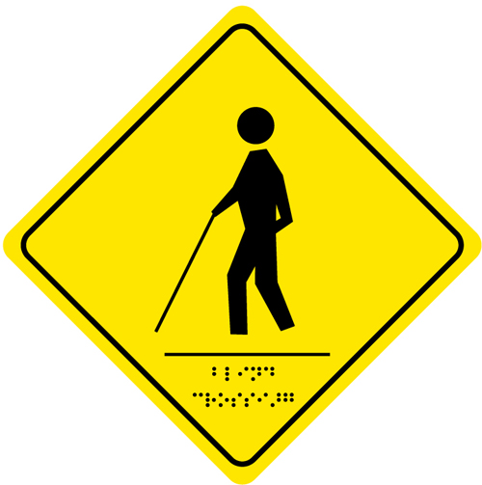
Client Statement
Time Incorporated, a leading watch manufacturing company in New England whose target audience is the young adult consumer (11-19-years old), has hired you, the engineers of Rising Star Academy. A recent development in the school of the owner’s children has given her the idea to develop a new wristwatch: a watch designed to help people with severe visual impairment. Your challenge is to develop a new wristwatch that fits the average 11-19-year old person, looks good, and is easy to understand. The number one goal of this product is to help young adults with visual impairment feel more independent.
Problem Statement (Define the problem in detail)
Design a wristwatch for an 11-19 year-old person who is blind and deaf. The completed watch should look “good” to the average young adult, having an appearance similar to a traditional wristwatch. The watch should be easy to understand and be safe for a person to wear during typical daily activities.
Functions (The action that the design or product is created for)
The wristwatch should be able to:
- tell time to the nearest 5 minutes
- be read without the sense of sight or hearing
- fit the average 11-19 year old person
Objectives (The attributes of the design or product)
The wristwatch should be able to:
- tell time to the nearest 5 minutes
- be read without the sense of sight or hearing
- fit the average 11-19 year-old person
Constraints (restrictions or limitations)
- The wristwatch must be safe to wear
- The wristwatch must tell time to the nearest five minutes
- The wristwatch wearer must not need the sense of sight or hearing to tell time
Background Research
Use the internet to research telling time, wristwatches, how clocks work, visual impairment and other related topics. Make sure to keep a record of relevant material and the website(s) you used for research.
Design Solutions
On a piece of graph paper, sketch three (minimum) possible design solutions. Discuss each design with team members. Create a pros and cons T-chart for each design on the backside of your design sketch.
Designs will vary
Creation of Prototype (describe your selected design and why you chose the design you did)
I/we selected to use design #2. We chose this design because it seemed to convey the time in a very simple way. The design utilizes braille numbers arranged around a traditional clock face. The person using the watch would open the protective cover to feel the hour and minute hands and the number to which they are pointing.
Test Design
Develop a 3-4 question survey to evaluate the effectiveness of your wristwatch design. The survey should evaluate the visual appeal of the wristwatch, the ease of understanding and at least one other focus area. Have five people evaluate your group’s wristwatch design
Test Results
Write out survey questions below. Use complete sentences. | Survey 1 | Survey 2 | Survey 3 | Survey 4 | Survey 5 | Average Score
On a scale of 1-10 how comfortable is the wristwatch? | 8 | 9 | 8 | 7 | 8 | 8
On a scale of 1-10 how appealing is the general watch design? | 9 | 5 | 8 | 8 | 8 | 7.6
On a scale of 1-10 how easy would it be for a person the tell time? | 7 | 5 | 5 | 6 | 6 | 5.8
Evaluation of Results (Based on the test results was your design effective? How do you know?)
Based on the results from our survey, I believe that our wristwatch had mixed reviews. With an average score of 8, the wristwatch proved to be very comfortable. The general appearance of the watch received mediocre results with a score of 7.6. Unfortunately, the watch had a very low score of 5.8 on the telling of time. The level of difficulty that people experienced may be a result of their dependency on the sense of sight. We would like to test this design with a person who can already read braille.

Future Recommendations (Based on the test results and your evaluation of the results, what you would recommend for improvements to your design, why would you make the selected changes)
Based on the low score that the wristwatch received in telling time, we would recommend changing the design. We believe that the design could be simplified to a single dot at each hour location, and a double dot at the typical 12 location. This simplified layout would reduce the complexity of trying to read braille.
Sketch any design changes in the space below (be sure to label parts of watch):

Identify the person (or group) who filled each role during the design process.

