Triple-Entry Bones Vocabulary Worksheet Answer Key

Word  …and where you have heard it before… | Definition  In your own words! | Memory aid or sketch
cranium | The part of the skull that encloses the brain. | 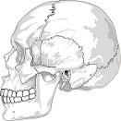  Image source: http://pixabay.com/en/skull-cracked-head-skeleton-side-31060/
mandible | The lower part of the jaw | 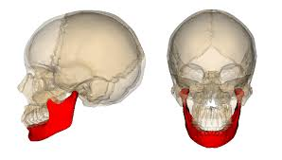  Image source: http://commons.wikimedia.org/wiki/File:Mandible_bone.png
clavicle | The collarbone; between scapula and sternum; makes up part of the shoulder | 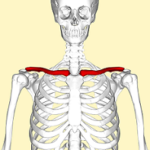  Image source: http://en.wikipedia.org/wiki/Clavicle
scapula | The shoulder blade; connects the humerus (upper arm bone) with the clavicle (collarbone) | 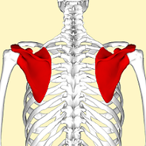  Image source: http://en.wikipedia.org/wiki/Scapula
vertebral column | The backbone or spine | 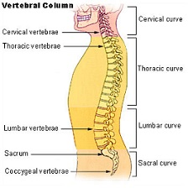  Image source: http://en.wikipedia.org/wiki/Vertebral_column
sternum | The breast plate; along with the ribs, forms the protective rib cage | 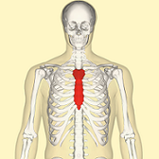  Image source: http://en.wikipedia.org/wiki/Sternum
ribs | A series of curved bones that are articulated with the vertebrae, and occur in pairs | 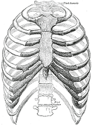  Image Source: http://en.wikipedia.org/wiki/Rib
humerus | The long bone in the upper arm, connecting the shoulder and the elbow | 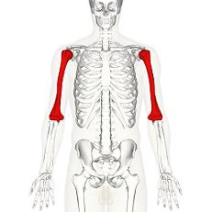  Image source: http://en.wikipedia.org/wiki/Humerus
radius | The smaller, shorter long bone in the lower arm, between the elbow and the thumb-side of the wrist | 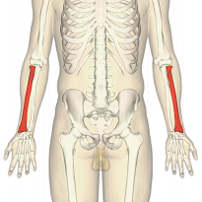  Image source: http://en.wikipedia.org/wiki/Radius_(bone)
ulna | The larger, longer long bone in the lower arm, on the side of the pinky finger | 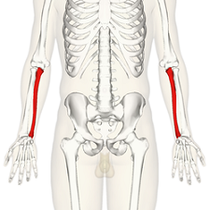  Image source: http://en.wikipedia.org/wiki/Ulna
pelvic girdle | Lower hip bones | 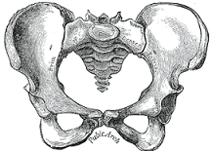  Image source: http://en.wikipedia.org/wiki/Human_pelvis
femur | Strongest and longest bone in the body, upper leg bone | 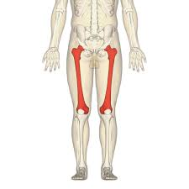  Image source: http://en.wikipedia.org/wiki/Femur
patella | The kneecap; flat triangular bone at front of knee joint | 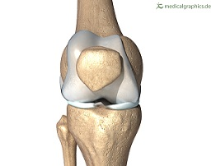  Image source: http://www.medicalgraphics.de/en/free-pictures/skeleton/knee-bones-front.html
fibula | The outer, thinner lower bone in the leg | 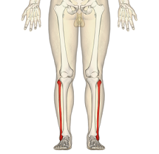  Image source: http://en.wikipedia.org/wiki/Fibula
tibia | The larger and stronger bone below the knee in the leg | 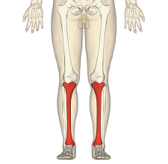  Image source: http://en.wikipedia.org/wiki/Tibia
carpus  (carpal bones) | Cluster of eight bones making up the wrist | 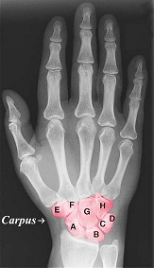  Image source: http://en.wikipedia.org/wiki/Carpus
metacarpus (metacarpal bones) | Five long bones, connecting each finger to the wrist | 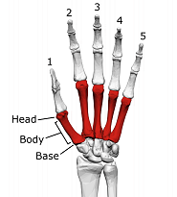  Image source: http://en.wikipedia.org/wiki/Metacarpus
tarsus  (tarsal bones) | Cluster of seven bones, making up the ankle, heel, and arch of the foot | 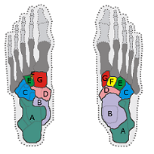  Image source: http://en.wikipedia.org/wiki/Tarsus_(skeleton)
metatarsus (metatarsal bones) | Five long bones, connecting each of the toes to the ankle | 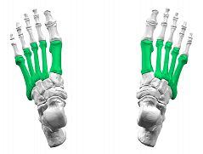  Image source: http://en.wikipedia.org/wiki/Metatarsus
phalanges | The fingers and toes | 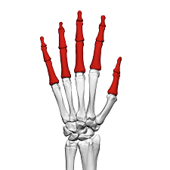  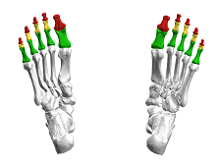  Image sources: http://commons.wikimedia.org/wiki/File:Phalanges_of_the_hand_(left_hand)_02_dorsal_view.png and http://commons.wikimedia.org/wiki/File:Phalanges_of_the_foot05_inferior_view.png

