Backyard Weather Station Activity –
Tool #1: Wind Vane Worksheet

Materials
Each group should have:
- One sheet of cardstock | - One full-sized pencil with full eraser
- A heavy marker | - One straight pin or T-pin
- One pair of scissors | - Small piece of modeling clay
- Glue (hot glue works best) | - Piece of cardboard (at least 12” x 12”)
- One plastic straw, non-bendable | - A compass

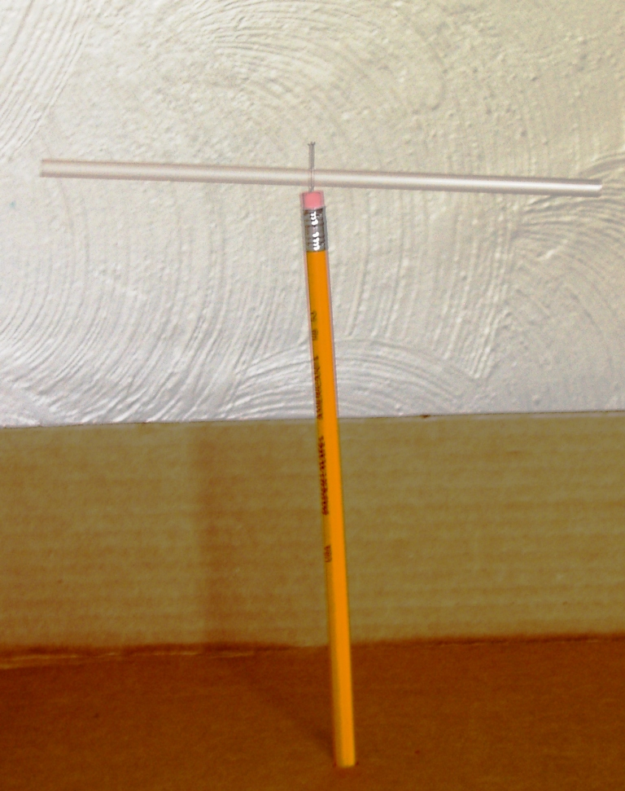
Instructions
- Push the pin through center of the straw.
- Insert into pencil eraser, making sure the straw has enough room to spin (see Figure at right).
- On a piece of cardstock, draw the shape of an arrow (see below). You can create multiple arrow shapes to test which shape works best in the wind.
- For each arrow design, cut two identical arrow shapes from the cardstock (as shown below).

- Glue one set of arrow shapes onto the sides of the straw so that the straight pin is between the shapes.
- Use a small piece of modeling clay to secure the pencil to the piece of flat cardboard (see picture below. (Note: Although shown on a piece of wood, you will affix the pencil to the cardboard instead).
- Check to make sure that the wind vane will spin and stand straight.
Using the Wind Vane
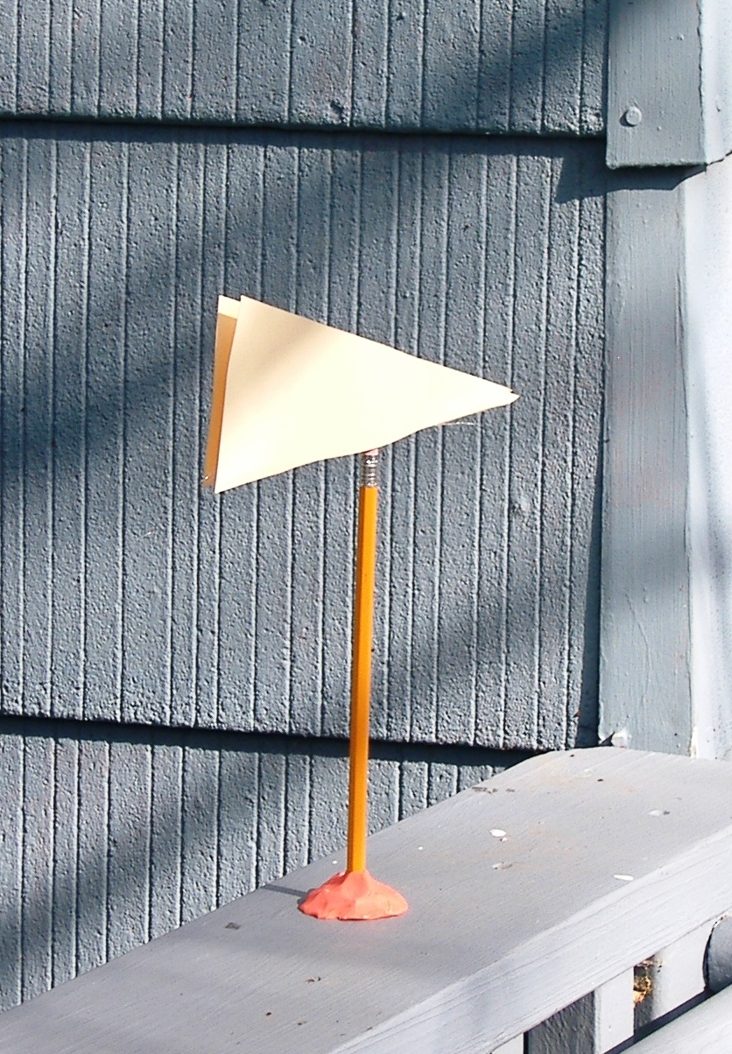
- Use a compass to figure out which way is North. Mark this direction on the cardboard.

- Let your wind vane blow in the wind. Observe the direction toward which the wind vane points.

- If the tip of the wind vane arrow is narrow enough and the back wide enough, the wind vane should point in the direction the wind is blowing.

- If your wind vane is not giving good results, try designing another arrow shape.

- Use your wind vane to observe the wind direction over a period of time.

- Record your wind data in the table below

Data Collection
Use the following table to collect data from your observations.
Time of Observation | Wind Direction | Notes

