Investigating Contact Angle Worksheet
Introduction
The way water interacts with the surface of an object can have important consequences. In this lab, you will learn more about different surface coatings and their uses.
Equipment
- pre-treated microscope slides
- beaker
- pipette
- magnifying glass
- hot plate
- tongs
- lab gloves
- Observing Surface Coatings
Introduction
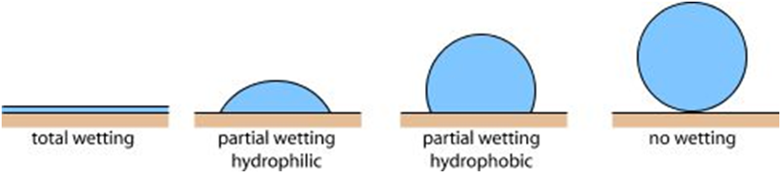Your teacher will provide you with up to five glass microscope slides labeled A-E. One of these slides is plain glass, and the rest have been treated with a variety of glass treatments to change the surface properties. In this part of the lab, you will observe how water acts differently on each of these surfaces. Wear gloves when handling coated glass.

superhydrophobic
superhydrophilic

Procedure
- On each glass slide, place a drop of water using the pipette. Look at the shape the water drops take on the glass slides. In the data table below, describe or carefully sketch what they look like.
- Next, pick up each slide with a water droplet and tilt them from side to side. How does the water drop behave on each slide?
- Using your observations from 1-3 and the diagram above, determine if the surface of each glass slide is hydrophilic or hydrophilic.
- Which slide is the most hydrophilic? ___________
- Which slide is the most hydrophobic? ___________

Slide | Water Drop Shape | Behavior of Drop When Tilted | Type of Surface  (hydrophilic or hydrophobic)
A
B
C
D
E

- Increasing Visibility in a Rain Storm
Introduction
If you have ever driven through a heavy downpour, you know rain can make it difficult to see the road or other cars. To improve visibility during a rainstorm, it is best if the windshield is able to shed water as fast as possible. In this part of the lab, you will test the surface coatings from Part A and decide which would be the best product to apply to the outside of a windshield to improve visibility during a rainstorm.
Prediction
In Part A, you observed the effect on water of different surface coatings. Using these observations, would you expect a hydrophobic or hydrophilic surface to shed water fastest? Which glass surface, A-E, do you expect to work best in a rain storm? (Answer on a separate sheet of paper. Use 2-3 sentences. Explain your answers and use evidence from Part A to support your answers.)
Procedure
- Fill a small beaker of water.
- Hold the microscope slide with coating A over a sink at an angle. When ready, pour the beaker of water down the side of the slide. Observe the water moving on the slide and record your observations in the table, below.
- Repeat steps 1-2 for the other coated slides.
Glass Coating | Observations
A
B
C
D
E
- Compare your observations for Part A and for Part B. Do you notice a relationship between a surface coating’s behavior in Part A and its behavior in Part B? If yes, state the relationship below.

- Was your prediction for the best rain coating correct? If not, provide 2-3 reasons the experiment may have come out differently than you had predicted.

- Anti-Fogging Properties
Introduction
Another important application for glass treatments is to avoid the reduced visibility caused by the condensation forming on glasses, goggles, windshields and other glass and plastic surfaces. In this section, you will predict which glass coating avoids this loss of visibility and perform an experiment to test your prediction.
Prediction
Use your observations from Part A to predict what type of surface coating has better anti-fogging properties, hydrophobic or hydrophilic. Which glass surface, A-E, do you expect to work the best? (Answer on a separate sheet of paper. Use 4-5 sentences. Explain your answers and use evidence from Part A and B to support your answers.)
Procedure
- Fill a beaker with water and place it on a hot plate. Turn the heat to medium.
- Wait five minutes. The water should be hot, but not boiling.
- Using the tongs, hold each slide above the beaker for 30 s. Before removing each slide, note the following observations: Has water condensed onto the slide? Has visibility been reduced through the glass? (Has it become foggy?) Record your observations in the table, below.
Glass Coating | Did Water Condense? | Has Slide Become Foggy?
A
B
C
D
E
- Compare your observations for Part A with your observations for Part C. Do you notice a correlation to the two behaviors? State your correlation below.

- Was your prediction for the best anti-fogging agent correct? If not, provide 2-3 reasons the experiment may have come out differently than you had predicted.

