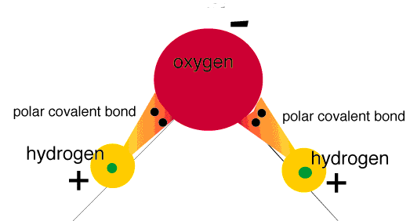
The Charges of Water Answer Key

- The diagram to the right shows the charges on a water molecule. Water is known to undergo cohesive forces, meaning it is attracted to other water molecules. Based on the diagram, why do water molecules become attracted to one another?
Figure 1: http://academic.brooklyn.cuny.edu/biology/bio4fv/page/image15.gif

Water is a polar molecule, mostly due to its asymmetric shape. The positive charges on one side of the molecule tend to attract the negative charges on the opposite side of a neighboring molecule.

- An adhesive force is when two dissimilar molecules are attracted to each-other. Discuss which glass treatment has the strongest adhesive force, and what this tells you about the polarity of the molecules in that glass treatment.

The hydrophilic Anti-Fog has strong adhesive forces, causing the water to stick to the glass. This means the hydrophilic coating is a strongly polar coating that attracts the charges of the water molecules.

- Below is the molecule Polydimethylsiloxane (PDMS): the primary ingredient in Rain-X. PDMS likes to form long polymer chains (right). How do you think the shape and structure of the PDMS molecule helps it to repel water?

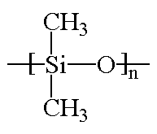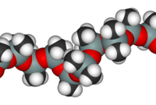
Figure 2: http://chemsrv1.uwsp.edu/macrogcss/silicone.html, http://soft-matter.seas.harvard.edu/index.php/Polymer_molecules

The PDMS has a symmetric structure that helps it to be non-polar. This means the cohesive forces between water molecules dominate and cause it to bead, or attract to itself.

